Sustainable Communities Initiative
Progress Report

April 2014

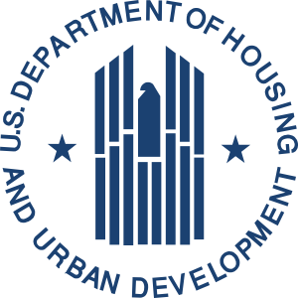
U.S. Department of Housing and Urban Development
Office of Economic Resilience

Sustainable Communities Initiative
Progress Report

April 2014

Prepared for
U.S. Department of Housing and Urban Development
Office of Economic Resilience

Submitted by

Summit Consulting, LLC
Washington, DC
Contract C-DEN-02532; CLIN 008
September 2013

For more information
hud.gov/sustainability
SustainableCommunities@hud.gov
(202) 402-3294

Executive Summary
In Fiscal Years 2010 and 2011, HUD’s Office of Economic Resilience (OER) provided $233.8 million in grant awards to 143 regional and local government entities in 48 states through their Sustainable Communities Initiative (SCI) grant program. The SCI grants are intended to help these local entities undertake a variety of planning activities to help communities and regions reach individual goals related to a set of six “Livability Principles” agreed upon by the U.S. Department of Housing and Urban Development (HUD), U.S. Department of Transportation (DOT), and the Environmental Protection Agency (EPA). These Livability Principles are to:
- Provide more transportation choices;
- Promote equitable, affordable housing;
- Enhance economic competitiveness;
- Support existing communities;
- Coordinate and leverage Federal policies and investment; and
- Value communities and neighborhoods.

The 143 grants overseen by OER assist over 1,200 municipalities, counties, and tribes—equal to approximately two-fifths of the U.S. population—in pursuing quality of life improvements for their communities.
OER contracted with Summit Consulting, to assess the progress and outcomes of the planning efforts for which funds were awarded in FY 2010.
This document serves as an interim progress and outcomes assessment report on only the FY10 cohort of Sustainable Communities Initiative grantees. This report is intended to offer a more comprehensive perspective of the ways through which the Sustainable Communities Initiative supported accomplishments in sustainability planning from January 2011 through September 2013—a majority of the three-year FY 2010 grant period.
This report includes the following findings regarding the 42 Community Challenge Planning (CCP) grantees and 45 Regional Integrated Planning (RIP) grantees funded in FY2010, over the first 2.5 years of the grant period of performance:
- SCI grantees are truly representative of the wide range of planning challenges faced across the United States. Grantees represent an impressive range of urban, rural, suburban, and tribal communities all across the country, including a wide range of community needs and project priorities.
- The six interagency Livability Principles provided a useful framework for grantee planning efforts. All of the Regional Integrated Planning (RIP) grantees addressed each principle in their communities. Though Community Challenge Planning (CCP) grantees were not required to address all Livability Principles through the planning process, these grantees also found the Livability Principle framework applicable to their work. Each Livability Principle was reflected in 73% to 95% of CCP grantee work plans.
- Public engagement in the planning process was a major grantee focus. Grantees held a total of nearly 2,000 meetings involving nearly 50,000 community residents over the first 2.5 years of the grant cycle.
- Although grantee performance measures are expected to change over the 36-month course of a planning process, at 30 months, most grantees were able to maintain most of the performance measures established at the start of the grant program. Approximately 84% of grantees achieved at least half of their stated services and activities performance measures as of the mid-2013 reporting period, while 40% of grantees had already achieved all of their performance outcome measures.
- FY 2010 Grantees leveraged a total additional contribution worth 91% of the original Sustainable Communities Initiative grant amount, bringing the total resources committed to the grant program from $138 million to approximately $281 million. Total resources include DOT TIGER II Planning grants and other resources committed to grantees through partners or other contributors in support of RIP- or CCP-funded projects.
- All RIP grantees and 73% of CCP grantees addressed affordable and affirmative housing opportunities in their planning processes, with a major focus on infill development and access to transit and jobs. Nearly half of grantees (47%) conducted some type of housing scenario planning. Grantees project that they will add a total of approximately 76,000 new units of affordable housing near transit based on the implementation of their plans.
- Increasing transportation choice was another major grantee objective. More than a quarter of grantees (27%) are using changes in mode share as a method of measuring transportation choice. To date, grantees have added a reported 1,600 miles of pedestrian/bike infrastructure in their communities. Through the implementation of their plans, grantees project they will have added a total of 2,650 miles of pedestrian/bike infrastructure, with many using the “Complete Streets” framework.
- Grantees plan to create significant new job opportunities for community residents through a wide range of strategies. Overall, grantees expect to create more than 3,000 new jobs directly, and are working on corridor and commercial reinvestment strategies that could have the ability to support the addition of nearly 3 million jobs in these areas. The majority of new jobs are to be created through investing in commercial and industrial centers, and through increasing workforce capacity based on education and training strategies.
- Infill development and brownfield remediation were another major grantee focus. Grantees have identified a total 316 brownfield sites for remediation thus far, 137 of which are located in predominately low-income or minority communities. Also, 10 grantees anticipate adding a total of 56 commercial and industrial facilities through infill development, creating infrastructural efficiencies and economic development.
- Incorporating public health issues and cultural assets in to the planning process were other themes explored by multiple grantees. Approximately 20% of grantees included representatives for the public health sector into their planning processes, and 13% of grantees adopted strategic plans to implement activities in support of cultural assets.
This report closes with a set of recommendations based on the contractor’s experience with preparing this report and providing technical assistance to grantees in performance measurement.
In addition, throughout this report are many case studies illustrating grantee performance. This includes two comprehensive case studies that review an entire grantee experience, five one-page case studies that illustrate specific aspects of the program, and many other brief citations of grantee work throughout the document. A list of all funded grantees is provided in Appendix A.

Table of Contents
Executive Summary 3
Table of Contents 5
List of Figures 6
List of Tables 7
About the Sustainable Communities Initiative 8
The PSC’s Six Livability Principles 8
Regional Integrated Planning (RIP) Grants Support the Development of Regional Plans for Sustainable Development 9
Community Challenge Planning (CCP) Grants Support Targeted Community Planning Projects 9
Program Expenditures 11
Program Grantees Represent a Diversity of Community and Grantee Types 12
FY 2010 and FY 2011 Sustainable Communities Initiative Grantee Locations* 14
The Role of Consortia in Grant Award and Planning Processes 15
Progress and Outcomes Assessment Framework 18
Program Theory of Change: How the Planning Process Impacts Local Sustainability 18
Progress and Outcomes Assessment Questions 20
Data Sources and Grantee Materials Utilized 21
Findings 22
Question 1: To what extent did grantees’ final submitted plans and other materials reflect the six Livability Principles? 26
RIP Grantees that Submitted Final Plans Addressed All Six Principles 26
CCP Grantees that Submitted Final Plans Also Addressed the Livability Principles 26
Grantees Incorporated the Livability Principles in their Planning Processes Using a Wide Variety of Strategies 27
Question 2: Did grantees meet the performance objectives they self-identified through the planning process in the first 2.5 years of the planning process? 35
Question 3: How did the Sustainable Communities Initiative influence performance measurement for sustainable development? 37
Step 1. Identify Needs 38
Step 2. Engage the Public and Set Goals 41
Step 3. Establish Performance Measures 44
Step 4. Start Measuring Progress 46
Step 5: Implement Performance Measures in Planning Documents 46
Question 4: What quantifiable sustainability impacts of the Sustainable Communities Initiative have occurred in the first 2.5 years of the planning process? 47
Livability Principle #1 - Transportation Choice 47
Livability Principle #2 - Promote Equitable, Affordable Housing 48
Livability Principle #3 - Enhance Economic Competitiveness to Create Jobs 48
Livability Principle #4 - Support Existing Communities through Transit-Oriented, Mixed-Use Development 48
Livability Principle #5 - Coordinate Policies and Leverage Investment 48
Livability Principle #6 - Invest in Healthy, Safe, and Walkable Neighborhoods 48
Comprehensive Case Studies 49
Comprehensive Case Study: Thunder Valley Community Development Corporation (Porcupine, SD) 49
Community Profile 49
Grantee Consortium Characteristics 50
Oglala Lakota Planning Process 50
Prioritizing Public Engagement 51
Alignment of the Planning Process with HUD Livability Principles 51
Performance Measures Established to Stay on Track 52
Next Steps 53
Comprehensive Case Study: City of Pittsburgh (PA) 54
Community Profile and Planning Impacts 54
Partners Involved in Planning Process 55
Alignment of the Planning Process with HUD Livability Principles 55
Performance Measures Established to Stay on Track 57
The Future of the Allegheny Riverfront Green Boulevard Plan 58
Conclusions and Recommendations 59
Conclusions 59
Recommendations 60
Appendices 62
Appendix A: 2010 Grantees Awarded through the Sustainable Communities Initiative 62
Appendix B: Data Description 66
Proposed Work Plan 66
eLogic Models 66
Performance Progress Reports 67
Submitted Plan 67
Appendix C: Master Planning in the New Economy (Grantee Profile) 68
City of Flint, Michigan 68
Appendix D: Creating a Healthy, Walkable Waterfront Community (Grantee Profile) 69
Northeast Los Angeles River Collaborative 69
Appendix E: Utilizing HUD Technical Assistance for Community Tracking (Grantee Profile) 70
Evansville Metropolitan Planning Organization (MPO) 70
Appendix F: Public Engagement for Sustainability in a Rural Context (Grantee Profile) 71
East Alabama’s CLEAR Plan 2030 71
Appendix G: Tracking Success through Performance Measurement (Grantee Profile) 72
Northern Maine Development Commission 72
Appendix H: Useful Acronyms 73

List of Figures
Figure 1: FY2010 Grantees by Grant Type 11
Figure 2: 2010 RIP & CCP Cumulative and Projected Grant Expenditures (February 2011-March 2014) 12
Figure 3: Number of Grantees by Community Type 14
Figure 4: Percentage of Grantees with Specific Partner Types Included in the Grantee Consortium 17
Figure 5: Types of Organizations Serving as Leads by Grant Program (RIP/CCP) 18
Figure 6: Logic Model Framework Describing Impact of Local Planning Efforts on Sustainability Outcomes 20
Figure 7: Percentage of CCP Grantee Projects Incorporating Each HUD Livability Principle 28
Figure 8: FY2010 Grantees with Mode Share Performance Measures – What Transportation Modes do they seek to Encourage? 29
Figure 9: Number of Grantees Pursuing Outcomes in “Supporting Existing Communities” Categories 34
Figure 10: Number of Grantees Pursuing Outcomes in “Healthy, Safe, and Walkable Neighborhoods” Categories 35
Figure 11: Percentages of Grantees who met their Services & Activities Performance Measures 37
Figure 12: Percentages of Grantees who met their Outcomes Performance Measures 37
Figure 13: Percentage of FY2010 RIP SC Grantees Selecting Each Need 40
Figure 14: Difference in Self-Reported Needs by Community Type (Urban, Suburban, Rural) 41
Figure 15: Grantee Self-Reported Needs Differed for Distressed Vs. Non-Distressed Communities 42

List of Tables
Table 1: Number of FY2010 Grantees and Total Funding by Grantee Type 13
Table 2: Summary of Grantee Final Plans and Related Deliverables 24
Table 4: Grantee-Projected Number of Jobs to Be Created as a Result of the Planning Process 31
Table 5: Grantee Needs to be Addressed in the Sustainable Communities Initiative 39
Table 6: Grantees Pursuing Scenario Planning 44
Table 7: Sustainability Goals Chosen by at least 10 CCP Grantees 44
Table 8: Sustainability Goals Chosen by at least 10 RIP Grantees 44
Table 9: Summary of the Flagship Sustainability Indicators 46
Table 10: Grantee Progress in Incorporating Planning Efforts in Local Regulations 48
Table 11: Expected Completion Dates for Pittsburgh Initiatives 58

About the Sustainable Communities Initiative
On December 16, 2009, the Consolidated Appropriations Act, 2010 established the Sustainable Communities Initiative. The goal of the initiative was to improve regional planning efforts that integrate housing and transportation decisions, as well as to increase state, regional, and local capacity to incorporate livability, sustainability, and social equity values into land use, planning, and zoning.
The Sustainable Communities Initiative is a product of the Partnership for Sustainable Communities (PSC), a joint partnership established by coordination between the U.S. Department of Housing and Urban Development (HUD), the U.S. Department of Transportation (DOT) and the Environmental Protection Agency (EPA). As part of this partnership, DOT, EPA, and HUD collaborate to advance development patterns and infrastructure investment programs that achieve improved economic prosperity and facilitate the development of healthy, environmentally sustainable, and opportunity-rich communities. The Sustainable Communities Initiative aims to utilize two unique grant programs, the Community Challenge Planning (CCP) and Regional Integrated Planning (RIP) programs, to better connect housing to jobs, coordinate Federal housing and transportation investments with local land use decisions, and reduce transportation costs for families through the incorporation of the following six Livability Principles in the planning process:

The PSC’s Six Livability Principles
1. Provide more transportation choices.
Develop safe, reliable, and economical transportation choices to decrease household transportation costs, reduce our nation’s dependence on foreign oil, improve air quality, reduce greenhouse gas emissions, and promote public health. Transportation choice includes providing residents choices such as high quality public transit, as well as biking, walking, and carpooling, and the choice to drive a personal car.
2. Promote equitable, affordable housing.
Expand location-efficient homes near transit, jobs, and other amenities, and energy-efficient housing choices for people of all ages, incomes, races, and ethnicities to increase accessibility and lower the overall combined cost of housing and transportation for the region, especially for low-income families.
3. Enhance economic competitiveness to create jobs.
Improve economic competitiveness through increasing reliable and timely access to employment centers, educational opportunities for children and adults, workforce development services, and other basic needs by workers, as well as expanded business access to markets.
4. Support existing communities through transit-oriented, mixed-use development.
Increase land use efficiency by prioritizing existing communities—through such strategies as transit-oriented development, mixed-use development, and land recycling and encouragement of infill development—to increase community revitalization, improve the efficiency of infrastructure investments, and safeguard rural landscapes and farm communities.
5. Coordinate policies and leverage investment.
Align Federal policies and funding to remove barriers to collaboration, leverage funding, and increase the accountability and effectiveness of all levels of government to plan for future growth, including making smart energy choices such as locally generated renewable energy.
6. Invest in healthy, safe, and walkable neighborhoods.
Enhance the unique characteristics of all communities by improving the health, safety, and walkability of rural, urban, and suburban neighborhoods.

In U.S. Government Fiscal Year 2010, under the Sustainable Communities Initiative, the Office of Economic Resilience (OER) provided $138 million in grant awards to 87 regional planning and governmental agencies, local government entities, and community nonprofits through the Regional Integrated Planning (RIP) and Community Challenge Planning (CCP) grant programs. In July 2011, OER announced an additional $100 million to support another 56 local initiatives targeting sustainability development initiatives for Fiscal Year 2011, but this assessment report only utilizes data from the grants awarded in Fiscal Year 2010.

Regional Integrated Planning (RIP) Grants Support the Development of Regional Plans for Sustainable Development
Under the RIP grant program, OER awarded competitive grants to support preparation or expansion of Regional Plans for Sustainable Development (RPSD). The purpose of the program is to support metropolitan and multijurisdictional partnerships that commit to adopt integrated plans, strategies, and management tools incorporating all six of HUD’s Livability Principles. HUD supported two categories of RIP grants:
RIP Category 1 grants support the preparation of Regional Plans that do not currently exist, or which require significant revisions or enhancements to fully incorporate a range of sustainable development priorities, including housing, economic development, transportation, energy, water, and environmental quality.
RIP Category 2 grants, in contrast, support efforts to “fine-tune” existing Regional Plans to increase alignment with the HUD Livability Principles, as well as provide resources to execute tasks or predevelopment planning activities described in an existing plan.
RIP grantees were required to submit RPSDs for their planning area. Regional Plans were required to be clearly defined, single, integrated plans for regional development that address potential population growth or decline over a minimum 20-year time frame, set appropriate 3- to 5-year benchmark performance targets, and delineate strategies to meet established performance goals. It is also envisioned that the grantees’ plans, policies, and implementation strategies will be adopted by all participating jurisdictions over time.

Community Challenge Planning (CCP) Grants Support Targeted Community Planning Projects
The CCP program is designed to foster reform and reduces barriers to achieving affordable, economically vital, and sustainable communities at the local or neighborhood level. CCP grantees are tasked with developing targeted projects in their communities, including corridor plans, neighborhood plans, and other targeted area interventions. For example, a Memphis, Tennessee consortium is using its CCP grant to develop an integrated transportation, housing, and economic development strategy centered on stimulating investment near the Memphis International Airport. The planning process included developing changes to zoning to allow for more economic development in order to create jobs and workforce housing in the area around the airport. Grand Traverse County, in Michigan, utilized their CCP grant to focus exclusively on promoting affordable housing along amenity-rich corridors. Their planning process included assessment of regulatory barriers to affordable housing, and review of the community master plan to pursue development of affordable housing facilities in key areas.
In addition to funding from HUD, funding was also available to CCPs from a portion of DOT’s National Infrastructure Investment Grants. These grants are often referred to as TIGER II Planning Grants. DOT and HUD issued a joint Notice of Funding Availability (NOFA) for the CCP and TIGER II Planning Grants in order to better align planning and improve linkages between DOT and HUD’s programs. Therefore, some CCP grantees, in addition to receiving funding from HUD, have also received funding from DOT. CCP grantees were instructed to address the Livability Principles to the extent that they reflected the needs of their individual communities, and incorporate the Principles in their planning processes as appropriate.
CCP grantees provided a larger range of deliverables based on the particular focus of their program, which could include amending local master plans, zoning codes, and building codes to promote mixed-use development, affordable housing, and the reuse of older buildings and structures for new purposes.
As shown in Figure 1 below, funded grantees are almost evenly split between RIP grantees working on a broad Regional Plan (52%) and CCP grantees who are working on more targeted plans (48%). A majority of RIP grantees are Category 1 grantees, which are still at the beginning of the regional planning process, while a minority of RIP grantees are Category 2 grantees, working to fine-tune or revise an existing plan.
Figure 1: FY2010 Grantees by Grant Type
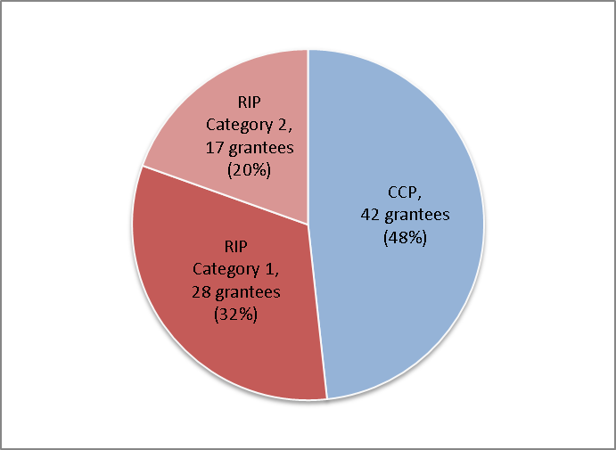
Source: http://portal.hud.gov/hudportal/HUD?src=/program_offices/sustainable_housing_communities

Program Expenditures
Of the $138 million in available grant funding for fiscal year 2010, a total of $98 million was allocated for the RIP program and $40 million for the CCP program. Figure 2 below illustrates expenditures made to grantees since the start of project funding disbursement in February 2011. Solid lines represent actual expenditures through August 2013, while the dotted lines represent projected expenditures through the end of the period of performance, based on grantee budgets.
Figure 2: 2010 RIP & CCP Cumulative and Projected Grant Expenditures (February 2011-March 2014)
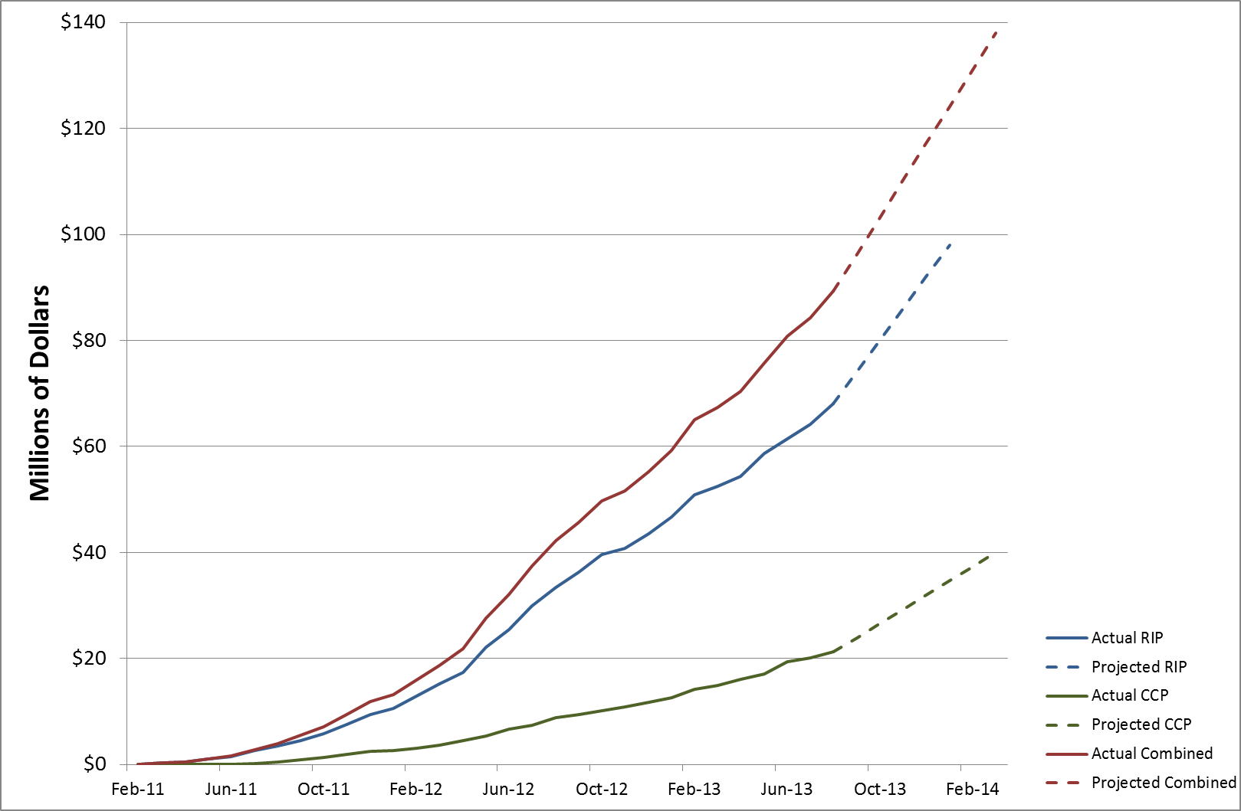
Source: HUD data provided to Summit on 9/10/2013.

As shown in the figure above, disbursement of funds started slowly, as grantees kicked-off their planning processes over the first year of grant implementation, and increased over year two. For example, overall RIP grantee disbursements occurred at a rate of approximately $880,000 per month during the first year of the grant programs, while second-year disbursements occurred at a rate of approximately $3 million per month. Overall CCP grantee disbursements showed a similar pattern, occurring at a rate of approximately $300,000 per month in the first year of the grant program, and a rate of approximately $945,000 per month in year two. It should be noted that a few grantees have been provided three- to six-month no-cost extensions of their period of performance, which may delay the full expenditure of grant funds past the originally scheduled end of period of performance.
In addition to HUD’s direct grant amount, both CCP and RIP grantees were required to utilize leveraged contributions either in cash or in-kind of at least 20% of the grant amount. These contributions may come from any combination of local, state, private, or philanthropic contributions dedicated to the express purposes of the grant proposal.

Table 1 shows the total funding for each type of grantee, as well as the amount of funding awarded through DOT, HUD, and from outside contributions. DOT funded CCP grantees in the amount of $9.45 million. HUD funding to CCP and RIP grantees amounted to $40 million and $98 million, respectively. Grantees leveraged a total additional contribution worth 91% of the original HUD and DOT grant amounts. This brings total resources committed to the grant program from $138 million to approximately $281 million for all grantees. Approximately two years into the grant period of performance, just under half of these promised outside contributions have been realized.
Table 1: Number of FY2010 Grantees and Total Funding by Grantee Type
Grant Type | Number of Grantees | HUD Amount Granted | DOT Amount Granted | Outside Contribution Committed | Total Resources Committed | Percentage of Federal Dollars Leveraged |  | Percent of Outside Contribution Realized as of 1/31/2013
CCP | 42 | $40,000,000 | $9,452,929 | $40,407,680 | $89,860,089 |  | 82% | 36%
RIP | 45 | $98,000,031 | $0 | $93,592,747 | $191,592,778 |  | 96% | 48%
All Grantees | 87 | $138,000,031 | $9,452,929 | $134,000,427 | $281,452,867 |  | 91% | 44%
Source: HUD data provided to Summit on 9/20/2013.

Program Grantees Represent a Diversity of Community and Grantee Types
Grantee communities represent a wide variety of community types, regions, and project focus areas. In particular, HUD made an effort in the grantmaking process to ensure that rural communities, including Native American communities, were well-represented. In particular, $25 million in grant funding was set aside for regions of less than 200,000 residents. Overall, 37% of grantees, including a majority of the RIP grantees, represent primarily rural jurisdictions. Figure 3 below illustrates the distribution of grantees across urban, rural, and suburban communities.

Figure 3: Number of Grantees by Community Type
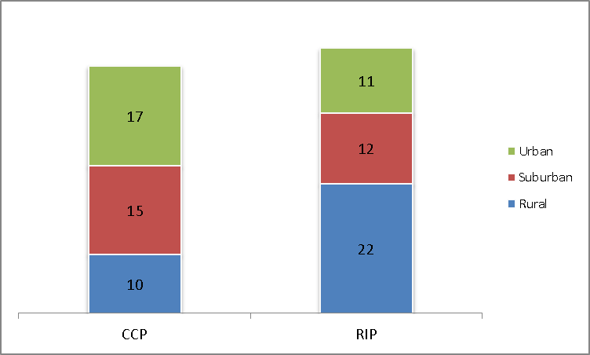
Source: http://portal.hud.gov/hudportal/HUD?src=/program_offices/sustainable_housing_communities

In addition to representing diverse community types, grantees also represented a range of locations across the U.S. The following map portrays the geographic distribution of all Sustainable Communities Initiative grantees.

FY 2010 and FY 2011 Sustainable Communities Initiative Grantee Locations*
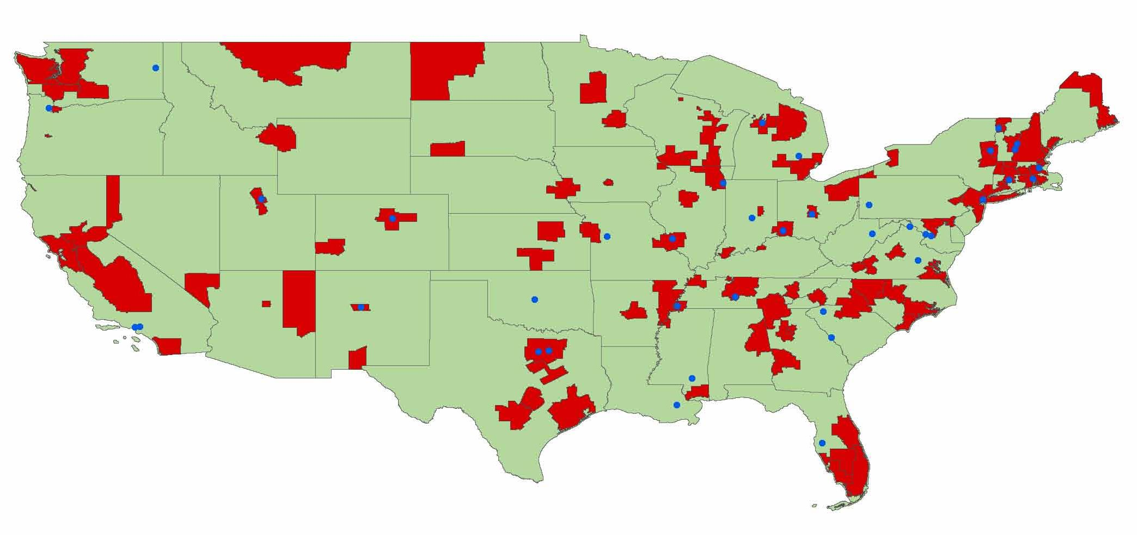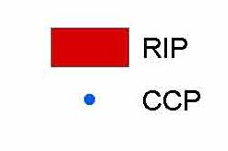
*Note: CCP grantee, City and County of Honolulu, not shown.
Source: Grantee planning area GIS shapefiles (RIP grantees) and lead organization locations (CCP grantees).

The Role of Consortia in Grant Award and Planning Processes
The Sustainable Communities Initiative grant programs were uniquely required to be submitted not by a single agency or organization, but by a consortium comprised of a group of community stakeholder groups that broadly represented an entire planning area. Funded consortia included representatives from a diverse group of stakeholders including governmental bodies, regional and transportation planning agencies, universities, nonprofit organizations, and private sector actors. Each consortium as a whole was required to collectively have the capacity and experience to carry out the proposed activities under the grant program, and to enter into an agreement to submit a single application for Sustainable Communities Initiative grant program funding. There were eight broad types of organizations participating in consortia, with example organizations from various grantees listed below:

- Local Government: The City of Pittsburgh leads its CCP project along with support from the Mayor’s office and other local government offices, such as the City of Pittsburgh Planning Department.
- Regional Government: East Hazel Crest, Illinois’ community planning efforts are led by the South Suburban Mayors and Managers Association (SSMMA). SSMMA is an intergovernmental agency, providing technical assistance and joint services to 42 municipalities representing a population over 650,000 in Cook and Will Counties. The leadership of the SSMMA consists of six mayors from various small towns.
- Council of Governments: Sacramento, California’s regional planning efforts are led by the Sacramento Area Council of Governments (SACOG), which describes itself as a Council of Governments/Metropolitan Planning Organization. SACOG is an association of local governments in the six-county Sacramento Region. Its members include the counties of El Dorado, Placer, Sacramento, Sutter, Yolo, and Yuba, as well as 22 cities. SACOG’s directors are chosen from the elected boards of its member governments.
- Metropolitan Planning Organization: Des Moines, Iowa’s regional planning efforts are led by the Des Moines Area Metropolitan Planning Organization (DMAMPO). The DMAMPO provides a regional forum to ensure coordination between the public and local, state, and Federal agencies with regard to planning issues and in preparing transportation plans and programs.
- Non-Profit Organization: Caribou, Maine’s regional planning efforts are led by the Northern Maine Development Commission (NMDC), a Private Non-Profit organization. NMDC is a membership organization comprised of participating communities and counties in the Aroostook Washington Economic Development District. It provides Federal and state services at the regional and local levels, and management and support for several other organizations.
- Academic Institution: Fresno, California’s regional planning efforts are led by the Fresno Foundation at the California State University (CSU). The Fresno Foundation at CSU provides administration and support services for sponsored programs (grants and contracts) awarded to the University.
- State Government: There are several community planning efforts being led by the Colorado Department of Local Affairs, which describes itself as the “face of state government” for communities throughout Colorado. The Department is assisting three rural communities develop their downtowns.
- Tribal Government: Wellpinit, Washington’s community planning efforts are led by the Spokane Tribe of Indians. Tribal lands are located on 159,000 acres in Wellpinit, Washington. The Tribe is a sovereign government body led by the Spokane Tribal Business Council, reporting to all enrolled Spokane Tribal members.
Figure 4 displays the percentage of grantees that included each type of partner in their consortium, irrespective of which organization serves as the lead organization for grant award purposes. Nearly all grantees utilize local governments as partners, with 95% of RIP grantees and 93% of CCP grantees listing this partner type in their application. Also present in a majority of the consortiums were non-profits (86% RIP, 64% CCP), Academic Institutions (71% RIP, 48% CCP), and Community Based Organizations (67% RIP, 48% CCP). Not surprisingly, RIP grantees are more likely to include all types of partner organizations.
Figure 4: Percentage of Grantees with Specific Partner Types Included in the Grantee Consortium
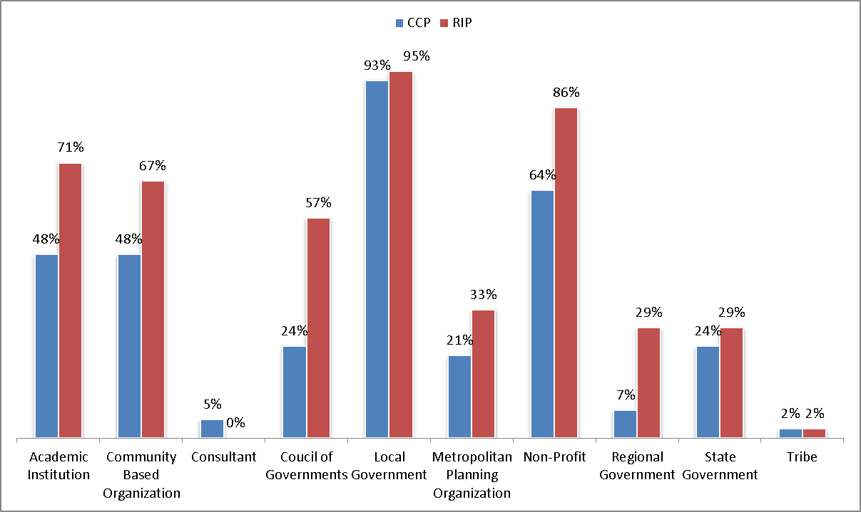
Source: Analysis of FY2010 grant applications, rating factor forms, and grantee websites as of 2/15/12.

Each consortium was required to designate a lead applicant, who would serve as the entity responsible for submitting the grant application to HUD, and would execute the cooperative agreement with HUD, assuming fiscal responsibility for the grant on behalf of the consortium. Figure 5 breaks down the types of organizations serving as lead applicants by grant program.
Figure 5: Types of Organizations Serving as Leads by Grant Program (RIP/CCP)
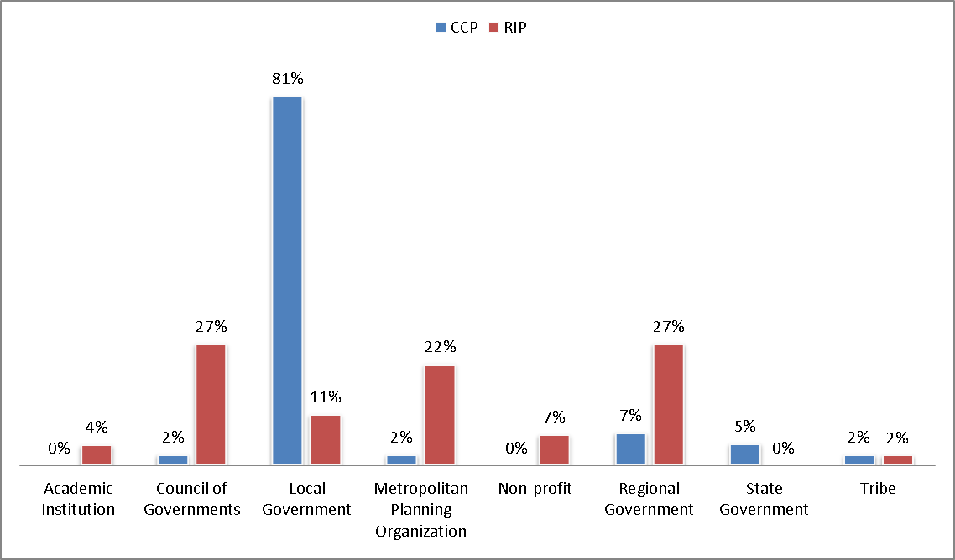Source: Analysis of FY2010 grant agreements, rating factor forms, and grantee websites as of 2/15/12.

For the RIP program, the most common types of lead organizations were Regional Governments (27%), Councils of Governments (27%), and Metropolitan Planning Organizations (22%). Local Government entities represented the majority (81%) of lead organizations among CCP grantees.
As is evident throughout this report, the HUD Sustainable Communities Initiative funded a diverse set of projects dedicated to sustainability planning across the country. The following section describes the framework used to prepare this progress and outcomes assessment report.

Progress and Outcomes Assessment Framework
This assessment serves to examine the planning processes of 87 FY 2010 SC grant recipients, including 45 RIP and 42 CCP grantees, and provides a description of grantee progress in meeting project goals through the first 2.5 years of the grant program.
In most cases, grantees received funding for a three-year period of performance, beginning in January 2011 and this report utilizes data collected through August 2013. Therefore, data used to inform the report covers the first 2.5 years of performance for most OER grantees, and does not cover the entire period of grantee performance. Data sources, described below, provided a detailed look at the grantee planning process, beginning with grantees’ project work plans, selected performance measures through HUD reporting forms, progress in project activities and outcomes over time, and in some cases, grantees’ final plans to be implemented in their communities and regions.

Program Theory of Change: How the Planning Process Impacts Local Sustainability
Much of the quantitative data in this report is based on grantee reporting in a template called the HUD eLogic model. The eLogic model is an Excel-based tool used within HUD and other Federal agencies, through which grantees report on the services, activities, and projected outcomes of their planning processes utilizing a logic model framework. Traditional logic models are narrative or graphical depictions of processes in real-life planning scenarios that communicate expected results of specific planning activities. Logic models illustrate a sequence of cause and effect relationships, and describe the underlying theory of change that describes the manner in which activities in a given project lead to final project goals. Logic models link the ‘Situation’ to the ‘Intervention’ (Inputs and Outputs) of a particular program, and finally to the ‘Impact’ or desired ‘Outcome.’
In the Sustainable Communities Initiative, the ‘Situation’ is the state of a grantee’s community and the planning needs identified by the grantee at the start of the planning period. These needs are then linked to the ‘Intervention’ stage, which proposes a set of ‘Outputs,’ or actions that the grantee undertakes during the grant period. These may include community and stakeholder outreach, collection of data to inform decision-making, and scenario planning or other planning outputs. Finally, the result of these ‘Outputs’ are ‘Outcomes’; the lasting results in the community.
The following Figure 6 illustrates this overall Logic Model framework to describe the Sustainable Communities Initiative based on the characteristics of the grant programs and HUD’s eLogic model template.

Figure 6: Logic Model Framework Describing Impact of Local Planning Efforts on Sustainability Outcomes
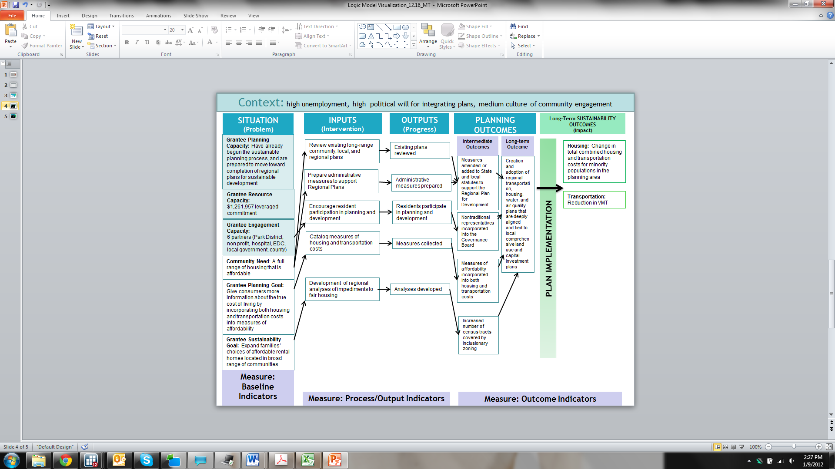

Progress and Outcomes Assessment Questions
This report serves to provide a comprehensive view of the grantee experience, along with analysis results based on the following research questions:
Question 1: To what extent did grantees’ final submitted plans and other materials reflect the six PSC Livability Principles?
Research Methodology: The Assessment Team’s methodology for Research Question 1 involved a content evaluation of all submitted final plans (including those not yet adopted locally), as well as the latest submitted reporting materials for all grantees. These materials were evaluated based on inclusion of outcomes connected to the Livability Principles. This analysis is supplemented by case studies that highlight particular grantee successes and innovative approaches, and includes information provided through the technical assistance process.
Question 2: Did grantees meet the performance objectives they self-identified through the planning process in the first 2.5 years of the planning process?
Research Methodology: Using data obtained through grantees’ submitted eLogic models, the Assessment Team created a descriptive documentation of grantee progress, as self-reported by grantees.
Question 3: How did the Sustainable Communities Initiative impact performance measurement for Sustainable Development in grantee planning areas?
Research Methodology: The Sustainable Communities Initiative was unique in its major focus on performance measurement itself, and the key role that performance measurement played in the planning process. HUD provided significant technical assistance to grantees, specifically targeted to improving grantees’ own performance measurement capacities, and performance measurement was a required part of the planning process.
To explore the impact of prioritizing performance measurement on the success of the program, the Assessment Team reviewed quantitative and qualitative sources of grantee reporting data to discover an emergent framework that grantees used to incorporate performance measurement in all aspects of their planning processes. Using this framework as a guide, the Team described how the performance measurement goals of the Sustainable Communities Initiative empower communities to more rigorously track and evaluate their progress toward meeting important, locally defined goals.
Question 4: What are the quantifiable impacts of the Sustainable Communities Initiative in the first 2.5 years of the planning process?
Research Methodology: The Team aggregated grantees’ self-reported outcomes in final plans and eLogic models, as well as numeric data compiled from grantee work plans, progress reports, and consortium agreements to provide an overall description of the projected planning outcomes for each grantee community. Although HUD directed grantees to report on the expected impacts of the planning process throughout the three-year period of performance, most outcomes developed through the planning process will occur over a 10- to 40-year timeline, and are not intended to occur during the grant period itself.
Finally, two comprehensive case studies illustrate how grantees utilized the programs in their communities.

Data Sources and Grantee Materials Utilized
Data utilized in this report are compiled from a variety of sources, including 2010 grantees’ semi-annual reporting documents, including the HUD eLogic Model, through which grantees were required to select a variety of services, activities, and outcomes, along with community needs, that best reflect their grant project and overall goals. Grantees self-selected individual performance measures for Year 1 through Year 3 of the grant cycle using individual eLogic Models, which were approved by HUD staff prior to grantee reporting. The following analysis incorporates 39 of 42 CCP and 40 of 45 RIP eLogic models that were provided to the Assessment Team as of August 31, 2013.
Beyond semi-annual reporting materials, this report incorporates grantees’ work plans and grant application documents, materials developed as a result of technical assistance services delivered, data collected by phone and e-mail used for case studies, and final plans received from 19 CCP and RIP 2010 grantees. The nature of this assessment required that analysis be conducted prior to the end of the grant period of performance, when only 19 total final plans had been submitted by grantees. A more complete description of the reporting materials submitted by grantees and utilized in this report is provided in Appendix B.

Findings
The following sections provide findings related to the primary progress and outcomes assessment questions, referenced below:
- To what extent did grantees’ final submitted plans and other materials reflect the six Livability Principles?
- Did grantees meet the performance objectives they self-identified through the planning process in the first 2.5 years of the planning process?
- How did the Sustainable Communities Initiative impact performance measurement for sustainable development in grantee planning areas?
- What are the quantifiable impacts of the Sustainable Communities Initiative in the first 2.5 years of the planning process?
A review of the 19 grantee final plans received to date provided a critical source of data. The following, Table 2, provides an in-depth summary of the 15 CCP and 4 RIP plans received and reviewed.

Table 2: Summary of Grantee Final Plans and Related Deliverables
Grantee | Grant Program | Plan Name | Plan Type | Major Focus Areas
Bernalillo County, NM | CCP/DOT | Bridge Boulevard Corridor Redevelopment Plan | Corridor Redevelopment Plan | Plan identifies strategies and improvements aimed to increase safety, reduce traffic congestion as traffic volumes increase, revitalize local businesses, and improve housing availability and affordability.
Chittenden County, VT | RIP Type 2 | 2013 Chittenden County ECOS (Environment, Community, Opportunity, Sustainability) Plan | Update to the County Regional Plan, Metropolitan Transportation Plan, and the Comprehensive Economic Development Strategy | Design and maintain a green infrastructure network. Enable all community members to participate in the workforce and civic and cultural activities. Build on the regional capacity for economic sustainability. Make public and private investments in the built environment.
City of Burlington, VT | CCP | planBTV: A Master Plan for Burlington’s Downtown and Waterfront Development | City Plan | The plan provides a baseline study of Burlington, focusing on the downtown and waterfront areas, and envisions pedestrian and waterfront projects that re-establish the urban grid, and readdress the waterfront. The city reached out to citizens through social media, a speaker series, and a large range of public events.
City of Covington, KY | CCP | Annual Action Plan 2012-2013 | Annual Action Plan | This plan primarily focused on home ownership and affordable housing, with additional discussion of citizen participation, infrastructure improvements and parks and recreation.
City of Dallas, TX | CCP | Station area plans for Hatcher, Vickery Meadow, Buckner, Lancaster Corridor, and Martin Luther King, Jr. DART (Dallas Area Rapid Transit) light rail stations | Five station area plans | Individual station area plans for each of five DART light rail stations. Focusing on improving multi-modal connectivity and pedestrian access, reinvigorating affordable housing, addressing land use density, and establishing overall strategies and guidelines to create a thriving, transit-oriented neighborhood over the long term.
City of Denver, CO | CCP/DOT | Sun Valley Neighborhood: Decatur-Federal Station Area Plan | Neighborhood Plan | Enhance walkability and “bike-ability” to make transit convenient. Integrate a system of parks and public spaces. Celebrate local culture. Encourage health for people and the environment. The neighborhood is "open for business" and economically competitive.
City of Glens Falls, NY | CCP | The Art & Culture Gateway to the Adirondacks | Downtown Vision & Development Strategy | Plan seeks to increase transit options and link regional transit services, improve the availability of affordable housing downtown, invest in energy-saving initiatives like car recharging stations, and improve cooperation and access to the city's most dynamic cultural destinations.
City of Pittsburgh, PA | CCP/DOT | Allegheny Riverfront Green Boulevard | Strategic Plan | Transformation of an existing railroad system to a multi-modal green boulevard that integrates commuter rail transit, a new riverfront open space destination, riverbank stabilization efforts and ecological enhancements, and a housing plan for mixed-use/transit-oriented development that promotes a live/work riverfront lifestyle.
City of Richmond, VA | CCP/DOT | Hull Street Corridor Revitalization Plan | Corridor Plan | Develop strong and safe multi-modal connections, transportation infrastructure upgrades, visual and physical enhancements, improved housing options, expanded job opportunities, and critical recreational and environmental investments. Provide easy access to parks/green space.
City of Santa Monica, CA | CCP | Bergamot Area Plan | Neighborhood Plan | Improving transit with streets that serve pedestrians, bicycles, cars, and buses. Improve the quality of life, shared space, and active and safe transportation. Conserve the authentic, industrial character of the neighborhood. Foster a creative community which creates new businesses.
City of Seattle, WA | CCP/DOT | The Growing Transit Communities Strategy | Corridor Plan | Plan addresses how the Puget Sound region will leverage the $15 billion the region recently committed to rapid transit to ensure that communities remain walkable, there are housing choices for low and moderate income households, and equitable access to opportunity for all the regions residents.
City of Somerville, MA | CCP | SomerVision: City of Somerville, Massachusetts Comprehensive Plan | City Plan | Support neighborhoods. Strengthen commercial corridors/growth districts to create jobs through transit-oriented districts. Support creative arts and public spaces. Improve transportation and infrastructure. Encourage mixed use, mixed income, and affordable housing.
City of Warrensburg, MO | CCP/DOT | Maguire Street Corridor Plan | Corridor Plan | Create a place that is comfortable, attractive, and successful, through economic competitiveness, (re)development, infrastructure, urban design, and sustainability. Common themes include transportation, design, and business environment.
Franklin Regional Council of Governments, MA | RIP Type 1 | Sustainable Franklin County | Regional Plan | Plan focuses on housing (quality, energy efficiency, location), transportation (choice), economic development, cultural resources, land use (redevelopment), infrastructure, energy, natural resources, and public participation. Overall goal is to make the region “more resilient and sustainable.”
Randolph, WV | CCP/DOT | Randolph County Housing & Transportation Study | Study | The Randolph County Housing Authority (RCHA) is pursuing a goal of increasing the number of affordable homes located on the public bus route in order to provide energy-efficient and transportation-efficient living for young families, new-to-town-households, the elderly, and the disabled.
Ranson, WV | CCP/DOT | 2012 Comprehensive Plan | City Plan | Create conditions favorable to health, safety, and mobility. Promote a sense of community. Focus development in existing developed areas and fill in vacant or underused land near existing developed areas to create well designed and coordinated communities.
Salt Lake City Corporation, UT | CCP | 400 South Livable Communities Master Plan and Zoning Map Amendments | Salt Lake City Zoning Ordinance, and Zoning Map for new station areas | Document outlines proposed station area plans with goal to implement livability goals for the corridor, including land use policies and zoning that support mixed use development and transportation choices for current and future residents and workers.
Spokane Tribe of Indians, WA | CCP | Sustainable Community Master Plan | Strategic Plan | This master plan addresses issues surrounding land use, economic development, transportation, housing, capital facilities and utilities, and parks and recreation for the Spokane Tribe of Indians.
Thunder Valley Community Development Corporation, SD | RIP Type 1 | Oyate Omniciye Ogala Lakota Plan | Regional Plan | Create meaningful economic and job opportunities that reignite cultural identity; promote and enhance public health and awareness of healthy alternatives; and provide and enhance infrastructure, housing, and social services at an affordable cost.
Source: Grantee final plans/final deliverables.

Question 1: To what extent did grantees’ final submitted plans and other materials reflect the six Livability Principles?
As described previously, the six Livability Principles established by the PSC are as follows:
- Provide more transportation choices;
- Promote equitable, affordable housing;
- Enhance economic competitiveness to create jobs;
- Support existing communities through transit-oriented, mixed-use development;
- Coordinate policies and leverage investment; and
- Invest in healthy, safe, and walkable neighborhoods.

According to the 2010 NOFA, RIP grantees were required to address the Principles throughout their planning processes, and reflect these goals in their submitted Regional Plans or other final program deliverables. CCP grantees were also encouraged to address the HUD Livability Principles, but due to the more targeted nature of their project areas, were permitted to limit their focus to those principles that best aligned with their communities’ needs.

RIP Grantees that Submitted Final Plans Addressed All Six Principles
Of the RIP grantees that submitted final plans, all demonstrated a comprehensive approach that corresponded to each of the six Livability Principles, either through their final plans or within reporting materials that documented strategies that fully incorporate all Principles.

CCP Grantees that Submitted Final Plans Also Addressed the Livability Principles
Although it was not a requirement for CCP grantees to address all six Principles, CCP final plan deliverables or eLogic model reporting reflected most Principles in some way. Figure 7 below provides the number of CCP grantees that address each of the Livability Principles.
Figure 7: Percentage of CCP Grantee Projects Incorporating Each HUD Livability Principle
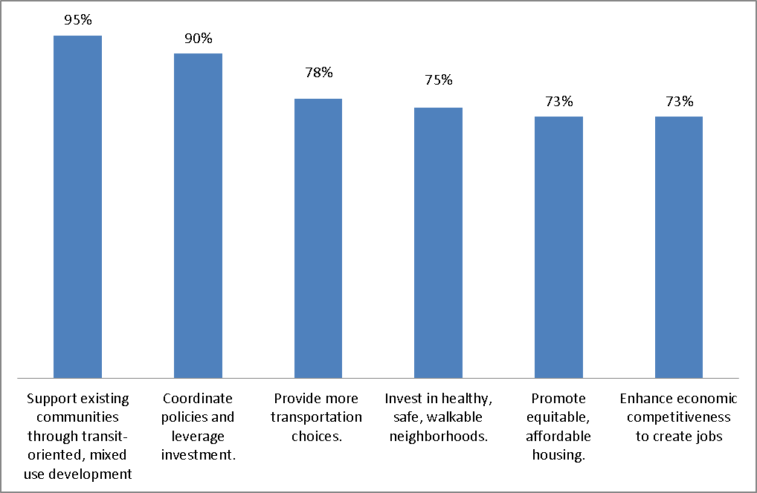Source: eLogic Models and/or final plans for 40 of 42 CCP grantees.

Grantees Incorporated the Livability Principles in their Planning Processes Using a Wide Variety of Strategies
The following section provides an overview of the ways through which both RIP and CCP grantee plans and reporting materials reflected each of the six Livability Principles.

Livability Principle #1 - Transportation Choice
Approximately 83% of grantees addressed transportation issues in their latest reporting materials, with nearly half of all grantees (47%) either improving transportation networks or prioritizing transportation planning as a community need. Increasing transportation choice includes providing community members with access to public transit, walking, biking, and carpooling, in addition to driving. For grantees, transportation choice often means improving or creating infrastructure for non-automobile transportation modes, which can include unique strategies ranging from expanding public transportation lines to improving the sidewalk infrastructure for pedestrians. Increasing transportation choice provides countless benefits, including economic benefits to residents. For example, a recent report published by the EPA estimated that driving alone costs commuters an average of $6,900 per year, while carpoolers spend only $3,700 per year, and transit commuters’ costs amount to $650 per year, on average. Where bicycling and walking are viable options, residents can enjoy significant health benefits and reduced commute costs. To increase travel by foot and bike, many grantees seek to improve infrastructure in these areas.
Grantee transportation priorities fell into four broad categories:

Changes in Mode Share
Approximately 38% of grantees sought to decrease reliance on individual automobile travel in their communities. Grantees targeted expanding mode share options both at the community-wide level and for commuters, specifically, according to their final plans or latest reporting materials. In some cases, grantees chose a specific mode of focus—for example, biking or transit—while many grantees pursued activities aimed at decreasing automobile reliance generally, or single-ridership vehicle travel modes. For grantees with goals of mode share change, Figure 8 provides the percentage of grantees that are focusing on each mode of transportation.
Figure 8: FY2010 Grantees with Mode Share Performance Measures – What Transportation Modes do they seek to Encourage?
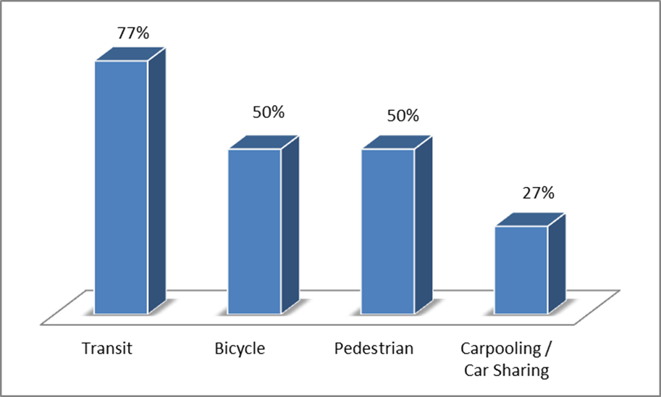
Source: eLogic models for 79 grantees for which data were available.

Miles of Pedestrian/Bike Infrastructure Provided
Rather than measuring changes in community transportation behavior, many grantees chose to directly measure the miles of pedestrian and bike infrastructure developed as a result of their planning process. Many grantees accomplished this through implementation of a “complete streets” policy. Complete streets policies instruct planners to design and operate the entire right of way to enable safe access for all users, regardless of age, ability, or mode of transportation. By the completion of the FY 2010 Sustainable Communities Initiative grant programs, grantees anticipate that they will have added a total of 2,650 new miles of pedestrian and bike infrastructure.

Decrease in Per-Capita VMT
Vehicle Miles Traveled (VMT) is a standard measure of the number of miles traveled by passenger vehicles. This information is collected by U.S. states and jurisdictions to meet Federal Highway Administration (FHWA) reporting requirements as part of the Highway Performance Monitoring System (HPMS). Federal guidelines dictate how VMT is captured. Twelve grantees aim to decrease VMT in their communities by a range of 1-10% over the planning horizon.

Livability Principle #2 - Promote Equitable, Affordable Housing
Housing issues were another major focus area for grantees. Improving housing affordability was the dominant housing issue, with 42% of grantees identifying a need for more affordable housing options, and 11% identifying a need for expanding opportunities for affirmative housing. All RIP grantees were required to complete a Fair Housing and Equity Assessment, and 73% of CCP grantees also plan to improve housing options in their planning areas, according to final plans or recent reporting materials, such as eLogic submissions. Broad themes around this topic include the following:

Ensuring Housing Affordability
Grantees utilized a number of different strategies for addressing housing affordability. For example, the city of Covington, Kentucky’s plan focuses almost exclusively on ways to make housing more affordable locally. Their strategy for addressing this issue was the initiation of a multitude of small programs to help low-income families purchase housing, as well as to help afford to repair existing houses. This will be achieved through a number of homebuyer assistance grants, as well as grants for low income individuals to rehabilitate their homes. Additionally, in conjunction with various other local agencies and Federal programs, such as the Housing Authority of Covington, the Covington Housing Resource Group, and the Hope VI program, Covington seeks to develop additional high quality affordable housing units and assist the homeless and special needs non-homeless.

Housing Located near Transit, Jobs, and Services
In addition to the cost of housing, the proximity of affordable housing to transit, employment, services, and amenities was another major issue for grantees. 24 grantees are working to increase the number of affordable housing units close to high-quality transit as an intended outcome of their grant, with a combined 75,919 units projected to be added to communities as a result of implemented plans.

Fair Housing/Affirmative Housing
The promotion of fair housing was the third most frequently selected housing goal among 2010 grantees. 19 grantees representing 209 distinct jurisdictions have voluntarily elected to carry out an analysis of impediments to fair housing (such as an RAI: Regional Analysis of Impediments) within their communities. Based on the results of these analyses, steps can be taken to strengthen laws related to fair housing, or to make sure the laws currently on the books are being properly enforced. Many grantees also reported increasing the number of census tracts covered by inclusionary zoning as a technique for achieving this goal.

Livability Principle #3 - Enhance Economic Competitiveness to Create Jobs
Economic development is a major focus of the Sustainable Communities Initiative. Nearly half of grantee communities identified a need for economic development in the beginning of their planning processes. In addition, as HUD listened to grantee concerns and priorities changing as a result of the public engagement process, economic development grew to be a more critical focus area for many grantee planning processes. Economic development strategies utilized by grantees encompass a wide range of strategies, including providing workforce development and apprenticeship opportunities, providing opportunities for new businesses, and employing residents directly through infrastructure investment.
Grantees are utilizing several activities related to economic development. These included items such as: creating business opportunities (nine grantees stated they would plan to undertake this activity); and increasing the number of low- and moderate-income persons that completed workforce development training (19 grantees).
In particular, several grantees plan to create significant new job opportunities for community residents through a wide range of strategies. Overall, grantees expect to create more than 3,000 new jobs directly, and are working on corridor and commercial reinvestment strategies which could have the ability to support the addition of nearly 3 million jobs in these areas. The majority of new jobs are to be created from investment in commercial and industrial centers and an increase in the workforce due to education and training strategies.
Grantees reported a diversity of methods designed to create direct and indirect job opportunities over their planning periods, which ranged from 10 to 40 years. Increased investment is expected to create jobs in several ways. As each job measure counts a different type of job creation expected over a different time period, we do not aggregate these data, but instead provide a detailed overview of the various job creation metrics provided by grantees. The following, Table 3, shows the numbers of jobs that grantees reported expecting to support through their planning processes.
Table 3: Grantee-Projected Number of Job Opportunities to Be Created as a Result of the Planning Process
Measure of Job Creation | Grantee Location | Number of Projected New Jobs within Planning Region | Source
Projected number of new job opportunities created as a result of reuse of existing commercial and industrial centers | Albuquerque, NM | 100 | eLogic Model (Year 3)
Number of persons employed as a result of investing in commercial and industrial centers | Austin, TX | 2,500 | eLogic Model (Total tab)
Projected change in the number of FTE* jobs filled by low-and moderate-income persons as a result of partnerships with an existing Workforce Investment Board (WIB) | Caribou, ME | 15 | eLogic Model (Year 3)
Projected number of new job opportunities created as a result of reuse of existing commercial and industrial centers | Columbus, OH | 20 | eLogic Model (Year 3)
Projected number of new job opportunities created as a result of reuse of existing commercial and industrial centers | Denver, CO | 200 | eLogic Model (Year 3)
Projected number of new job opportunities created as a result of reuse of existing commercial and industrial centers | Eugene, OR | 5,000 | eLogic Model (Total tab)
Projected number of new job opportunities created as a result of reuse of existing commercial and industrial centers | Hartford, CT | 25 | eLogic Model (Total tab)
How many new jobs are expected to be created as a result of the plans that have been adopted? | Helena-West Helena, AR | 55 | eLogic Model (Reporting tab)
How many new jobs are expected to be created as a result of the plans that have been adopted (by 2040)? | Kansas City, MO | 109,561 | eLogic Model (Reporting tab)
Number of persons employed as a result of investing in commercial and industrial centers | Lac du Flambeau, WI | 200 | eLogic Model (Year 3)
Projected number of new job opportunities for low- and moderate-income residents as a result of implementation of infrastructure improvements | Memphis, TN | 1,000 | eLogic Model (Total tab)
Projected number of low-and moderate-income persons who completed workforce development training and obtained a FTE* job | Peoria, IL | 40 | eLogic Model (Year 3)
Projected number of new job opportunities created as a result of reuse of existing commercial and industrial centers | Peoria, IL | 5 | eLogic Model (Year 3)
Number of new jobs projected | Pittsburgh, PA | 1,600 | Final Plan
Projected number of new job opportunities created as a result of reuse of existing commercial and industrial centers | Santa Monica, CA | 2,000 | eLogic Model (Year 3)
Number of new jobs projected | Somerville, MA | 30,000 | Final Plan
Projected number of new FTE* jobs along the corridor | St. Paul, MN | 266,340 | eLogic Model (Total tab)
How many new jobs are expected to be created as a result of the plans that have been adopted? | Staples, MN | 106 | eLogic Model (Reporting tab)
Number of persons employed as a result of investing in transportation | Willimantic, CT | 70 | eLogic Model (Total tab)
Projected number of low-and moderate-income persons who completed workforce development training and obtained a FTE* job | Willimantic, CT | 110 | eLogic Model (Total tab)
Expected Job Creation (Post Construction) | Winooski, VT | 5,552 | Final Plan
*”FTE” refers to “Full-Time Employment” jobs.
Source: eLogic models and/or final plans for 80 of 87 grantees.

To gain a more comprehensive understanding of how grantees incorporated Livability Principle 3 in their communities, please see Appendix C for a profile on the City of Flint, Michigan.

Livability Principle #4 - Support Existing Communities through Transit-Oriented, Mixed-Use Development
Communities and regions can build prosperity through planning strategies that focus on successful integration of mixed-use development efforts, along with transit-oriented development and investments made to improve the efficiency of public works infrastructure. Grantees reported having local needs that correspond with this Principle, including approximately one-fifth (20%) stating a need for proactive urban design in their planning areas and 14% citing transportation planning as a vital need. Overall, 96% of grantees addressed issues related to transit-oriented development, mixed-use development, or land recycling in their reporting materials to date, including final plans.
Efforts dedicated to advancing this sustainability area are often captured through measuring redevelopment efforts such as the number of areas identified for infill development and the number of brownfield sites targeted for remediation. Both of these measures are important to foster economic revitalization because of the ways in which they can rehabilitate land for residential or commercial purposes.
Of the grantees that have submitted final reporting data, which captures total expected accomplishments over the entire grant period, several demonstrated significant progress utilizing and reforming infill sites. For example, seven grantees expect to add 2,339 housing units as a result of plans that incorporate reuse of infill sites. Additionally, six grantees expect to make available a total of 42 commercial facilities resulting from plans incorporating infill rehabilitation efforts, and four grantees anticipate adding 14 industrial facilities through infill redevelopment. Grantees also estimate projected economic development resulting from establishing commercial facilities on formerly underutilized infill sites.

Brownfield Remediation
Brownfields are a type of infill area, but represent sites that may pose threats to public safety and therefore must be rehabilitated with extreme care and dedicated coordination with public officials. Brownfields may include former industrial sites or gas stations, abandoned or dilapidated buildings, or asbestos-laden facilities. According to the American Planning Association, there are currently an estimated 450,000 brownfield sites in the U.S. Grantees have identified a total of 316 brownfield sites for remediation thus far in their plans, 137 of which are located in predominately low-income or minority communities. Also, 10 grantees anticipate adding a total of 56 commercial and industrial facilities through infill development.
Figure 9 below portrays the outcome categories most frequently selected by grantees to achieve the Livability Principle #4: Support Existing Communities through Transit-Oriented, Mixed Use Development.
Figure 9: Number of Grantees Pursuing Outcomes in “Supporting Existing Communities” Categories
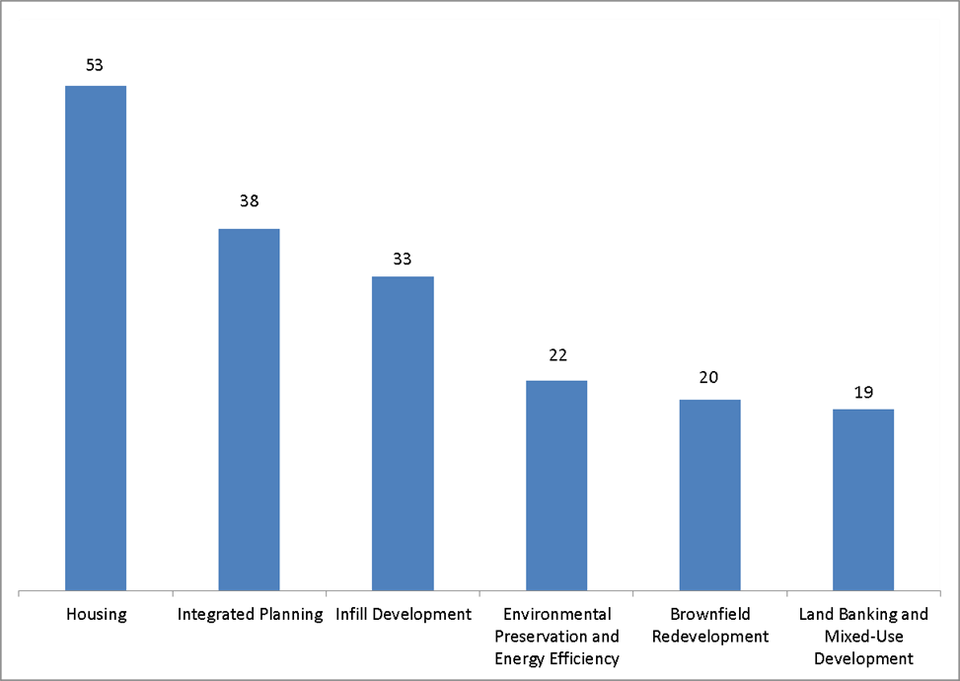
Source: eLogic models for 79 grantees for which data were available.

Livability Principle #5 - Coordinate Policies and Leverage Investment
Grantees have identified a range of Federal resources, in addition to HUD funding, to support planning efforts and development targets. Locally, grantees have sought support from businesses, nonprofits, and community-based organizations, among other sources. Altogether, 90% of grantees plan to utilize strategies to coordinate policies and leverage investment.
Though all grantees were required to outline sources of leveraged funding in their grant applications, some grantees elected to report increases in leveraged investment to support planning efforts over the grant period. For example, 17 grantees have monitored the projected Federal investment (non-HUD) aligned with their plan. Similarly, 12 grantees have identified private and non-Federal leveraged funding secured as a key outcome during the grant period.
To promote alignment of policies between local governing policies, 11 grantees have established goals related to the number of jurisdictions adopting the corridor plan. One grantee also has a planning outcome that identifies the number of jurisdictions adopting greenhouse gas reduction targets that are consistent with statewide goals. Other innovative planning goals developed by grantees in support of policy alignment are as follows:
- Jurisdictions involved in regional governance structure
- Planning consortia established to support ongoing inter-agency planning in the project area
- “Green building” policies adopted

Livability Principle #6 - Invest in Healthy, Safe and Walkable Neighborhoods
Overall, nearly three-quarters of all grantees (73%) utilized performance measures or incorporated elements in final plans related to valuing communities through investment in healthy, safe, and walkable neighborhoods. In addressing this Livability Principle, grantees can develop strategies to encourage healthy lifestyles among their residents, including establishing a safe environment where healthy behavior can prosper.
Grantees chose to measure their progress in establishing or maintaining healthy, safe, and walkable neighborhoods in a variety of ways. The unique focus areas that grantees selected in addressing this Livability Principle are illustrated below in Figure 10.

Figure 10: Number of Grantees Pursuing Outcomes in “Healthy, Safe, and Walkable Neighborhoods” Categories
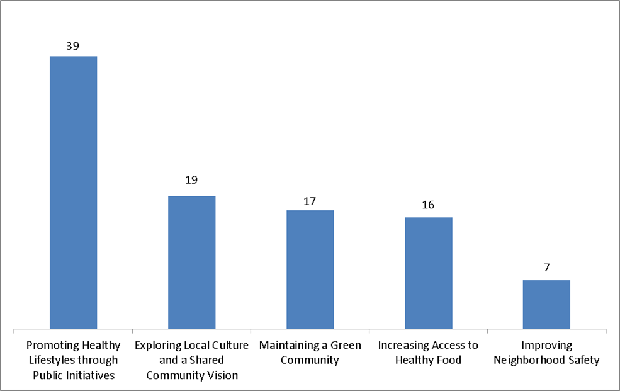
Source: eLogic models for 79 grantees for which data were available.
Planning officials can promote healthy lifestyles in communities through coordination with public health officials and targeted outreach efforts, along with increasing opportunities for outdoor recreation and improving the availability of fresh food. Efforts to increase neighborhood safety can decrease the incidence of crime while providing residents with the option to travel by foot to nearby destinations.

Public Health Initiatives
Inviting public health officials to participate in the planning process can promote information sharing between local leaders where significant community health concerns may be of concern. For example, neighborhoods with high obesity rates would benefit from both access to parks or open space for recreational activity, as well as targeted outreach from public health workers to provide guidance to residents on incorporating outdoor exercise in a healthy lifestyle and the importance of making healthy food choices. To date, 11 grantees have included 58 public health workers in their working groups associated with planning processes.

Prioritizing Local Culture
Incorporating cultural norms in the planning process can improve the likelihood of plan success by demonstrating the ways through which local traditions will be preserved with the establishment of new planning initiatives. Engaging the community in this way can secure public buy-in and facilitate public involvement in the planning process. Furthermore, building and publicizing cultural facilities locally can support economic development through tourism and jobs. The City of Glens Falls, New York, for example, has produced a Downtown Vision and Development Strategy entitled, “The Art and Culture Gateway to the Adirondacks,” which identifies ways to connect the community’s blue-collar traditional and high-tech workforces with the recreational opportunities and tourism dollars that the nearby Adirondacks Mountains provide. With a historical cultural presence around the arts, the plan seeks to transform “arts and culture excitement into economic revitalization.” By improving regional transportation linkages and renovating former factory buildings, Glens Falls aims to strategically connect the city’s arts and culture destination in a meaningful way for both residents and visitors alike.
To gain a more comprehensive understanding of how grantees incorporated Livability Principle 6 in their communities, please see Appendix D for a profile on the Northeast Los Angeles River Collaborative.

Question 2: Did grantees meet the performance objectives they self-identified through the planning process in the first 2.5 years of the planning process?
At the beginning of the planning process, grantees were required to develop a set of services and activities that they planned to undertake in order to meet their goals. Grantees are then required to create a set of performance measures for the services and activities to be undertaken in each of the three years of the grant period of performance. These services and activities are up to the discretion of the grantee, but usually include studies and baseline analyses completed, meetings held, number of attendees at public meetings, steering committees formed, and other interim actions and goals that are part of the planning process.
Shown below in Figure 11, through year two of the planning process, 93% of grantees have met at least half of performance measures that they self-identified as interim goals to have reached by year two. Approximately 28% of grantees achieved all of their performance measures related to services and activities.
Figure 11: Percentages of Grantees who met their Services & Activities Performance Measures
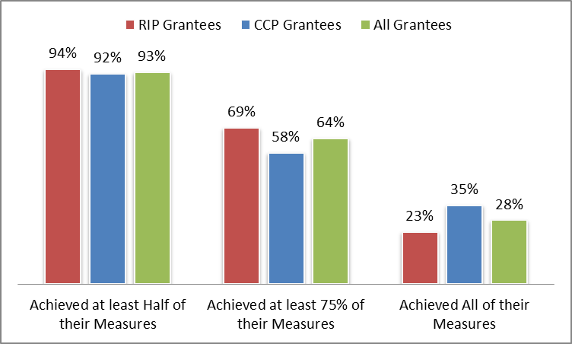
Source: eLogic models for 79 grantees for which data were available.
Grantees were also required to develop a set of outcome performance measures that reflected particular planning and/or sustainability outcomes. These performance measures represented a diverse group of outcomes of the planning process, including adoption of plans and zoning amendments, and other goals specific to the Livability Principles, for example “Number of brownfield sites identified for remediation” or “Number of measures amended or added to state and local statutes.” Through year two of the planning process, 84% of grantees have met at least half of performance measures that they self-identified as interim goals to have reached by year two as shown in Figure 12. Approximately 40% of grantees have achieved all of their outcome performance measures.
Figure 12: Percentages of Grantees who met their Outcomes Performance Measures
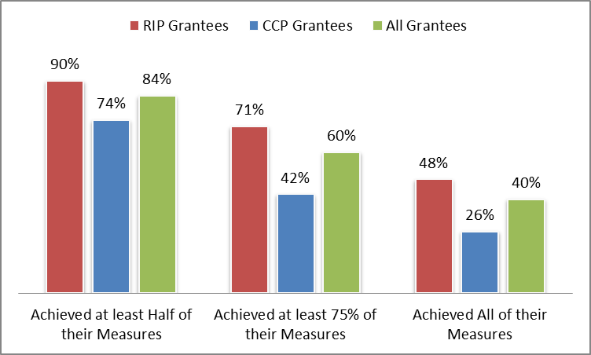
Source: eLogic models for 79 grantees for which data were available.

Question 3: How did the Sustainable Communities Initiative influence performance measurement for sustainable development?
Performance measurement refers to the ongoing monitoring and reporting of accomplishments toward meeting a set of goals. One of the most unique aspects of the Sustainable Communities Initiative in comparison with other sustainability initiatives is that it encourages community-driven, data-supported approaches to sustainable development; communities are encouraged to develop goals and metrics that are rigorous and data-driven while remaining appropriate to their local context.
According to the NOFA (the original funding guidance), grantees were required to:
- Establish performance goals and measures that are, at a minimum, consistent with the PSC Livability Principles, and
- Utilize geo-coded data sets and other metrics in developing, implementing, monitoring, and assessing the performance goals of various reinvestment scenarios.
The figure below illustrates the framework under which grantees addressed the performance measurement requirements of the HUD NOFA, and how these requirements interacted with the grantee’s community-driven planning processes.

As a result of this framework, each grantee developed a customized set of performance measures and published them in their planning documents. In the following section, we walk through this five-step process and how grantees utilized the Sustainable Communities Initiative framework to inform and add rigor to the performance measurement process.

Step 1. Identify Needs
The Livability Principles were designed to respond to a diverse set of community needs. Grantees in both programs were required to identify a set of needs related to the Livability Principles in their initial grant application that were to be addressed during the planning process. Grantees could specify as many needs as were relevant to their communities. Table 4 below shows the set of community needs from which grantees could select a set of needs that described the baseline situation of their communities that they wished to address over the following three years.
Table 4: Grantee Needs to be Addressed in the Sustainable Communities Initiative
Name | Description of Need in eLogic Model | Grant Program
Affirmative Housing Opportunities | There is a need to affirmatively create housing opportunities throughout the area without discrimination due to race, color, national origin, sex, religion, disability, or familial status, while eliminating the effects of discriminatory housing patterns. | CCP, RIP
Affordable Housing | There is a need to create a full range of housing that is affordable to all income ranges throughout the region, which is connected to high-functioning transportation networks and accessible to persons with disabilities. | CCP, RIP
Environmental Justice | There is a need for comprehensive planning to avoid adverse environmental impacts on neighborhoods and redress persistent environmental justice concerns in communities. | CCP, RIP
Proactive Urban Design | There is a need for pro-active short- and long-term urban design strategies that consider risks from disasters and climate change while harmonizing land use for sustainable development/conservation/transportation and water infrastructure. | CCP, RIP
Economic Development | There is a need for economic development activities focusing on reuse/expansion/creation of commercial/industrial centers that create jobs for residents of all income levels and create a strong regional economy. | CCP, RIP
Education and Job Training | There is a need for improved educational and job training opportunities to prepare the workforce of the future and attract industry looking for a qualified workforce. | CCP, RIP
Healthy Living | There is a need to improve public safety, cultural opportunities, and access to health care and living environments that provide opportunities for healthy living and support healthy lifestyles by meeting the needs of existing residents and attracting multicultural, economically diverse, and multi-ethnic populations for a diverse living environment. | CCP, RIP
Integrated Environmental Planning | There is a need for integrated environmental planning for air, water, and land use to ensure healthy environments and to avoid environmental impacts. | CCP, RIP
Public Engagement | There is a need for public engagement which includes populations typically marginalized from the public planning processes and creates opportunities for meaningful decision-making leading to adoption of a shared community vision/shared regional vision. | CCP, RIP
Equitable Development | There is a need to transform isolated, racially, and economically segregated areas into communities of opportunity that reduce social disparities so all have access to quality jobs, schools, affordable housing, transportation, and cultural and physical amenities. | CCP, RIP
Transportation Networks | There is a need for transportation networks that expand mode choices, address infrastructure investments, reduce particulate emissions, improve service for historically marginalized populations, and minimize residential and small business displacement | CCP, RIP
Transportation Planning | There is a need for transportation planning that provides for coordination of transportation planning with economic development and housing plans | RIP
Source: Analysis and review of eLogic models.

Through this process, key findings were made about overall community self-identified needs. The needs selected by CCP grantees were often specific to their particular projects, whereas the needs selected by RIP grantees were designed to be reflective of the overall priorities of those communities and regions. Figure 13 shows the most commonly selected needs, as a percentage of grantees selecting that need for all RIP Grantees. Economic Development was the most commonly cited need by RIP grantees, followed by affordable housing and transportation networks.
Figure 13: Percentage of FY2010 RIP SC Grantees Selecting Each Need

Source: eLogic models for 40 of 45 RIP grantees for which data were available.

Not surprisingly, self-reported grantee needs varied for different types of communities. For example, urban and suburban grantees identified housing-related needs much more frequently than rural grantees. Rural grantees, on the other hand, most often reported having needs related to economic development, job training, and transportation planning.
Figure 14: Difference in Self-Reported Needs by Community Type (Urban, Suburban, Rural)
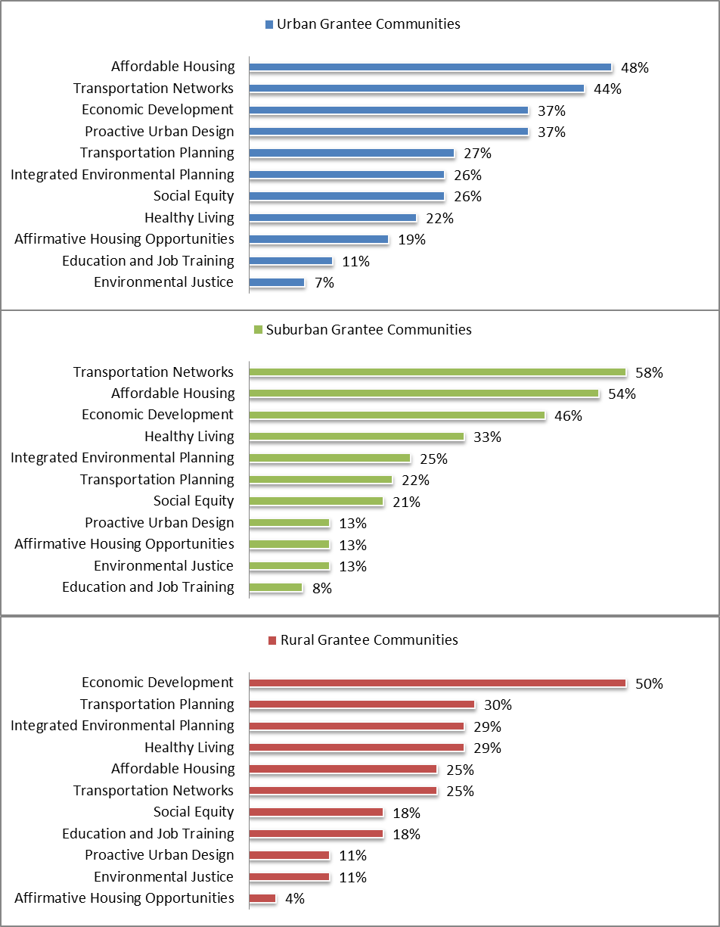 Source: eLogic models for 79 of 87 grantees for which data were available (“Transportation Planning” need percentage based on 40 RIP Logic Models, due to only being available in RIP logic models).
Grantee needs also varied based on their baseline economic condition. As part of the application process, some communities were classified as economically distressed based on HUD’s definition of distressed communities.
Figure 15, below, illustrates the differences in community self-identified needs in the 17 distressed communities as compared to the non-distressed communities. Distressed communities place a nearly equal priority on transportation planning and healthy living as those which are not distressed. However, distressed communities identify a much greater need to address social equity, as well as economic development, whereas other communities are able to focus on concerns such as affordable housing, transportation networks, and proactive urban design. Distressed communities were much less likely to see affordable housing as a need, and no distressed grantee cited “affirmative housing opportunities” as a need.

Figure 15: Grantee Self-Reported Needs Differed for Distressed Vs. Non-Distressed Communities
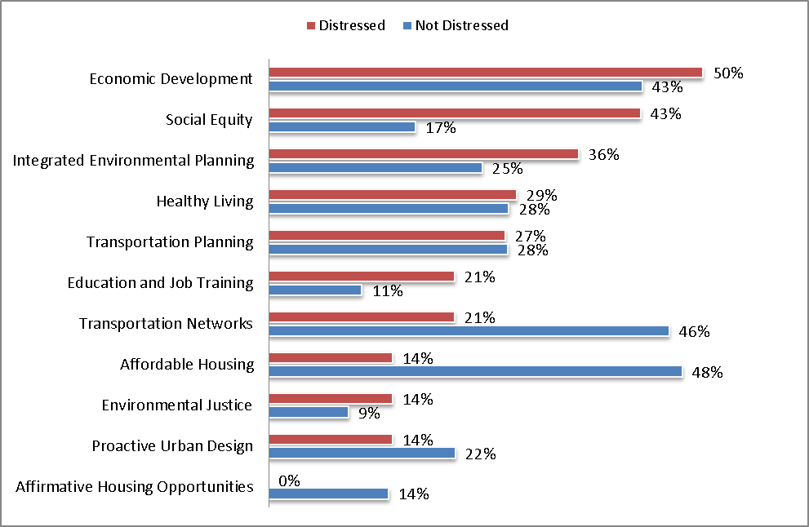
Source: eLogic models for 79 of 87 grantees for which data were available (“Transportation Planning” need percentage based on 40 RIP Logic Models, due to only being available in RIP logic models).

Step 2. Engage the Public and Set Goals
Although grantee projects reflect a diverse set of goals and implementation strategies, they all have similarly well-developed public engagement process. As part of the NOFA, grantees were required to “engage residents and other stakeholders substantively and meaningfully in the development of the shared vision and its implementation early and throughout the process, including communities traditionally marginalized from such processes, while accommodating limited English speakers, persons with disabilities, and the elderly.”
Public meetings, not surprisingly, were the cornerstone of many grantee public engagement processes. Throughout the first 2.5 years of the grant cycle, grantees held nearly 2,000 public meetings attended by approximately 50,000 community residents in total.
In addition, many grantees also used varied engagement strategies such as posting materials, meeting minutes, and presentations on websites, as well as utilization of social media. Many grantees also made sure their materials were available in Spanish or tribal languages. For example, RIP grantee Thunder Valley Development Corporation’s plan, Oglala Omniciyé, which includes preservation of culture as one of its main tenets, was published in the Lakota language as well as English to fully engage their Oglala Lakota Native American constituency.
Another common method to gain perspective on local conditions at the start of plan development is through community outreach, including conducting surveys or visioning workshops through which local residents can communicate their perspective of the most prevalent community issues to planning committees and express their vision for the future of the neighborhood or the region. Such pre-planning strategies can ensure that planning priorities between local leaders and residents are compatible, encourage cooperation between the two entities, and promote citizen buy-in to the planning process.
The City of Dallas, a 2010 CCP grantee, was awarded $2.5 million to create five station area plans for the Dallas Area Rapid Transit (DART) light rail system. To determine the community issues most important to local residents, planning teams recruited 159 residents of diverse backgrounds to be interviewed in focus groups or in supplemental research. As part of the focus groups, visualizations of potential “catalyst projects” were presented to the participants and their responses were recorded by observers to establish common themes according to neighborhood or demographic characteristics. In response to this initial visioning exercise, the grantee established a unique performance metric, measuring the increase in residents that provided feedback throughout each year of the planning process.

Grantees Pursue Scenario Planning as a Public Outreach Strategy
In preparation for plan development, several grantees conducted “scenario planning” research or workshop sessions to envision the potential effects of unique development projects under consideration. Scenario planning provides a framework for developing a shared vision for the future by analyzing various forces (e.g., health, transportation, economic, environmental, land use, etc.) that affect growth. Scenario planning—which can be done at the statewide- or metropolitan-level—tests various future alternatives that meet state and community needs. Table 5 lists several types of scenario planning, and the number of grantees that sought to utilize scenario planning under each development category.

Table 5: Grantees Pursuing Scenario Planning
Scenario Planning Category | Number of Grantees Conducting Scenario Planning
Transportation | 42
Affordable Housing | 37
Economic Development | 29
Water Infrastructure | 20
Land Acquisition and Assembly for Site Specific Projects | 11
Source: eLogic models for 79 grantees for which data were available.

In conjunction with formal scenario planning exercises, 54 grantees planned to perform technical planning studies that would examine the feasibility of new projects.
In addition to general public engagement, several grantees focused on building more inclusive community leadership within the planning process. Specifically:
- 32 grantees have reported engaging a total of 5,458 residents participating on dedicated planning committees targeted to fulfill the objectives of grantee projects;
- 3,219 people representing grant partner organizations attended training to strengthen management and decision-making capacities; and
- 7,136 residents attended education and training sessions on community planning and development issues, which were reported to total.

Community Goals Were Developed as an Output of the Public Engagement Process
The final input of the community planning process is a set of community goals that will be addressed in either the RPSD, or, for CCP grantees, another planning document. Tables 6 and 7 provide the most common goals pursued by each type of grantee.

Table 6: Sustainability Goals Chosen by at least 10 CCP Grantees
CCP Grantee Target Outcomes | Number of Grantees
Change in transit mode share | 19
Adoption of a Corridor Plan | 16
Increased number of affordable housing units close to high-quality transit service in urban areas | 13
Construction of housing units on underutilized infill sites | 10
Decrease in VMT & transportation-related emissions | 10
New housing units built along the corridor | 10
Source: eLogic models for 39 of 42 CCP grantees for which data were available.

Table 7: Sustainability Goals Chosen by at least 10 RIP Grantees
RIP Grantee Target Outcomes | Number of Grantees
Increased participation in the governance structure as a result of the education and outreach sessions | 28
Increase in participation by traditionally underrepresented persons in planning process & civic activities | 27
Measures amended or added to state and local statutes to support the Regional Plan for Sustainable Development | 19
Increase the number of low and very low-income households within a 30-minute transit commute of employment centers | 17
Incorporation of nontraditional representatives incorporated into the Governance Board | 16
Adoption of comprehensive integrated water, air and land use plans in participating jurisdictions | 14
Increased bike/pedestrian infrastructure | 14
Redevelopment of brownfield sites | 11
Secure private and non-Federal funding to support local planning efforts | 11
Development of affordable housing units close to high-quality transit service in urban areas | 11
Change in transit mode share | 11
Decrease in combined housing and transportation costs for low-income and minority populations in the planning area | 10
Creation of job opportunities as a result of reuse of existing commercial and industrial centers | 10
Source: eLogic models for 40 of 45 RIP grantees for which data were available.

To gain a more comprehensive understanding of how grantees incorporated public engagement strategies in their communities, please see Appendix F and Appendix G for a profile on East Alabama Regional Planning and Development Commission and the Northern Maine Development Commission, respectively.

Step 3. Establish Performance Measures
Once goals have been set, grantees were required to convert those goals into a set of performance measures that can help track and monitor performance toward the community’s sustainability goals. Grantees were required to report on these performance measures through their semi-annual reporting process to HUD.

Grantee Goals and Technical Assistance Needs Led to the Creation of the Flagship Sustainability Indicators
Developing performance measures proved challenging to many grantees. In the first two years of the Sustainable Communities Initiative, performance measurement became a major focus of grantee requests for technical assistance. In particular, grantees were often at a loss as to how to collect data on performance measures in a way that could track an outcome 10, 20, or 50 years into the future. In response to this grantee need, HUD, in interagency collaboration with DOT and EPA, developed a uniform system of housing, transportation, and environmental metrics. Formally released in 2012, these Flagship Sustainability Indicators (FSIs) became a key component of the program for future cohorts of grantees. The goal of the FSIs is to meet grantee needs for a common performances measurement framework to establish performance measures that addressed sustainability goals common to a large set of grantees.
The FSIs are designed to demonstrate the impact of the Sustainable Communities Initiative over time, while also allowing communities to track progress toward their individual sustainability goals. The FSIs were designed to use mainly easy-to-collect community data or public data, providing a common baseline for comparison amongst grantees. Table 8 provides an overview of the FSIs.

Table 8: Summary of the Flagship Sustainability Indicators
Sustainability Outcome | Flagship Sustainability Indicators
1. Transportation Choice | 1.1 Total percentage of workers commuting via walking, biking, transit, or rideshare
2. Housing Affordability | 2.1 Percentage of renter units and owner units affordable to population earning 80% of area median income renter
3. Equitable Development  Note: All indicators calculated separately for:  - The entire planning area  - Census tracts in which at least 50% of households are low-to-moderate income (earning 80 percent or less of HUD area median family income) | 3.1. H+T Affordability: Proportion of household income spent on housing and transportation costs
 | 3.2 Access to healthy food choices: Percent of total population that reside in a low income census tract AND reside more than one mile from a supermarket/large grocery store (for rural census tracts, the distance is more than 10 miles)
 | 3.3 Access to open space: Percent of population that reside within one mile of a park or open space for rural or ½ mile for urban
4. Economic Resilience | 4.1 Economic Diversification Index
4. Economic Resilience | 4.2 General local government debt to revenue ratio
5. Growth through Reinvestment | 5.1 Net acres of agricultural and natural resource land lost annually to development per new resident

Although FSIs were not required of all grantees until the FY 2011 program cohort, OER provided written, email, and on-site technical assistance for using these measures to track grantee performance for all grantees, including those in the FY 2010 cohort.

Grantees Also Developed a Customized Set of Performance Measures to Reflect Individual Performance Measurement Needs
No set of overall FSIs can meet every grantee need or address every grantee concern. Many grantees developed their own customized performance measures, which responded to local community or regional conditions. Such innovative measures included the following:
- Number of car-share memberships
- Hours of vehicle delay during rush hour
- Number of residential/commercial units that incorporate green building and/or energy efficient materials
- Percent of storm water run-off that is infiltrated through development practices
- Number of jobs well served by transit
- Gini coefficient on income (measuring inequality)

Step 4. Start Measuring Progress
Once performance measures were developed, grantees started the difficult processes of collecting data and measuring progress. The first step in this process was for grantees to develop a baseline value for each performance measure. To accomplish this task, grantees first conducted a number of interim analyses.

Health Analyses
Eight grantees planned to conduct a baseline spatial analysis of health status indicators for their individual areas, and two grantees reported pursuing an ongoing spatial assessment of health status indicators, examining such factors as cardiovascular disease mortality, obesity, violent crime rates, life expectancy, infant mortality, respiratory disease, and pedestrian injury. As a result of these baseline spatial assessments of health indicators, grantees reported adding 20 new plan elements into the planning process.

Transportation Analyses
Some grantees focusing on improving local transportation options carried out a Transportation Assessment to collect data in preparation for more formal planning activities, allowing them to measure their plan efficacy over time. Bernalillo County, a CCP grantee, conducted its own Transportation Assessment to provide an inventory of the existing transportation system within the Bridge Boulevard Corridor, along with potential tools and strategies for improvements. Through this process, planners confirmed that the road network immediately surrounding Bridge Boulevard had limited connectivity, and data collected indicated that a majority of the east-west traffic traveled through the Corridor without stopping at local destinations. The assessment further estimated that by 2035, traffic on Bridge Boulevard would exceed motor vehicle capacity and would cause serious congestion.
Based on the results of Bernalillo’s Transportation Assessment, the project team proposed, studied, and tested several Corridor design options at a May 2012 design workshop. A series of roadway concepts were presented to stakeholders at public meetings, steering committee meetings, and team meetings. Steering committee members offered qualitative input on each concept and the project team screened roadway concepts against livability criteria through an innovative screening matrix.
To gain a more comprehensive understanding of how grantees incorporated performance measurement in their own communities, please see Appendix E for a profile on the Evansville Metropolitan Planning Organization.

Step 5: Implement Performance Measures in Planning Documents
The fifth step of HUD’s performance measure framework called for the incorporation of performance measures into the project plan and into local government codes and statutes. Twenty-seven grantees prioritized the establishment of intergovernmental planning and cooperation mechanisms, with 636 agreements secured. In addition, 48 measures were amended or added to state or local statutes to date to support planning across 13 grantees.
Additionally, grantees prioritized amending zoning laws to promote fair housing opportunities, as well as adjusting land use regulations that enable access and efficiency in pursuing sustainable development projects. Through the first 2.5 years of the planning process, grantees have made significant progress in these areas, as shown Table 9, below. In the remaining months of grant funding, it is expected that additional grantees will meet their targets and record progress that meets or exceeds the initial projected values shown below.
Table 9: Grantee Progress in Incorporating Planning Efforts in Local Regulations
Performance Measure | Projected Value
Measures were amended or added to state or local statutes | 48 Measures
Change in the number of Census tracts covered by inclusionary zoning to affirmatively further fair housing | 20 Census tracts
Develop or amend land use regulations to streamline regulations (number of regulations added/amended) | 747 regulations
Develop or amend land use regulations to streamline regulations (number of jurisdictions involved) | 25 jurisdictions
Source: eLogic models for 79 grantees for which data were available.

Some grantees may also use grant funding to develop extensions of their existing local plans, which may include proposed changes to zoning codes, efforts to consolidate plans from local jurisdictions, or official documentation gathered to reform building codes.
Three CCP grantees, for example, used grant funding to produce final deliverables that did not resemble traditional “plans,” but rather aligned with community needs to develop other tools essential for local sustainable development priorities. The cities of Covington, KY and Claremont, NH, along with the Salt Lake City Corporation, all produced alternative planning documents consisting of an annual action plan, zoning ordinance documents, and proposed zoning map amendments, respectively.
The Salt Lake City Corporation plan, for example, is a legal document from the city’s mayor to request to amend the Central Community Master Plan, Salt Lake City Zoning Ordinance, and Zoning Map to accommodate new transit station areas. The proposal outlines new zoning regulations that would enable the city to implement the Livability Principles within the corridor, including land use policies and zoning that support mixed-use development and transportation choices for current and future residents and workers. The proposed station area plans that would be supported by the new regulations are also included in the planning document.

Question 4: What quantifiable sustainability impacts of the Sustainable Communities Initiative have occurred in the first 2.5 years of the planning process?
The final plans developed by grantees are generally designed to be implemented and to realize sustainability goals over a 10- to 50-year timeframe. However, over the first 30 months of the grant period, some grantees have already recorded several significant outcomes that have already occurred due to the planning process put in place. The following sections provide a summary of grantee-reported achievements to date, organized by their corresponding Livability Principles:

Livability Principle #1 - Transportation Choice
Grantees have reported the following progress toward increasing transportation choice:
- Five grantees have reported a 2.4% average change in non-automobile mode share.
- Grantees have added a reported 1,600 miles of pedestrian/bike infrastructure in their communities. By the completion of the RIP and CCP grant programs, grantees project they will have added a total of 2,650 new miles of pedestrian/bike infrastructure.
- The City of Seattle has reported a 3% reduction in VMT since the beginning of the grant program.

Livability Principle #2 - Promote Equitable, Affordable Housing
As of September, 2013, 19 grantees had conducted a Fair Housing and Equity Analysis (FHEA) to promote equitable, affordable housing. All 45 Regional Planning Grantees are required to complete a FHEA by the end of the performance period in 2014. 72.3 Million Americans live within these 45 grantee regions that will benefit from a new equity strategy.

Livability Principle #3 - Enhance Economic Competitiveness to Create Jobs
Grantees have documented the following progress in implementing strategies that lead to enhanced economic competitiveness:
- 1,197 low- and moderate-income persons have completed workforce development training.
- Grantees have targeted 261 sites in existing commercial and industrial centers for revitalization.

Livability Principle #4 - Support Existing Communities through Transit-Oriented, Mixed-Use Development
Efforts dedicated to advancing this sustainability area are often captured through measuring redevelopment efforts, including areas identified for infill development and the number of brownfield sites targeted for remediation. Grantees have reported the following progress toward supporting existing communities through transit-oriented, mixed-use development:
- Communities have identified 316 brownfield sites for remediation, of which 137 are in predominately low-income areas.

Livability Principle #5 - Coordinate Policies and Leverage Investment
Grantees have identified several Federal resources which they could use to help achieve the goals of their Sustainable Communities Initiatives grants, including diverse agencies such as the Federal Emergency Management Agency (FEMA), EPA, the U.S. Department of Agriculture (USDA), U.S. Department of Health and Human Services (HHS), U.S. Department of Education, U.S. Department of Energy (DOE), and other HUD programs.
- Six grantees project $45.2 million in Federal investment aligned with their plan. Another seven grantees have secured approximately $29.7 million in private and non-Federal funding as leverage to Federal funds to support local planning efforts.

Livability Principle #6 - Invest in Healthy, Safe, and Walkable Neighborhoods
Grantees reported adding 20 different health-focused strategies into final planning documents in response to baseline assessments of critical health indicators. Additionally, four grantees adopted strategic plans to implement activities that support local cultural assets.

Comprehensive Case Studies
This section offers comprehensive case studies that illustrate the grantee experience from application to implementation. These case studies focus on two grantees: the Thunder Valley Community Development Corporation in South Dakota and the City of Pittsburgh in Pennsylvania. Thunder Valley represents a rural RIP grantee seeking to implement their Oglala Lakota Regional Plan for Sustainable Development in southwestern South Dakota while preserving their rich Native American culture. Pittsburgh, on the other hand, is an urban CCP grantee working to implement sustainable development practices alongside renewed economic growth in their transition from rustbelt town to a booming center of technology and innovation. Both studies provide the full perspective of grantees’ planning experience, from their initial grant application and public engagement strategies, to plan development and adoption. Finally, the studies preview both grantees’ efforts toward plan implementation.

Comprehensive Case Study: Thunder Valley Community Development Corporation (Porcupine, SD)
The Thunder Valley CDC in Porcupine, South Dakota received a $996,100 RIP Category 1 grant through the Sustainable Communities Initiative in 2010. This funding enabled Thunder Valley to pursue efforts to build sustainable infrastructure that supports improvements to housing, transportation, and economic opportunity for the Lakota people, while preserving and strengthening the cultural identity of this largely Native American population. Over the grant period, Thunder Valley developed the Pine Ridge Indian Reservation RPSD, which was adopted by the Oglala Lakota tribal council on October 30, 2012.

Community Profile
Thunder Valley represents an expansive rural area; less than 19,000 residents live within the planning area of Shannon, Jackson, and Bennett Counties in southwestern South Dakota. Consistently ranked among the ten poorest census metropolitan statistical areas, the region’s high incidence of poverty and low economic performance contributed to the grantee’s categorization as a ‘distressed’ community.
Poor housing conditions contribute to the cycle of poverty in the region, with a median home value of $27,379 in the village of Pine Ridge, compared to $118,700 for a similar size home in other parts of South Dakota. There is also a critical need for increased transportation connectivity, with automobile transportation necessary to travel the 2.8 million rural acres that comprise the Pine Ridge Indian Reservation (PRIR).² Although a recently created Oglala Sioux Tribe (OST) Bus Transit service on the PRIR includes six routes inside the Reservation, there are no major highways, railroads, or regular commercial air services connecting to PRIR from the outside.² Furthermore, since residents still rely primarily on personal vehicles to access basic services and commute to employment, planning efforts have targeted affordable transit and improved accessibility as a key tenet of the RPSD. Establishing model communities that incorporate housing, retail, and even employment opportunities will continue to support reduced transportation costs, improve resident access to basic services (including child care), and improve overall affordability and convenience in the region.
To improve integration of services and resources across this diverse landscape, Thunder Valley CDC sought to lead a two-year regional sustainability planning process and create an RPSD that would identify strategies to achieve the following:
- Continue the healing and strengthening of the Oglala Lakota people by bolstering identity and opportunity through the unique and beautiful perspective of Lakota knowledge, culture, and language;
- Recreate a thriving, dynamic, and robust society where all share in the benefits;
- Protect the environment while honoring Oglala Lakota connections with the Earth;
- Create meaningful economic and job opportunities that highlight cultural identity;
- Enhance public health and awareness of healthy alternatives; and
- Implement integrated infrastructure, housing, and social services.

Grantee Consortium Characteristics
A multi-faceted consortium of community leaders supports advancement of the Oglala Lakota plan. The consortium’s efforts are guided under the direction of the Thunder Valley CDC, which is a 501(c)(3) nonprofit led by an all-Lakota board and staff. Thunder Valley CDC was incorporated in 2006 and operates out of the Porcupine District of the PRIR. Its mission is to “empower Lakota youth and families to improve the health, culture, and environment of our communities; and heal and strengthen Lakota cultural identity.”
Other consortium members represent a range of diverse organizations and include the following: Oglala Sioux Tribe (OST) Office of the President; Oglala Sioux (Lakota) Housing Authority; OST Environmental Protection Program; OST Rural Water Authority; OST Health Administration; OST Office of Economic Development; Pine Ridge Bureau of Indian Affairs; Pine Ridge Area Chamber of Commerce; and Lakota Funds, a business development organization.
Together, the consortium and other supporters leveraged over $250,000 in matching funds to support the planning process and creation of the RPSD. This represents nearly 25% of their total grant award.

Oglala Lakota Planning Process
In preparation for development of the RPSD, Thunder Valley CDC led a steering committee that guided a nine-phase planning process, which included:
- Mobilizing the planning team.
- Discovering an “identity” for the plan with community input and feedback from local elders and Federal agency members.
- Analyzing baseline community data to uncover trends, barriers, and opportunities in addressing the Livability Principles.
- Planning to gather stakeholders and develop scenarios.
- Aligning connections between tribal representatives, local businesses, and government to build capacity and ensure that planning goals meet with community needs.
- Adopting the plan via a Tribal Council vote following consensus reached by the consortium and Steering Committee, along with review of recommendations provided by the Tribal President.
- Implementing the final plan by identifying phasing, responsible parties, action steps, time frame, and costs to implement, along with refining performance measurement indicators related to plan goals.
- Training of consortium members through two workshops focused on planning skills, building capacity, and monitoring community progress, along with ongoing community engagement initiatives.
- Sustaining ongoing planning efforts through fundraising for leveraged resources and the establishment of a permanent structure for regional planning.

Prioritizing Public Engagement
To advance planning priorities, establish goals, and promote successful plan implementation, Thunder Valley CDC pursued extensive public engagement activities throughout the planning process. Thunder Valley CDC explains that “the RPSD for Pine Ridge Indian Reservation is a plan for The People.” In this spirit, the planning committee sought the advice of consortium members and community elders in plan development. Community commitment to the plan was also advanced through local radio and television outreach, a plan website, public meetings for visioning activities and scenario development, translation services, and a monthly newsletter, among other efforts. The results of public engagement strategies are evident through review of the final RPSD, which was also published in the Lakota language, to accommodate those whose primary language is not English and to support their continued involvement in implementing the Oglala Lakota Plan.

Alignment of the Planning Process with HUD Livability Principles
Thunder Valley’s RPSD is a comprehensive document that clearly links to each of the HUD Livability Principles. Early in the planning process, Thunder Valley CDC selected initial targets that exemplified the planning priorities of the Livability Principles. The table below demonstrates this cross-section between Livability Principles and RPSD goals originally presented in the grantee’s application for RIP funding, and how these strategies were later included in the final Oglala Lakota plan.
 | HUD Livability Principle | Inclusion of Principle in  Initial Planning Strategy | Inclusion of Principle in Adopted RPSD
1 | Provide more transportation choices | Decrease in per capita VMT and transportation-related emissions for the region.  Decrease in overall combined housing and transportation costs per household.  Increased proportion of low- and very low-income households within a 30- minute transit commute of major employment centers. | Expansion of the regional bus transit system, small-scale alternative fuels production, ride sharing, and better coordination of school bus routes to increase mode options and reduce detrimental environmental effects.
2 | Promote equitable, affordable housing | Decrease in overall combined housing and transportation costs per household. | Build model communities - a mix of housing styles and incomes to enable integrated support for ownership and advancement opportunities with affordable housing options to serve those in need. Different types of housing that are designed creatively with shared spaces and amenities to accommodate different family structures, support social interaction and relationship building, and reflect and reinforce cultural values and traditions.
3 | Enhance economic competitiveness to create jobs | Reduced social and economic disparities for the low-income, minority communities, and other disadvantaged populations within the target region. | Incorporating basic services such as grocery stores, pharmacies, clothing retail, and auto services in model communities to spur job creation and support a more self-sufficient region through investment in the local economy.  Expansion of economic opportunity by increasing knowledge, skills, and job opportunities through education and workforce development efforts related to various components of the construction, management, and maintenance of model communities.
4 | Support existing communities through transit-oriented, mixed-use development | Creation of regional transportation, housing, water, and air quality plans that are deeply aligned and tied to local comprehensive land use and capital investment plans.  Increase in the share of residential and commercial construction on underutilized infill development sites that encourage revitalization, while minimizing displacement in neighborhoods with significant disadvantaged populations. | Establishing zoning codes to enable the government to coordinate development with infrastructure investments, and ensure residential, commercial, and industrial uses are appropriately located to protect the environment, cultural sites, and human health.
5 | Coordinate policies and leverage investment | Aligned Federal planning and investment resources that mirror the local and regional strategies for achieving sustainable communities. | Create Regional Planning Office (RPO) to support a range of organizational missions in a coordinated way by working to leverage resources for greater impact.
6 | Invest in healthy, safe, and walkable neighborhoods | Increased participation and decision-making in developing and implementing a long range vision for the region by populations traditionally marginalized in public planning processes. | Bolster programs for physical health (including healthy food and active living), mental health (positive ways to deal with abuse, suicide, addiction, etc.), spiritual health, and ultimately overall societal wellness.
Source: Grantee work plan and final plan deliverable.

To further the concepts incorporated in Thunder Valley’s final plan, the following section describes the specific performance measures selected by Thunder Valley, and approved by HUD, to effectively execute planning strategies and track progress over time.

Performance Measures Established to Stay on Track
Working directly with HUD staff, Thunder Valley CDC selected performance measures to identify activities, outputs, and outcomes that strongly correlated with planning efforts and would allow various stakeholders to measure planning results, both during the planning process and throughout plan implementation. Notable measures and progress to date are detailed in the following table.
Measure Category | Performance Measure | Reported Progress to Date
Governance | Establish intergovernmental planning and cooperation mechanisms | 20 jurisdictions represented
Outreach | Resident participation in plan development and governance | 669 persons attending meetings
Outreach | Number of persons attending education or training sessions on sustainability | 57 persons
Regional Planning | Conduct scenario planning regarding economic development | 6 scenarios developed
Regional Planning | Conduct scenario planning regarding transportation | 7 scenarios developed
Transportation | Projected increased change in the number of low and very low-income households within a 30-minute transit commute of employment centers | 40% increase
Source: Grantee eLogic model.

Next Steps
Since plan adoption in October 2012, the Oglala Lakota community has worked to foster implementation of the RPSD. In December 2012, for example, the planning committee held a meeting to scope out the next steps to developing the Regional Planning Office (RPO), a key project initiative, which marked the beginning of post-adoption implementation work. To support this effort, the National Association of Development Organizations (NADO) and the Minnesota Housing Partnership facilitated a training session to members of the planning leadership team. As of September 2013, Thunder Valley CDC and Oglala Lakota residents continue to work to gather local support and engage stakeholders to further plan implementation.

Comprehensive Case Study: City of Pittsburgh (PA)
The City of Pittsburgh in southwestern Pennsylvania received combined funding totaling $1.5 million through the CCP and DOT TIGER II programs in 2010. Grant monies were intended to develop a detailed planning study for the Allegheny Valley Railroad (AVR) freight corridor, which parallels the southern bank of the Allegheny River and extends from downtown Pittsburgh to the eastern edge of the city. Under the leadership of the Urban Redevelopment Authority (URA) of Pittsburgh, planners addressing this six-mile stretch of corridor, to be named the Allegheny Riverfront Green Boulevard, will seek to transform an existing railroad right-of-way into a multimodal green boulevard, including a bicycle-pedestrian path, passenger and freight rail corridor, and storm water management technologies. The project also aims to develop sustainable housing and open space initiatives along the riverfront.
During the grant period of performance, URA developed the Allegheny Riverfront Green Boulevard Plan. Its final version was agreed upon by all partners and presented to the steering committee in early 2013. The final plan was also shared publicly online and through media outlets. Plan partners are currently working toward implementation with the support of various stakeholders.

Community Profile and Planning Impacts
Pittsburgh is well known as the “Steel City,” which characterizes its status as the national leader in the U.S. steel industry through the mid-twentieth century. With the decline of the steel industry in the 1970s and 1980s, it was largely believed that Pittsburgh would not overcome the collapse to reestablish its status as a prosperous American city. Nevertheless, Pittsburgh continues to transform itself into an academic and technology leader with a diverse economy, whose narrative reflects triumph over a wholly industrial past. As former Pittsburgh Mayor Luke Ravenstahl stated, “Pittsburgh is currently experiencing its Third Renaissance – a revitalization marked by job creation, neighborhood development, and population growth.”
Pittsburgh’s Allegheny Riverfront was a major center for the development of the steel industry throughout the twentieth century. Transforming this area into a source of mixed-use development can “provide unique business and development opportunities, riverfront living, recreation opportunities and connected trails, access to transportation choices, and a renewed riverfront environment and ecosystem.” The Allegheny Riverfront Green Boulevard Plan concentrates on four primary tasks to achieve development goals:
- Public outreach to engage the Pittsburgh community in the realization of the Green Boulevard;
- Transportation improvements, including a plan to transform an existing railroad right of way (ROW) into a multi-modal green boulevard including integration of a commuter rail into the Allegheny Valley Railroad freight corridor, station area planning around the proposed station areas, station design, and a shared multi-use path for pedestrians and cyclists;
- Creation of a new riverfront open space system with access points to the river, habitat and ecological enhancements, new community open space amenities, riverbank stabilization, and storm water technologies; and
- A housing plan for mixed-use and transit-oriented development opportunities that create a live/work riverfront neighborhood for Lawrenceville in the 43rd Street District.
The Allegheny Riverfront Green Boulevard Plan has the potential to impact over 36,000 residents who currently live along the Allegheny Riverfront corridor, along with another 87,200 people who work in this concentrated area of economic activity. Local planners believe that new transit options, including a road and trail connection to downtown, will alter commuting patterns, save time and money, and reduce environmental impacts currently caused by single-occupancy vehicle travel. The success of the Green Boulevard could also play a role in attracting new residents and employers to the city, spurring economic growth and expanding the tax base of the city.
Furthermore, the introduction of passenger rail services on the AVR line would provide expanded mobility choices for 36,531 residents in communities within one-quarter to one-half of a mile along this 19.5 mile corridor. For commuters who are currently limited to bus service or driving on a congested highway to access jobs downtown, a commuter train would offer efficient rail service, with studies suggesting that commute time could be cut in half for some downtown workers. Additionally, the proposed six miles of bike and pedestrian trail extension would be accessible to 246,277 residents within a three mile radius of this trail segment.⁵

Partners Involved in Planning Process
Performing a range of pre-planning activities (conducting community surveys and preparing cost estimates, for example) along with work on plan development and implementation, the City of Pittsburgh partnered with the Urban Redevelopment Authority of Pittsburgh (URA), the AVR, and Riverlife (a nonprofit focused on open space development along Pittsburgh’s rivers). Sasaki Associates, a consulting firm hired through a Request for Proposal (RFP) competition, was also closely involved throughout the planning process, especially through coordination of efforts between the partners and other stakeholders.
Besides formal partners, the City of Pittsburgh engaged a diverse group of stakeholders throughout the project, including: the City of Pittsburgh Planning Department, several local Community Based Organizations (CBOs) and Community Development Corporations (CDCs, including Lawrenceville Corporation, Lawrenceville United, Neighbors in the Strip, Highland Park CDC), the Buncher Company (owner/developer of significant properties within project area), Regional Industrial Development Corporation (nonprofit owner/developer of significant properties within project area), Bike Pittsburgh (bicycle advocacy organization), National Robotics Engineering Center (robotics research facility within project area), and many others, including the Mayor’s Office and State Senator Jim Ferlo.
Partners and stakeholders were further organized into a Steering Committee, Sub-Steering Committees (separate for rail and trail), and an Advisory Committee comprised of potential implementers.

Alignment of the Planning Process with HUD Livability Principles
The Allegheny Riverfront Green Boulevard Plan corresponds to each of the HUD Livability Principles in its planning process, though it focuses primarily on the following:
- Provide more transportation choices (Livability Principle #1)
- Enhance economic competitiveness to create jobs (Livability Principle #3)
- Support existing communities through transit-oriented, mixed-use development (Livability Principle #4)
- Invest in healthy, safe, and walkable neighborhoods (Livability Principle #6)
As a CCP grantee, the City of Pittsburgh chose to focus primarily on these Principles which best align with their planning process to develop the Allegheny Riverfront Green Boulevard. The table below demonstrates the cross-section between Livability Principles and plan goals originally presented in the grantee’s application for CCP funding, and how these strategies later evolved to be included in the final Allegheny Riverfront Green Boulevard Plan.
 | HUD Livability Principle | Inclusion of Principle in  Initial Planning Strategy | Inclusion of Principle in  Final Corridor Plan
1 | Provide more transportation choices | Planned to draft needs assessment and feasibility plan for introduction of a shared-use multimodal corridor within AVR right of way. | Explores the technical feasibility of integrating commuter rail into the existing freight rail line, with six commuter rail station areas considered for inclusion in the new system.  Concludes that reuse of the AVR corridor affords the opportunity to create a connected commuter bike path running the length of the corridor.
2 | Enhance economic competitiveness to create jobs | Planned to evaluate the economic impact of a multimodal corridor to relate projected ridership, mode capacity/connectivity, land use intensity, land use density, and value capture area.  Planned to estimate number of jobs created within walking/biking/transit distance of new development. | Commuter rail stations planned to improve access to jobs downtown.  Increased waterfront development identified (commercial and residential).  1,600 new jobs projected in new Lawrenceville mixed-use development (see below).
3 | Support existing communities through transit-oriented, mixed-use development | Planned to present land use impact scenarios in terms of density and intensity for a variety of land uses in response to the land use, open space, storm water, and riverfront planning components. | A new riverfront neighborhood with 1.4 million square feet of new and renovated space along the river in Lawrenceville, including nearly 0.5 million square feet of urban flex space with a technology focus, 84,000 square feet of light industrial growth, and 6,300 square feet of retail (planned).  600 new housing units are projected in neighborhood.
4 | Invest in healthy, safe, and walkable neighborhoods | Planned connectivity study of continuous pedestrian linkage and interconnected open spaces for entire length of study area. | Green Boulevard multi-use path will accommodate pedestrians, bicyclists, individuals operating wheelchairs, and other users.  Four at-grade crossings on path will be designed with public safety in mind, featuring consistent lighting, fencing, signage, and site furnishings including benches, trash cans, and bicycle racks.
Source: Grantee work plan and final plan deliverable.

To accomplish the pre-planning activities identified in Pittsburgh’s initial grant application and move planning strategies from concept to reality, the City established ongoing performance measures, described below.

Performance Measures Established to Stay on Track
With support from HUD staff, the City of Pittsburgh selected performance measures to identify activities, outputs, and outcomes that strongly correlated with planning efforts and could be tracked during the planning process and beyond the grant period. Notable measures and progress to date include the following:
- Four public meetings held
- 200 residents attended meetings⁶
- Two training sessions conducted to strengthen management and decision-making capacities of applicable partners⁶
- Open Space Plan and Riverfront Access Report created and utilized to support design work for riverfront sections
- Feasibility study of multimodal corridor completed by AVR⁷
- Scenario planning conducted for the following development topics: Economic Development, Transportation, and Water Infrastructure⁶
The nature of most major planning efforts is that the real “results” of the plan, such as positive environmental externalities, will not be realized until several years after plan implementation. In this vein, Pittsburgh has reported projected measures that the City expects to achieve over time and beyond the life of the grant. The most notable goals are summarized below in Table 10 with expected completion dates.

Table 10: Expected Completion Dates for Pittsburgh Initiatives
Measure | Expected Achievement Date
7.5% Reduction in Vehicle Miles Traveled (VMT) Per Capita | July 2015
Secured Railroad Easement (to enable construction of bike-pedestrian trail) | July 2016
Creation of Open Space along Riverfront | July 2017
Completed Construction of Bike/Pedestrian Trail | July 2020
Source: Grantee eLogic model.

The Future of the Allegheny Riverfront Green Boulevard Plan
Besides enabling the City of Pittsburgh to create a corridor plan along an underutilized portion of the Allegheny riverfront, the CCP grant program has provided the City with an opportunity to examine planning strategies on a wider scale. In turn, local planners expect to pursue more efficiently designed planning approaches going forward. For example, the grantee is currently reviewing the potential for utilizing an easement on the railroad for the planned bicycle/pedestrian trail, which would run throughout the six communities covered in the planning study, rather than just one or two neighborhoods. According to the grantee, conducting a planning study demonstrated that many of the issues facing these communities are interrelated and can be best managed by taking a coordinated approach.
Following plan approval by partners in early 2013, the City encountered unexpected obstacles to plan implementation. These included site control and land ownership of areas identified for modification or rebuild in the plan, a competing riverfront development initiative, and changing project leadership at key points during the planning process. Despite these challenges, the City continues efforts to implement the Allegheny Riverfront Green Boulevard Plan. Such strategies include working with the Public Works Department of the City on right-of-way improvements already scheduled for the area to incorporate more storm water management techniques; working with local CDCs to incorporate storm water retention tanks into parking improvement plans; coordinating with CBOs and CDCs to continue pushing for affordable housing in new development plans for the area; and pursuing grant funding and conducting scenario planning to facilitate the creation of green space near the Pittsburgh Zoo, beginning in 2014. In addition, the team is working with the new Mayor-elect on approaches to advance commuter rail transit in the Pittsburgh area.⁸

Conclusions and Recommendations

Conclusions
The Sustainable Communities Initiative supported a wide variety of innovative, locally-driven projects with the common goal of fostering sustainable development patterns. The CCP and RIP programs have led grantees to achieve notable successes so far, and have prepared grantees, partner organizations, and local residents alike to realize the positive impacts of sustainability initiatives far into the future. Based on the research questions defined above and corresponding analysis of grantee data, the Assessment Team provides the following conclusions:
- The Livability Principles provided a useful framework highly relevant to local sustainability needs.
The review of grantees’ initial application materials, reporting deliverables, and final planning documents demonstrate the high degree to which grantees found the Livability Principles relevant to the specific needs of their individual planning areas. Even CCP grantees, who were not required to use the Livability Principles as a framework, often used these principles to frame their work and projects.
- Integrated planning grant programs such as the CCP and RIP can be a useful framework for addressing economic development, including job creation.
Through the Sustainable Communities Initiative, grantees pursued economic development strategies that they estimate will create more than 3,000 new jobs as a direct result of sustainable planning frameworks. With a strong focus on investing commercial and industrial centers and increasing workforce capacity through education and training, grantees project additional future job creation equaling nearly three million new jobs for citizens across the United States. Livability Principle 3, which advocates fostering economic competitiveness through access to employment and educational opportunities for local residents, in addition to market access, fully supports grantees’ planning strategies in this area and promotes job growth.
- Many communities now consider affordable housing planning to be inextricably linked with transportation planning.
Needs for affordable housing and transportation networks were the most commonly cited community needs. Of the total affordable housing units projected to be developed through grantee plans, fully 80% are planned for areas accessible to high-quality transit. Through the technical assistance process and the development of the FSIs, one of the most exciting developments to grantees was the Housing + Transportation index, which includes transportation costs with Housing Costs. This is an area where future guidance, technical assistance, and support from HUD would be extremely valuable to communities.

Recommendations
To build on the momentum spurred by the CCP and RIP programs, the Assessment team that prepared this report offers the following recommendations, intended to be applicable to designing and implementing similar integrated regional and community planning grants focused on sustainability:
- Consider investing resources in developing innovative impact measures for public health and water quality outcomes.
One underemphasized area of grantee interest is the inclusion of public health within integrated planning. More than 20% of grantees included a stakeholder from the public health sector in their plans, and many other grantees sought technical assistance to measure food deserts, access to fresh and healthy food, and public health outcomes. Another underrated area of grantee interest was water quality. Although the technical assistance team was able to assist grantees with developing some useful performance measures in these areas with local data,far fewer data sources and performance measures exist for water quality than for transportation or economic development. This could be an area in which HUD or another agency could provide some focus and support.
- Consider framing public engagement in the planning process as one of the Liability Principles. Grantees’ prioritization of outreach initiatives was highly evident within their performance measures and final plans. Grantees used CCP and RIP grant funding to enhance the planning process, working alongside community members to conduct scenario planning, visioning workshops, resident surveys, and community forums, along with other engagement activities. Using this approach, planners were able to adjust planning priorities based on those issues described as most relevant to community members, and ensure that diverse community voices were integrated in each stage of the planning process. Framing public engagement as a Livability Principle would ensure that there is a way to prioritize and recognize grantee success in this particular area.
- In performance reporting for planning grants, a clear distinction should be made between program outputs and program outcomes. The HUD eLogic model is meant to mimic the logic model framework. Such a framework recognizes that outputs, or the measurable results of services and activities, are inherently different from outcomes, which can be defined as changes in behavior, practices, policies, or economic and environmental conditions. Examples of outputs include meetings held, steering committees formed, scenario plans developed, baseline studies conducted, and zoning changes introduced. Alternatively, outcomes may consist of changes in transit mode share, the number of jobs created, or the number of new affordable housing units established.
Output and outcome categories were conflated in the eLogic model that framed the grantee performance measurement process, weakening the theory of change underlying the grant programs. Future performance tracking mechanisms could be improved through better distinction of output and outcome categories for performance measurement.
- Consider allowing grantees to set goals related to specific sustainability outcomes at the close of the public engagement process, rather than at the beginning.
Measuring performance in the context of a planning process is complex. Setting goals in advance of the planning process itself may be inappropriate, as goals may be developed and evolve as stakeholders grow to be more engaged and as baseline data are collected. However, as part of the Sustainable Communities Initiative, grantees were required to submit a logic model that identified specific program goals before beginning the public engagement process. These goals included outcomes such as specific percentage changes in mode share, number of census tracts covered by inclusionary zoning, and other quantitative goals that are more appropriately determined as a result of the planning process, not beforehand. Setting such specific goals before the public engagement process begins also exposed many grantees to charges of “imposing Federal will” on the planning process, which exacerbated political opposition to many grantees’ planning processes.
- Allow grantees to maintain a smaller, more focused group of grant performance outputs they can measure over time.
A smaller group of outputs could include the following:
- Development of a performance measure for each projected sustainability outcome
- Calculation of a baseline value for each sustainability performance measure
- Percent increase in the number of persons attending scenario and public meetings on regional planning as a result of attending education and training sessions
- Inclusion of representative(s) from public health sector (e.g., state, county, or local health commissioner(s), environmental health specialist(s), or other designee(s)) in consortium and work group(s), and steering committees
- Private and non-Federal funding secured and used as leverage to Federal funds to support local planning efforts
- Projected Federal investment aligned with the plan
- Comprehensive integrated water, air, and land use plans adopted by participating jurisdictions
- Number of measures amended or added to state and local statutes to support the RPSD
- Number of brownfields identified for remediation

- Consider providing technical assistance in not only how to develop a performance measure, but how to track it over time.
Many grantees, especially those in nonprofit organizations with frequent turnover, had trouble maintaining grant performance data over time. Many felt that they were “reinventing the wheel” when they had to measure process against a baseline value. To help with this need, HUD could develop a worksheet tool that walks grantees through the steps of developing a performance measure, and setting up systems that allow data tracking through changes in personnel over time. Also, targeting the calculation of baseline values focuses grantee efforts to ensure that grantees are working to compile data that they can use later in planning processes. Calculating a baseline value is a useful task that sets up the grantee for accurate tracking against plan goals and overall success.

Appendices

Appendix A: 2010 Grantees Awarded through the Sustainable Communities Initiative
Grantee Name | Grantee Location | Grant Type | Grant Award Amount
Apache County | St. Johns, AZ | RIP Type 1 | $820,500
Augusta-Richmond County | Augusta, GA | CCP/DOT | $893,769
Berkshire Regional Planning Commission | Pittsfield, MA | RIP Type 1 | $590,731
Bernalillo County | Albuquerque, NM | CCP/DOT | $237,500
California State University, Fresno Foundation | Fresno, CA | RIP Type 2 | $4,000,000
Capital Area Council of Governments | Austin, TX | RIP Type 2 | $3,700,000
Capital Area Regional Planning Commission | Madison, WI | RIP Type 2 | $1,997,500
Capitol Region Council of Governments | Hartford, CT | RIP Type 2 | $4,200,000
Central Florida Regional Planning Council | Bartow, FL | RIP Type 1 | $1,400,000
Chicago Metropolitan Agency for Planning | Chicago, IL | RIP Type 2 | $4,250,000
Chittenden County Regional Planning Commission | Winooski, VT | RIP Type 2 | $995,000
City and County of Honolulu | Honolulu, HI | CCP | $2,383,424
City of Burlington | Burlington, VT | CCP | $286,750
City of Cincinnati Department of City Planning | Cincinnati, OH | CCP | $2,400,000
City of Claremont | Claremont, NH | CCP | $58,740
City of Columbia, TN | Columbia, TN | CCP | $250,000
City of Covington | Covington, KY | CCP | $359,300
City of Dallas | Dallas, TX | CCP | $2,225,000
City of Denver | Denver, CO | CCP/DOT | $1,797,500
City of Flint | Flint, MI | CCP | $1,570,233
City of Glens Falls, NY/Community & Economic Development | Glens Falls, NY | CCP | $200,000
City of Greenville, South Carolina | Greenville, SC | CCP/DOT | $1,565,000
City of Hattiesburg | Hattiesburg, MS | CCP | $150,000
City of Indianapolis Division of Planning | Indianapolis, IN | CCP | $1,197,622
City of Knoxville, Tennessee | Knoxville, TN | RIP Type 1 | $4,327,500
City of Memphis | Memphis, TN | CCP | $1,260,905
City of New Orleans | New Orleans, LA | CCP | $928,000
City of Oklahoma City | Oklahoma City, OK | CCP | $500,000
City of Pittsburgh | Pittsburgh, PA | CCP/DOT | $675,000
City of Providence | Providence, RI | CCP | $910,000
City of Ranson, WV | Ranson, WV | CCP/DOT | $271,500
City of Richmond | Richmond, VA | CCP/DOT | $300,000
City of Santa Monica | Santa Monica, CA | CCP | $652,500
City of Somerville | Somerville, MA | CCP | $1,800,000
City of Tampa | Tampa, FL | CCP | $1,181,250
City of University City | University City, MO | CCP/DOT | $165,687
City of Warrensburg, Missouri | Warrensburg, MO | CCP/DOT | $44,900
Colorado Department of Local Affairs | Denver City, CO | CCP | $886,365
Connecticut Department of Economic and Community Development | Hartford, CT | CCP | $2,000,000
Des Moines Area Metropolitan Planning Organization | Urbandale, IA | RIP Type 1 | $2,000,000
East Alabama Regional Planning and Development Commission | Anniston, AL | RIP Type 1 | $555,000
East-West Gateway Council of Governments | St. Louis, MO | RIP Type 1 | $4,687,750
Evansville Metropolitan Planning Organization | Evansville, IN | RIP Type 1 | $1,420,300
Franklin Regional Council of Governments | Greenfield, MA | RIP Type 1 | $425,000
Grand Traverse County | Traverse City, MI | CCP | $395,000
Greater Portland Council of Governments | Portland, ME | RIP Type 1 | $1,600,000
Gulf Regional Planning Commission | Gulfport, MS | RIP Type 1 | $2,000,000
Houston-Galveston Area Council | Houston, TX | RIP Type 1 | $3,750,000
Jersey City Redevelopment Agency | Jersey City, NJ | CCP/DOT | $308,970
Land-of-Sky Regional Council | Asheville, NC | RIP Type 1 | $1,600,000
Lane Council of Governments | Eugene, OR | RIP Type 2 | $1,450,000
Metropolitan Area Planning Council | Boston, MA | RIP Type 2 | $4,000,000
Metropolitan Council | St. Paul, MN | RIP Type 2 | $5,000,000
Mid-America Regional Council | Kansas City, MO | RIP Type 2 | $4,250,000
Mid-Ohio Regional Planning Commission | Columbus, OH | CCP | $864,989
New River Valley Planning District Commission | Radford, VA | RIP Type 1 | $1,000,000
North Central Texas Council of Governments | Ft. Worth, TX | CCP | $640,000
Northeast Ohio Areawide Coordinating Agency | Cleveland, OH | RIP Type 1 | $4,250,000
Northern Maine Development Commission | Caribou, ME | RIP Type 1 | $800,000
Northwoods NiiJii Enterprise Community, Inc. | Lac du Flambeau, WI | RIP Type 1 | $525,000
Piedmont Authority for Regional Transportation | Greensboro, NC | RIP Type 1 | $1,600,000
Puget Sound Regional Council | Seattle, WA | RIP Type 2 | $4,999,700
Randolph County Housing Authority | Randolph, WV | CCP/DOT | $67,750
Region Five Development Commission | Staples, MN | RIP Type 1 | $825,050
Regional Plan Association Inc. | New York, NY | RIP Type 2 | $3,500,000
Roanoke Valley Alleghany Regional Commission | Roanoke, VA | RIP Type 1 | $625,000
Rockford Metropolitan Agency for Planning | Rockford, IL | RIP Type 1 | $600,000
Sacramento Area Council of Governments | Sacramento, CA | RIP Type 2 | $1,500,000
Salt Lake City Corporation | Salt Lake City, UT | CCP | $22,620
Salt Lake County | Salt Lake City, UT | RIP Type 2 | $5,000,000
South Florida Regional Planning Council | Hollywood, FL | RIP Type 1 | $4,250,000
South Suburban Mayors and Managers Association (SSMMA) | East Hazel Crest, IL | CCP | $2,351,848
Southeast Michigan Council of Governments | Detroit, MI | RIP Type 2 | $2,850,000
Southern Bancorp Capital Partners | Helena-West Helena, AR | RIP Type 1 | $710,900
Southwestern Wisconsin Regional Planning Commission | Platteville, WI | RIP Type 1 | $475,000
Spokane Tribe of Indians | Spokane, WA | CCP | $1,500,000
The Community Redevelopment Agency of the City of Los Angeles | Los Angeles, CA | CCP | $2,250,000
The Maryland-National Capital Park and Planning Commission | Upper Marlboro, MD | CCP | $800,000
Thomas Jefferson Planning District Commission | Charlottesville, VA | RIP Type 2 | $999,000
Thunder Valley Community Development Corporation | Porcupine, SD | RIP Type 1 | $996,100
Thurston Regional Planning Council | Olympia, WA | RIP Type 1 | $1,500,000
Tri-County Regional Planning Commission | Peoria, IL | RIP Type 2 | $1,200,000
University of Kentucky Research Foundation | Lexington, KY | RIP Type 1 | $550,000
Upper Valley Lake Sunapee Regional Planning Commission | Lebanon, NH | CCP | $147,878
Washington County | Hillsboro, OR | CCP/DOT | $500,000
Washington DC Department of Housing and Community Development | Washington, DC | CCP | $3,000,000
Windham Region Council of Governments | Willimantic, CT | RIP Type 1 | $225,000
Source: http://portal.hud.gov/hudportal/HUD?src=/program_offices/sustainable_housing_communities

Appendix B: Data Description
The following section describes the materials grantees submitted to HUD to report on their progress in the Sustainable Communities Initiative.

Proposed Work Plan
Each applicant is required to develop a work plan that includes specific, measurable, and time-phased objectives for each major activity. The work plan contains the following grantee information:
- The sustainability goals the grantee will strive to meet through the planning program and the tasks that the grantee will undertake to achieve those goals;
- A description of how the grantee will achieve each of the mandatory outcomes of the planning grant program identified by HUD in the NOFA; and
- Timeframes for achieving outcomes.

The proposed work plan establishes a set of tasks and deliverables that will take place within specified timelines. Throughout the life of the progress and outcomes assessment period, progress reporting in the eLogic model and the performance progress report will be compared to goals stated in the proposed work plan to evaluate grantee progress toward achieving the program outcomes. Included in the list of outcomes are the following items:
- Creation of regional transportation, housing, water, and air quality plans that are deeply aligned and tied to local comprehensive land use and capital investment plans;
- Aligned Federal planning and investment resources that mirror the local and regional strategies for achieving sustainable communities; and
- Increased participation and decision-making in developing and implementing a long-range vision for the region by populations traditionally marginalized in public planning processes.

eLogic Models
The HUD eLogic Model is a tool that identifies associations between grantee services/activities and intended outcomes. The eLogic Model serves as an executive summary for the entire grant application and as an important basis for monitoring and progress and outcomes assessments. It contains the following grantee information:
- A list of needs, services, outputs, and outcomes which the grantee populates into the model according to the tasks and goals laid out in the work plan;
- Performance data used to measure a grantee’s progress towards meeting established benchmarks and outcomes; and
- The HUD sustainability goal that the grantee will address by providing services and undertaking activities to meet a specific planning need.

The eLogic model can be used to compare performance data for each grantee across all program grantees, as well as to measure a grantee’s progress towards meeting their established benchmarks and outcomes. These data can inform the grant-level and program-level progress and outcomes assessments.
The eLogic model defines a set of services and activities that will take place within each year, and the ways in which those services and activities will be measured. In particular, the “Reporting” tab describes the outcomes that are a goal of each grantee. eLogic models also have an outcome under which grantees report whether their plan has been adopted or not.

Performance Progress Reports
These reports are completed and certified by the grantee semi-annually, and provide updates on grantee progress in meeting the goals, deliverables, and tasks outlined in their work plan. The Performance Progress Report contains the following grantee information:
- Performance Narrative: the performance narrative summarizes progress to date on different tasks and activities.
- Performance Measures: a form for reporting progress on performance measures is included, as well as the reporting period, to determine whether progress has been achieved or not. This is now also the place where FY11 and some FY10 grantees will report on, and perhaps update, their Flagship Sustainability Indicators.
- Program Indicators: a form for reporting the status of activities and an explanation of actions taken since the last progress report.
- Activity-Based Expenditures: reports data on funding expended on activities to date, intended to track grantee use of funds over the life of the grant.
- Program/Project Management and Sub-Award Management: this form provides a set of questions on planning, administration, and management of the program.

This document will be compared to the work plan, eLogic model, and the list of seven deliverables laid out in the HUD1044 to track grantee progress against individual work plans and goals. The data will be pulled from the Performance Progress Reports on a semi-annual basis, with the next report to be submitted in February 2013. This data will be used in the grant-level, program-level, and outcome assessments.

Submitted Plan
At the end of the grant program, each grantee is expected to submit a completed Community Challenge or Regional Plan. This plan will be compared with the work plan and evaluated to inform grantee progress and success toward meeting their work plan goals.

Appendix C: Master Planning in the New Economy (Grantee Profile)

City of Flint, Michigan
The City of Flint, Michigan is developing a new master plan, and since the city’s master plan was last updated in 1960, much has changed. In the early to mid-20th century, Flint was at the heart of America’s automobile industry, as the birthplace of General Motors. With deindustrialization, however, Flint experienced significant economic and population decline. Between 1960 and 2010, the city lost more than 40% of its population, leaving behind large swaths of vacant land, dwindling public resources, and a fractured economic base.
The CCP grant is being used to conduct the master planning process, which will result in the development of a new master plan and land use plans for specific sub-areas/corridors. The City of Flint is approaching the process of creating a new master plan as an opportunity for residents, community leaders, and local officials to collaborate on thinking creatively about how to reshape its economy and physical footprint through their Imagine Flint initiative. Their vision is for the city is “not bound by today’s limitations, but by tomorrow’s potential.” Public engagement is a critical component of this planning process, and the residents have been actively involved in dialogue about the future of their city. Visioning sessions and planning workshops have been attended by hundreds, and citizens are also very active in advisory groups.
Imagine Flint is managed by Chief Planning Officer Megan Hunter, who was hired from the City of Los Angeles’ Planning Department to lead the master planning effort. Due to a contentious mayoral election, Hunter didn’t start her position until one year of the grant period had elapsed, giving her two remaining years to complete an already ambitious project. Given the accelerated timeline as well as limited staff resources, the City of Flint welcomed technical assistance to support the development and refinement of performance measures associated with their grant. Some of the challenges Ms. Hunter faced centered on developing performance measures related to stabilizing the community, given that the city is unlikely to regain its former population size over the next 50 years.
While the technical assistance team assisted the grantee with meeting HUD's performance measurement requirements, the focus of the technical assistance was on developing performance measures to track progress on the master plan, and considering how to communicate progress toward these metrics over time to the public, project partners and various stakeholder groups. Together, Ms. Hunter and the technical assistance team developed a list of 30 potential performance measures aligned with the following major themes identified in the Vision and Guiding Principles document for the master planning process: Social Equity & Sustainability/Civic Live; Reshaping the Economy/Adapting to Change; Quality of Life; and Youth. Ms. Hunter and her team also reviewed example communication strategies from other communities to publicize community change towards the master plan goals through the performance measures.
The City of Flint is now well prepared to incorporate performance measurement into the development and implementation of the master plan—an important undertaking that will extend beyond the life of the grant and demonstrate real community progress on key initiatives far into the future.

Appendix D: Creating a Healthy, Walkable Waterfront Community (Grantee Profile)

Northeast Los Angeles River Collaborative
The Northeast Los Angeles River Collaborative (NELA RC) is working to transform communities surrounding the Los Angeles River. In 2007, the City of Los Angeles adopted a master plan to reinvent the river, which has been channelized in concrete for over 60 years, and transform the area into a recreational space, natural area, and community resource. NELA RC received a $2.25 million CCP grant in 2010 to develop an implementation strategy for the master plan and encourage resident participation in riverfront communities in Northeast Los Angeles that include several low-income neighborhoods.
Though the NELA RC project is the latest step in a longstanding, much-needed effort to revitalize the Los Angeles River, it almost didn’t happen. Los Angeles’ Community Redevelopment Agency was slated to play a key role in the project, but the State of California dissolved redevelopment agencies in 2012, creating a major funding and management gap. The project is now back on track, and the 10 organizations that make up NELA RC, including city agencies, academic institutions, independent media, and non-profits, are now working to complete three years’ worth of work in a year. This means simultaneously pursuing several diverse project components, including an economic development study to identify high-growth employment sectors, community planning efforts to connect neighborhoods to both the river and to transit stations, and creating a food distribution network that will increase residents’ access to healthy food. All of these strategies are supported by innovative civic engagement strategies, including setting up temporary kiosks where community members can submit their visions for the river, conducting a bicycling/walking tour of the riverwalk where participants identified needed improvements, and enlisting students to map potential new accessways to the river.
This multi-pronged effort required NELA RC members to swiftly develop expertise in several cutting-edge topics in urban planning, and engaging with HUD’s technical assistance contractor team, NELA RC members successfully developed communication and analysis strategies of key aspects of this complex project. Through this process, NELA RC developed performance metrics to track and communicate progress toward project goals, and particularly to measure the impact of the project’s community engagement strategies. Further, NELA RC successfully communicated project results online through the organization’s website.
NELA RC’s ambitious plan includes a “food hub” to connect community members with small urban farmers, develop local food processing and distribution jobs, and increase access to healthy food. Though food access is a topic of emerging importance in many communities, it can be challenging to find the necessary research and data to support a plan. The technical assistance team provided feedback on NELA RC’s surveys of local residents and businesses in order to help assess local needs for healthy food and opportunities for food-related businesses. Going forward, NELA RC will utilize resources to support planning for the food hub, including baseline data on community access to healthy food, survey instruments to analyze the availability of healthy food, studies on the economic benefits of local food production to help estimate the local impacts of a food hub, and case studies of conversions of infill sites to food businesses in order to aid with site selection.
The innovative nature of this project requires NELA RC to accomplish an ambitious scope of work on a fast-paced timeline. Given NELA RC’s recent success in incorporating planning resources into their overall program goals, however, the grantee is well positioned to ultimately implement the master plan and demonstrate the breadth and depth of the Community Challenge program.

Appendix E: Utilizing HUD Technical Assistance for Community Tracking (Grantee Profile)

Evansville Metropolitan Planning Organization (MPO)
The Evansville Metropolitan Planning Organization (MPO) is working to promote more sustainable development in the Evansville, Indiana area, located in the southwestern part of the state. Evansville MPO received an RIP grant to support the development of its RPSD. The broad vision for this plan is to improve quality of life, economic opportunity, and environmental health in the region primarily through housing and transportation initiatives.
The RPSD supports outcomes focused on the following: improved housing options, enhanced connectivity and efficiency of the multi-modal transportation system, fostering of infill development, and promotion of cultural economic development. The development of the plan has involved major public involvement and data collection efforts with the aim of improving regional collaboration, building widespread public trust and buy-in for the plan, and replacing antiquated policies to further promote sustainability. For this project, Evansville MPO developed performance measures to track progress throughout the plan development and implementation process, including the results of public engagement activities and the number of plan alternatives considered. Other performance measures developed during the planning process most directly related to transportation, economic growth, housing, and infrastructure development.
Working with a variety of national data sources to fulfill HUD reporting requirements, Evansville MPO was able to enhance its own internal performance measurement efforts. Technical assistance provided through the grant program also helped Evansville MPO to address technical issues in calculating measures of housing affordability and equitable development (combined housing and transportation affordability). Evansville MPO noticed that the standardhousing and transportation cost metrics did not accurately represent the burden of these costs on low income communities, so the technical assistance team helped the MPO find ways to adjust the measure to compare these costs to specific incomes, rather than the regional median. Additionally, Evansville worked to quantify the costs of sprawl, which better informed its communication efforts with the public about the effects of sprawl on the region. Working through the reporting processes and identifying measures that best aligned with their grant project, Evansville was better prepared to fulfill the HUD reporting requirements for its grant, as well as conduct its own performance measurement tracking to establish a long-term, effective, and multi-faceted RPSD.

Appendix F: Public Engagement for Sustainability in a Rural Context (Grantee Profile)

East Alabama’s CLEAR Plan 2030
The East Alabama Regional Planning and Development Commission (EARPDC) is leading the development of the Community Livability for the East Alabama Region (CLEAR) Plan 2030. The planning region includes 10 counties in a predominantly rural region of Alabama that have had economic struggles through the last few decades. The region’s public is often skeptical of “sustainable” practices, which are seen as barriers to economic development, so EARPDC staff has focused on the region’s communities’ expressed interest in preserving small town character, agricultural lands, and open space.
The plan is being informed by the work of seven Livability Resources Teams (LRTs) composed of stakeholders from a variety of public and private entities around the region. The LRTs are focused on: Transportation, Housing, Economic Competitiveness, Community Engagement, Policy, Education, and Health. The consortium guiding the project has placed a strong emphasis on involving traditionally marginalized communities in the planning process, and sought to identify and break down the various existing barriers to sustainability throughout the region. In addition to promoting equity for all residents, key objectives of the plan include improving health, particularly for the aging population in the region, enhancing quality of life, preserving open space, and providing more transportation choices.
EARPDC planners led several public outreach initiativesincluding an extensive public analysis of various long-term scenarios for the region. While developing goals and objectives, EARPDC staff utilized resources provided by technical assistance staff to brainstorm how progress toward each goal and objective could be measured. EARPDC reviewed all 54 city comprehensive plans within the county and used knowledge gained through this exercise as a basis for discussion about community priorities. To capitalize on this effort, TA staff provided guidance on “measuring what matters” through guidelines on the considerations for selecting measures, including data availability, the extent to which the plan can affect outcomes, and the extent to which a measure would be considered meaningful to the public. EARPDC worked to ensure that scenarios explored during the next outreach phase were evaluated based on the same measures that would be used to track progress and change in the community during project implementation.
Besides improving their capabilities related to Federal performance measurement, EARPDC staff focused on how to engage stakeholders and convey the value of the CLEAR Plan planning process, such as highlighting community-specific issues that were identified, providing educational resources, and leveraging regional success stories in the plan itself. One example of a regional success story was the redevelopment of an old mill into a successful carpet scrap recycling company. EARPDC also pursued research related to smart growth fixes for rural planning and zoning, in addition to promoting active aging in the region. Linking planning activities back to the characteristics of the region that citizens care most about, EARPDC is working to fuse small town character with enhanced open space and recreational resources.

Appendix G: Tracking Success through Performance Measurement (Grantee Profile)

Northern Maine Development Commission
The Northern Maine Development Commission (NMDC) is leading an 11-member coalition in the development of a Regional Plan for Washington and Aroostook Counties, located at the northeastern end of the state. These two counties received an $800,000 RIP grant to create the Washington Aroostook Regional Plan for Sustainable Development (WARPSD), which integrates several different planning processes taking place throughout this large rural area to comprehensively address some of the region’s most pressing issues. The two counties include more land than the entire State of Vermont, but are home to only slightly over 100,000 people.
The 16 elements of WARPSPD tackle the region’s low household incomes, high unemployment rates, population loss, and high housing and transportation costs through strategies such as identifying regional centers and brownfield sites for redevelopment, planning a new energy and telecommunications infrastructure, improving food access, and creating rural transportation alternatives.
It was clear to NMDC what the long-term results of their plan should be—rising household incomes, reductions in vehicle travel and household costs, new development on underutilized sites, and local plans and investments in support of WARPSD, among others. The challenge was tracing these long-term, overarching goals back to the discreet elements of the plan to create short-term metrics that NMDC could use to ensure that it was staying on track to meet its high-level goals. Participating in a comprehensive review of potential performance metrics with the technical assistance team, NMDC identified short-term metrics that were relevant to the project, feasible to track, and could be expected to respond to changes implemented over the three-year grant period. These included the implementation of workforce training programs, the adoption of state-level policy changes in support of WARPSD’s goals, participation of key groups in the planning process, and the completion of key aspects of the plan, such as identification of brownfield sites for redevelopment and a baseline health spatial assessment. NMDC and the technical assistance team created a plan for tracking these measures and reporting progress to HUD.
The planned health spatial assessment was a daunting task for NMDC and its partners, since accurately assessing key issues such as access to food and health care potentially involved mapping food sources and healthcare providers across the large, sparsely populated project area. NMDC utilized several different sources of county-level health data to further investigate and identify key issues.
Although the phrase “sustainable communities” may conjure up images of dense, mixed-use urban communities with high-frequency transit service, the NMDC and its partners are working to chart a path toward sustainable rural development that supports the region’s small clusters of development while preserving its natural resources. Identifying and accomplishing key short-term goals will help NMDC to stay on track and ultimately achieve this ambitious long-term goal.

Appendix H: Useful Acronyms

CCP Community Challenge Planning (grant)

DOT U.S. Department of Transportation

EPA U.S. Environmental Protection Agency

FHEA Fair Housing and Equity Analysis

FY Fiscal Year

HUD U.S. Department of Housing and Urban Development

NOFA Notice of Funding Availability

OER Office of Economic Resilience

OSHC Office of Sustainable Housing and Communities

PSC Partnership for Sustainable Communities

RAI Regional Analysis of Impediments

RIP Regional Integrated Planning (grants)

SCI Sustainable Communities Initiative (grant program)

http://portal.hud.gov/hudportal/documents/huddoc?id=DOC_35389.pdf
http://portal.hud.gov/hudportal/HUD?src=/program_offices/administration/grants/nofa11/2011grpscrplCCP
Grantee final plan.
South Suburban Mayors and Managers Association. Assistance/Award Amendment. p. 2.
http://www.ssmma.org/home.aspx
http://www.sacog.org/
http://www.dmampo.org/
California State University Fresno Foundation. Assistance/Award Number. p. 5.
Department of Local Affairs. Assistance/Award Amendment. p. 1.
The Spokane Tribe of Indians. Assistance/Award Amendment. p. 1.
http://www.spokanetribe.com/
http://portal.hud.gov/hudportal/documents/huddoc?id=DOC_35393.pdf
U.S. EPA Draft Guidebook for Sustainable Community Performance Measurement, August 12, 2011
http://www.planning.org/research/brownfields/pdf/brownfieldsguide.pdf
http://www.planning.org/research/brownfields/
These values were calculated using Year 1 and Year 2 reporting data. Date-based measures were not counted. In order to account for possible incorrect completion of eLogic models, duplicates of the same measure within grantees were also not counted.
Distressed communities are defined as regions with 1) a poverty rate exceeding 20%; 2) median household income at 70% or less of the national average; and 3) an unemployment rate at 1.2 times the national average. These communities were given extra points in the grant making process.
Per HUD classification.
Source: Grantee workplan.
Source: Grantee workplan.
Source: Grantee SF-PPR-B reporting.
Source: Grantee workplan.
Source: Grantee final narrative.
Source: Allegheny Riverfront Green Boulevard Plan.
Source: Allegheny Riverfront Green Boulevard Plan.
Source: Grantee Rating Factor Form.
Source: Grantee eLogic Model.
Source: Grantee SF-PPR-B Form reporting.
Source: Grantee final narrative.

