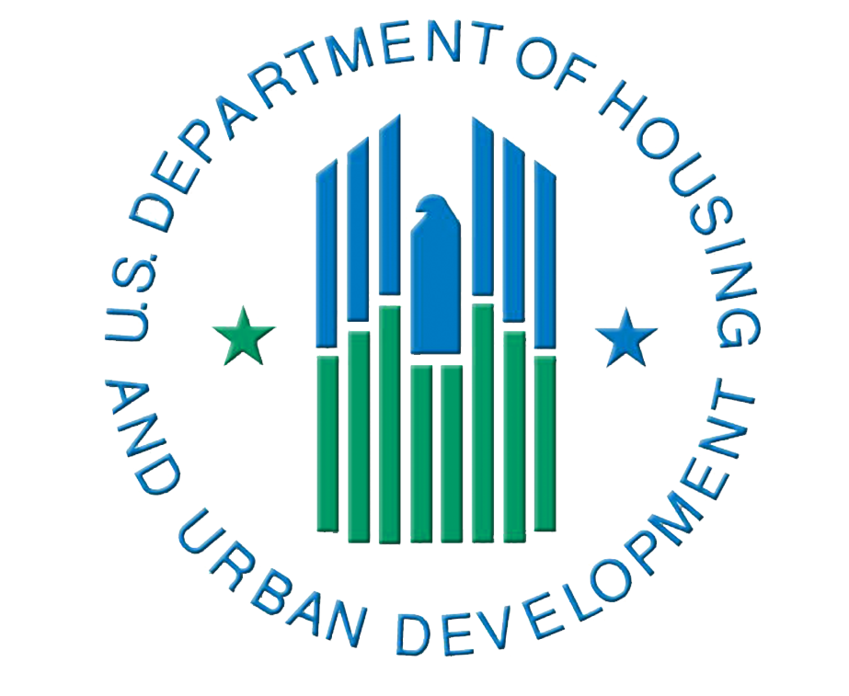
U.S. Department of Housing and
Urban Development
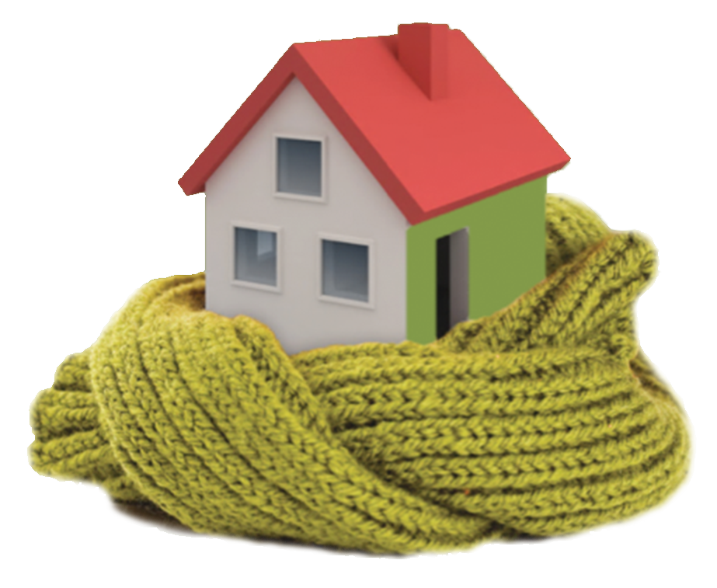

Secretary’s Award for Healthy Homes
Applications due April 30, 2015
The US Department of Housing and Urban Development, in partnership with the National Environmental Health Association (NEHA), announces the first annual Secretary’s Awards for Healthy Homes.
These awards will recognize excellence in healthy housing innovation and achievement in three categories: Public Housing/ Multifamily Supported Housing, Public Policy, and Cross Program Coordination among Health, Environment and Housing. The activities or policies nominated must show measurable benefits in the health of residents and be available to low and/or moderate income families.
Complete applications must be submitted via email no later than 11:59:59 p.m. PT, April 30, 2015. The Awards will be presented at the NEHA Annual Educational Conference & Exhibition. Please complete this application form, then email it and all other required materials as attachments to HUDAward@neha.org.
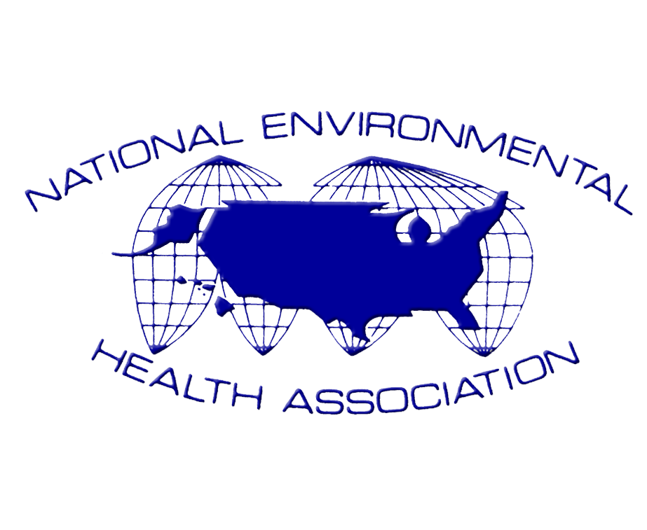
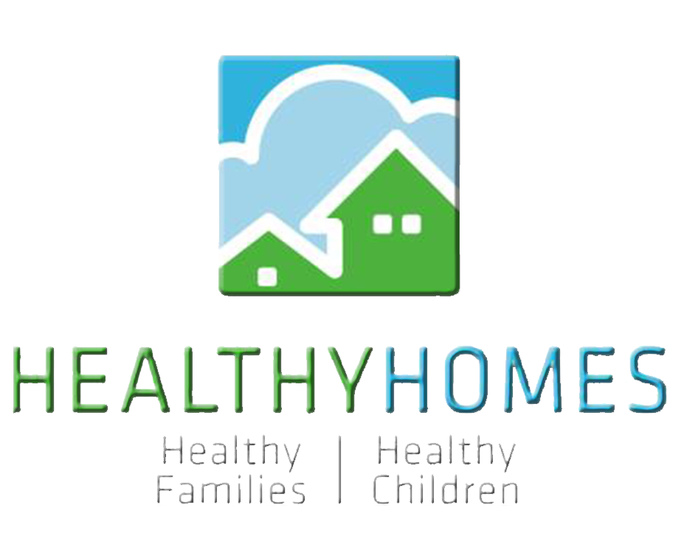
Award Categories
Award Submissions will be considered in one of three categories described below. An organization may submit only a single application as the lead agency. Organizations may participate as partnering organizations in more than one application.
 | Healthy Home Award Categories
 | Public Housing/Multifamily Housing | Public Policy | Cross Sector Coordination
Eligible Applicants | - Public Housing Authorities;  - Multifamily Housing Owners, Managers;  - Resident Organizations (e.g., tenant task forces) in public or private assisted housing | - State, County, City, regional units of government (including legislative bodies);  - Health Care Providers (including hospitals);  - Non-Profit Organizations;  - Health Insurance Providers;  - Advocacy Organizations | - State, County, City, regional units of government;  - Health Care Providers (including hospitals);  - Housing Providers;  - Non-Profit Organizations;  - Health Insurance Providers;  - Advocacy Organizations
Nomination Examples | - A public housing authority’s universal adopting smoke free and/or integrated pest management policies;  - A tenant task force creating and implementing a resident health and energy program | - Creating adopted local/state code enhancements with significant health outcomes or impacts;  - Developing an implemented system for enhancing housing and/or code inspection efficiency and effectiveness | - Comprehensive cross-program coordination; e.g., a county health department coordinating asthma interventions with CDBG and/or HOME rehabilitation resources;  - A national or regional foundation creates and funds a healthy housing program based on cross sector coordination
Outcome Data Necessary for Consideration | - Number of residents impacted by policy;  - Number or rate of residents with improved health outcomes due to implementation of healthy homes activity;  - Number or rate of reduction in asthmatic episodes among residents;  - Measurable reduction of indoor air pollutants related to policy | - Numbers of localities adopting public policy change(s);  - Number of residents directly and indirectly affected by the public policy change(s) | - Number or rate of residents with improved health outcomes due to implementation of healthy homes activity; e.g., reduction in asthmatic episodes among residents, or falls in the home among the elderly
Award winners are ineligible to apply for the award in the next year. Applicants selected for an award agree to submit a summary of their accomplishments to be published in NEHA’s Journal of Environmental Health.
Criteria for Judging:
Applications will be judged on meeting eligibility criteria, completeness, timeliness, as well as employing the required format. Applications that meet this threshold will be rated on the following factors:
- Innovation in policy or program development
- Health impact on residents
- Impact on physical environment
- Partnership in development and/or implementation of the policy or program
- Sustainability of the policy or program

Applications will be subject to a thorough screening and review of eligibility, program/technical and impact/effectiveness. Applications will be evaluated by NEHA. Nominees will be forwarded to HUD’s Office of Lead Hazard Control and Healthy Homes for review and submission to the HUD Secretary for selection of the awardees.

The evaluation process includes, but is not limited to, an assessment of the criteria listed below. Due to the wide variety of projects that can be considered, a project does not need to address each criterion. In the text of the application description section (the five-page maximum policy/program narrative) the application should describe:

- Policy/Program Innovation – the policy or program, with specific emphasis on the impact it has had on a health/housing condition(s) previously unaddressed or specific improvements made to existing programs. Policies/programs do not necessarily need to address a new subject of concern, but all policies/programs discussed should demonstrate innovative aspects of addressing the concerns.

- Health Impact on Population – data on the policy/program’s health outcomes including, where available, data on healthcare utilization (e.g., emergency/urgent care visits, inpatient hospital stays, healthcare costs), absenteeism (e.g., from school or work), data on self-reported or objectively-reported symptom impact, and data on reduction of unhealthy resident activities (e.g., use of tobacco products, proximity to those who smoke, etc.).

- Impact on Physical Environment – data on the policy/program’s effect on reducing environmental hazards (e.g., lead paint hazards, asbestos, combustion gasses, toxic chemicals, asthma triggers/allergens, etc.), home safety hazards, and other impacts.

- Partnership/Collaboration – how the policy/program was developed and implemented and the role(s) that partnering organizations played. These partnering organizations do not necessarily need to be formal partners and may have played an important role in just one or a few phases of the development or implementation of the policy/program. The text should identify whether formal partnerships do exist and describe ongoing efforts to coordinate activities. Applicants should identify whether the policy/program was or is supported by philanthropy, governmental, and/or other sources, and what kind(s) of support was (were) provided.

- Sustainability – how the policy/program will continue to have impact into the future. In cases of policy advances based on statutory or regulatory actions, a description of anticipated permanence; e.g., lack of sunset provision in the legislation or demonstration of ongoing industry acceptance of policy, will suffice. For program sustainability, applicants should describe permanent and temporary sources of support.

Name Of Applicant
Organization Type | Choose an Organization.
Project Name
Applicant Organization
Street Address
City
State
ZIP
Contact Name
Contact Email
Telephone
Website
Award Category | Choose a Category.
Partner Organizations (identify up to 8 project contributing partners)

Will someone from your program be present to accept the award at the NEHA Annual Education Conference in Orlando, FL, July 13-15, 2015?

Yes No
Submission Abstract (Limit to 300 words)
Briefly describe the main elements of the program, project, and/or policy, and the impact it has had on healthy homes, and the nature of partner participation.

Submission Information and Requirements
All entries must be completed using the award’s fillable Word Document form and submitted by an eligible policy/program via e-mail to HUDAward@neha.org. The fillable form will be available beginning March 15, 2015, at www.neha.org/awards and www.huduser.org/secaward/healthyhomes. The deadline for completing e-mail submission is 11:59:59 p.m. PT, April 30, 2015.
The electronic submission should include the following information:
- The Application Form
A 2015 Secretary’s Award for Healthy Homes application form that includes the title of the entry, name and contact information of the person from the policy/program submitting the application and who serves as the point of contact for the award application, and information about the policy/program and project. Include in the application form a brief summary of the initiative (only the first 300 words will be read) that can be used for publication and includes profile data on the policy/program application including the initiative’s goals, objectives, partners, public funding sources, and results, as applicable.

- Project Narrative
A narrative of no more than five pages describing the history of the initiative and addressing the five criteria for award consideration. (The narrative must be in 12 point non-narrow type font, on 8½ x 11” pages with margins no smaller than 1”.)

- Support Letters and Statements
Letters or statements support of the initiative should offer substantive support for the value of the effort (i.e., say more than “this is a good idea”) and may not be written by the organization applying or its parent or subsidiary organizations. Comments from partners (including government partners, residents, donors, and other local stakeholders familiar with or knowledgeable about the nominated effort are encouraged. The letter must accompany the application; it can be addressed to the applicant or the panel of judges.

- Images
Applicants should submit a high resolution image of your organization’s logo. In addition, the applicant may submit up to five digital images (.jpg format) with 15-to-25-word photo captions provided separately (on a page in addition to that of the project narrative) that provide context and show the initiative’s results. Images should supplement what exists in the application. Photo collages and slide (e.g., PowerPoint) presentations are NOT acceptable. Submit only digital images that are not copyrighted and that may be reproduced by NEHA or HUD without a fee, charge, or copyright infringement.

- Supporting Documentation and Attachments
One additional item (not to exceed five 8½ x 11” pages) may be included in the application. The supporting item could take the form of a review of the implementation effort; analysis of the results; newspaper clippings; editorials; legislative, regulatory, or policy provisions, etc.

Additional Information:

Brevity is encouraged in all documents.

No confidential, trade-secret, or otherwise non-disclosable information may be submitted, and neither NEHA nor HUD will review an application that indicates that it contains such information.

Applications from individuals will not be reviewed.

All applications become the property of NEHA, with HUD obtaining a license-free right to copy and distribute information in them. No fee is required to submit an entry or receive an award.

Schedule

• Applications must be submitted with an emailing time no later than 11:59:59 p.m. PT April 30, 2015.
• Applicants will be notified of their application’s status by May 31, 2015.
• Presentation of the award will take place during the awards ceremony at NEHA’s Annual Educational Conference & Exhibition in Orlando, FL, July 13-15, 2015.
• Award winners will be required to provide to NEHA, within 60 days of their being notified of their selection, a report of no more than 800 words on their project for possible publication in the Journal of Environmental Health. NEHA will provide the winners with the Journal’s writing style guidance.

