Small Area Fair Market Rents Methodology

Last updated July 2025

Introduction
The use of small area fair market rents (SAFMRs), which are fair market rents (FMRs) calculated for smaller geographical areas, expanded with a final rule published on November 16, 2016 (planned effective January 17, 2017, with an actual effective date of April 1, 2018), although their development was years in the making. As early as 1994, the Government Accountability Office (GAO) noted that FMRs would be improved if they were based on smaller geographic areas. However, the GAO report also determined that there were some fundamental barriers to their development, including substantial data costs that could range from $5 million to $750 million annually.
Prior to the development of SAFMRs, the U.S. Department of Housing and Urban Development (HUD) attempted to address “a pattern of high voucher concentration in relatively low-cost areas” by allowing certain areas deemed concentrated based on certain criteria to use FMRs at the 50th percentile, per an interim rule issued on October 2, 2000. The intent of the 50th percentile FMRs was to help public housing agencies (PHAs) de-concentrate voucher use patterns by providing some areas with larger subsidy thresholds, thereby allowing subsidy holders to use their higher subsidies to move to higher opportunity neighborhoods. Unfortunately, providing a larger subsidy throughout an FMR area did not result in the desired outcome.
The Office of Policy Development and Research (PD&R) began looking into ways to vary FMRs within metropolitan areas starting in 2009. This coincided with the first collection of American Community Survey (ACS) 5-year data becoming available in 2010, which allowed access to data on a smaller geographic level that would be updated at least every five years. This eliminated the most important cost concern cited in the GAO report. HUD developed SAFMRs based on smaller ZIP Code areas with the intent to enable Housing Choice Voucher (HCV) tenants to access more units in neighborhoods of opportunity while discouraging HCV tenants from locating in neighborhoods of concentrated poverty by more accurately reflecting the cost of rental housing in an area.
Prior to issuing a final SAFMR rule in 2016, HUD had issued SAFMRs for use in two occaisons. First, PHAs in the Dallas, Texas (TX) HUD Metro FMR Area (HMFA) used SAFMRs based on HUD’s settlement of a lawsuit by the Inclusive Communities Project (ICP), a non-profit fair housing-focused organization working in the Dallas metropolitan area. HUD also launched a SAFMR demonstration project with five PHA beginning in 2012. An official evaluation of the SAFMR Demonstration Project started in 2015.
In the SAFMR final rule, HUD identified 24 metropolitan areas (including the Dallas, TX HMFA) where vouchers were highly concentrated in areas of high poverty or low-income. PHAs in mandatory SAFMR areas are required to use SAFMRs to determine payment standards for the HCV program. Other PHAs may opt-in with the approval of HUD’s Office of Public and Indian Housing (PIH). The designation of mandatory areas is updated every five years, but once an area is designated as an SAFMR area, it remains so permanently. Criteria for evaluating SAFMR areas are discussed in Appendix I. Current mandatory SAFMRs, as well as areas that have opted into their use, are listed in Appendix II.
More detailed information on the history of SAFMR development can be found in Bibler et al. (2019). The remainder of this paper covers:
- the data upon which SAFMRs are based (Section II),
- the methodology and calculation of SAFMRs (Section III), and
- various appendices, including those already mentioned.

Data
As discussed in the Introduction, SAFMRs are required in metropolitan areas that have been identified as having high concentrations of voucher holders in areas of high poverty or low-income, although other areas may opt in as well. Currently, mandatory SAFMRs only apply to metropolitan counties or towns. Starting in fiscal year (FY) 2025, HUD calculated SAFMRs for both metropolitan and non-metropolitan areas. The non-metropolitan SAFMRs are intended to provide information to PHAs who may be considering opting into SAFMRs, which may now be adopted in non-metropolitan areas as well.
As with FMRs, SAFMRs are calculated using ACS “adjusted standard quality” (ASQ) gross rents for metropolitan statistical areas (MSAs) but taken to a smaller geographic level – ZIP Codes. SAFMRs replaced the 50th percentile rent to address high levels of voucher concentration. Using ZIP Codes as the basis for SAFMRs has several benefits. One, it allows for a wider range of payment standards within a metropolitan area. Two, it reduces undue subsidies in lower rent areas. And three, it provides tenants with greater mobility options.
The remainder of this section discusses the area definitions, in particular ZIP Codes and their relationship to ZIP Code Tabulation Areas (ZCTAs), the code used by the U.S. Census Bureau (Census or Census Bureau) to report data for ZIP Codes (Section 2.1.1). This section also discusses the MSAs, the higher-level of geography that is sometimes required to calculate SAFMRs as well (Section 2.1.2). This discussion summarizes the one in the FMR methodology, however, as does the discussion of ACS ASQ gross rents (Section 2.2).

Area Definitions
The SAFMR calculations are made for ZIP Code areas within metropolitan counties or towns and, as of FY 2025, non-metropolitan counties as well. In some cases, data for the higher-level parent geography is required as well. Therefore, both ZIP Code areas (Section 2.1.1) and MSAs (Section 2.1.2) are discussed below.

ZIP Code Tabulation Areas (ZCTAs) and ZIP Codes
ZIP Code area data were selected for SAFMRs for several reasons. In particular, they are well understood and small enough to localize rents, yet large enough to have statistically reliable data in many cases.
ZCTAs are a standard Census geography and, therefore, have data annually reported by the Census Bureau. Because the Census cannot release “individual housing unit addresses or location information,” point-based ZIP Code data is aggregated and extrapolated to a polygonal-based unit. The Census describes the resulting ZCTAs as “generalized areal representations of the geographic extent and distribution of the point-based ZIP Codes built using…Census tabulation blocks.” The resulting ZCTAs are current, valid ZIP Codes but not all valid ZIP Codes are represented by a ZCTA. In fact, most ZCTAs are the same as ZIP Codes, but because the United States Postal Service (USPS) sets ZIP Codes for efficient delivery of mail, the USPS ZIP Code boundaries may change boundaries more frequently than the Census Bureau changes ZCTAs. The result is that there may be times “where the ZIP Code for the property does not match the ZCTA containing the property.” In such cases HUD allows PHAs to use the SAFMR associated with either the ZCTA or the ZIP Code.
The SAFMR methodology uses the Census ZCTA Codes and supplements it with USPS data on ZIP Codes for residential and other non-residential, non-commercial addresses. The ZIP Codes are further supplemented with any additional ZIP codes from voucher count data provided by the PIH Information Center (PIC). Because the final SAFMR data represents both ZCTA ZIP Codes from the Census and non-ZCTA ZIP Codes from other sources, the final SAFMRs are all at the ZIP Code-level, even though the SAFMRs with ZIP Codes that stem from Census data are at the ZCTA-level.
In fact, most SAFMRs are based on ZCTA-level estimates from the ACS. However, HUD attempts to calculate SAFMRs for additional ZIP Codes that do not appear in the ACS using county-level data as proxies (see Section 3.1.4). Therefore, SAFMRs are best thought of as ZIP Code-level estimates.

Metropolitan Statistical Areas (MSAs)
While SAFMRs are calculated for ZIP Codes (as discussed in Section 2.1.1), in some cases the data that is used is at a higher level of geography that is then applied to the ZIP Code-level (in particular, if the county-level rent ratio must be used, as discussed in Section 3.1.4). In those cases, FMR areas are used. These areas are discussed in detail in the FMR methodology but a high-level summary is provided here as well.
FMR areas are based in part on the MSAs, a sub type of “Core Based Statistical Areas” (or CBSAs) determined by the Office of Management and Budget (OMB). In metropolitan areas, one FMR is calculated and used for the constituent counties within the metropolitan area (i.e., one FMR area), while non-metropolitan counties receive their own FMR (i.e., individual FMR areas). In Virginia (VA), where independent cities have county-equivalent status, non-metropolitan cities are grouped with their surrounding or adjacent counties. And in the five of the six New England states where towns are the primary unit of geography, FMR areas remain based on pre-2000 designations of metropolitan areas, as the current CBSA criteria use counties to define metropolitan areas. The sixth New England state, Connecticut (CT), has officially changed its county-equivalent geographic units from counties to planning regions. Because the CT planning regions do not match the boundaries of the former counties, starting with the FY 2026 FMRs and SAFMRs, HUD has adopted the new MSA definitions for Connecticut rather than maintaining its previous HMFA definitions.
HMFAs, as defined in the Introduction, represent cases where HUD has occasionally differed from the metropolitan areas determined by OMB and created its own metropolitan definitions. The need for HMFA exception areas goes back to the start of the HUD income limits system. Exceptions may occur, for example, when counties that are only marginally part of a metropolitan area are included in the OMB definition and modifications are needed to comply with HUD program objectives. In order to preserve local variation in FMRs, HUD’s current practice is to treat any county added to a metropolitan area by OMB as a separate HMFA (also known as a CBSAsub, referred to as “hud_area_codes” in the publicly available datasets), treating the remainder of the metropolitan area as a separate HMFA as well. HUD’s treatment of the CT revisions represents a necessary exception to that approach for the reason cited above.

ACS Adjusted Standard Quality Gross Rents
Regardless of whether the gross rent data used to calculate SAFMRs comes from the ZIP Code-level or a higher-level geography, its source comes from special tabulations of the ACS procured by HUD from the Census annually. As discussed in more detail in the FMR methodology, special tabulations are required to: (1) attempt to remove publicly assisted units (i.e., those with low rent levels), (2) identify “standard quality” units (those with cash rent, on 10 acres or less, with full plumbing and a full kitchen, and meals not included with rent, (3) obtain 40th percentile estimates, (4) restrict rents to recent movers, and (5) produce estimates for custom geographic areas . ACS staff calculate 40th percentile ASQ gross rents after these adjustments have been made.

Methodology and Calculation
This section discusses the various steps involved in calculating SAFMRs. The SAFMR calculation begins with a preliminary two-bedroom calculation. As described in Section 3.1, how the preliminary calculation is made will depend upon the availability and reliability of the data. Floors and ceilings are then applied by comparing the preliminary two-bedroom SAFMR to the appropriate parent FMR, as discussed in Section 3.2. Next, SAFMRs for other bedroom sizes are generated, using the FMR bedroom ratios for the ZIP Code's parent metropolitan area or non-metropolitan county as a basis (see Section 3.3). Finally, Section 3.4 describes the application of year-to-year decline limits.

Preliminary SAFMR Calculation
There are five possible paths that the preliminary SAFMR calculation may take. The evaluation follows through all the paths but ultimately, only one path (“Case”) is relevant for the final SAFMR calculation made for each ZIP Code. If base rent data for specific bedroom sizes is reliable to some extent, base rent is used for the calculation. The specifics of the calculation depend upon the level at which the data is reliable, as discussed in Section 3.1.1 (Case A). If none of the data required to calculate base rent is reliable, the Case B (Section 3.1.2) path must be followed. Under Case B, rent ratios are calculated using ZIP Code-level all-bedroom data. If there are insufficient statistically reliable all-bedroom data available, ZCTA-based SAFMRs for neighboring ZIP Codes, Case C (Section 3.1.3) are used where possible. If not possible, the ZIP Code’s parent county data will be used to calculate a rent ratio instead (Case D, Section 3.1.4). Finally, in cases where ACS data is unavailable either at the ZIP Code or county level, Case E must be used instead, as described in Section 3.1.5. Case E may occur in rare cases for non-metropolitan areas. A high-level flowchart showing this decision process is shown in Figure 1. Additional figures showing the details for each case are provided in their appropriate section below.

Case A: Base Rent
Where possible, base rent is used. A base rent can only be calculated if the underlying data is statistically reliable at some level. The base rent is set as an average for three collection years of 5-year ACS ASQ 40th percentile gross rent data for two-bedroom units (or two-bedroom equivalent, if the one- or three-bedroom data is converted to two-bedroom data as described below). Using an average accounts for the inherent volatility of estimates at low levels of geography in the ACS. Figure 2 shows graphically the decision-making process described below.
First, each bedroom size (two-, one-, and three-) is evaluated for statistical reliability. Statistical reliability is evaluated in two ways: (1) the margin of error ratio must be less than 50 percent and (2) there must be at least 100 survey cases. Consistent with the FMR methodology, the margin of error ratio is calculated by dividing the margin of error by the gross rent estimate. Also consistent with FMRs, the number of survey cases is represented by an indicator variable in the data. If the indicator variable is at least 4, the estimate represents 100 or more survey cases.
Current ACS year: If current year data is statistically reliable, the two-bedroom data can be used without further adjustment and the one-bedroom and three-bedroom data would only need to be converted to a two-bedroom rent using the appropriate parent HUD metropolitan area or

Figure 1: SAFMR Methodology Overview
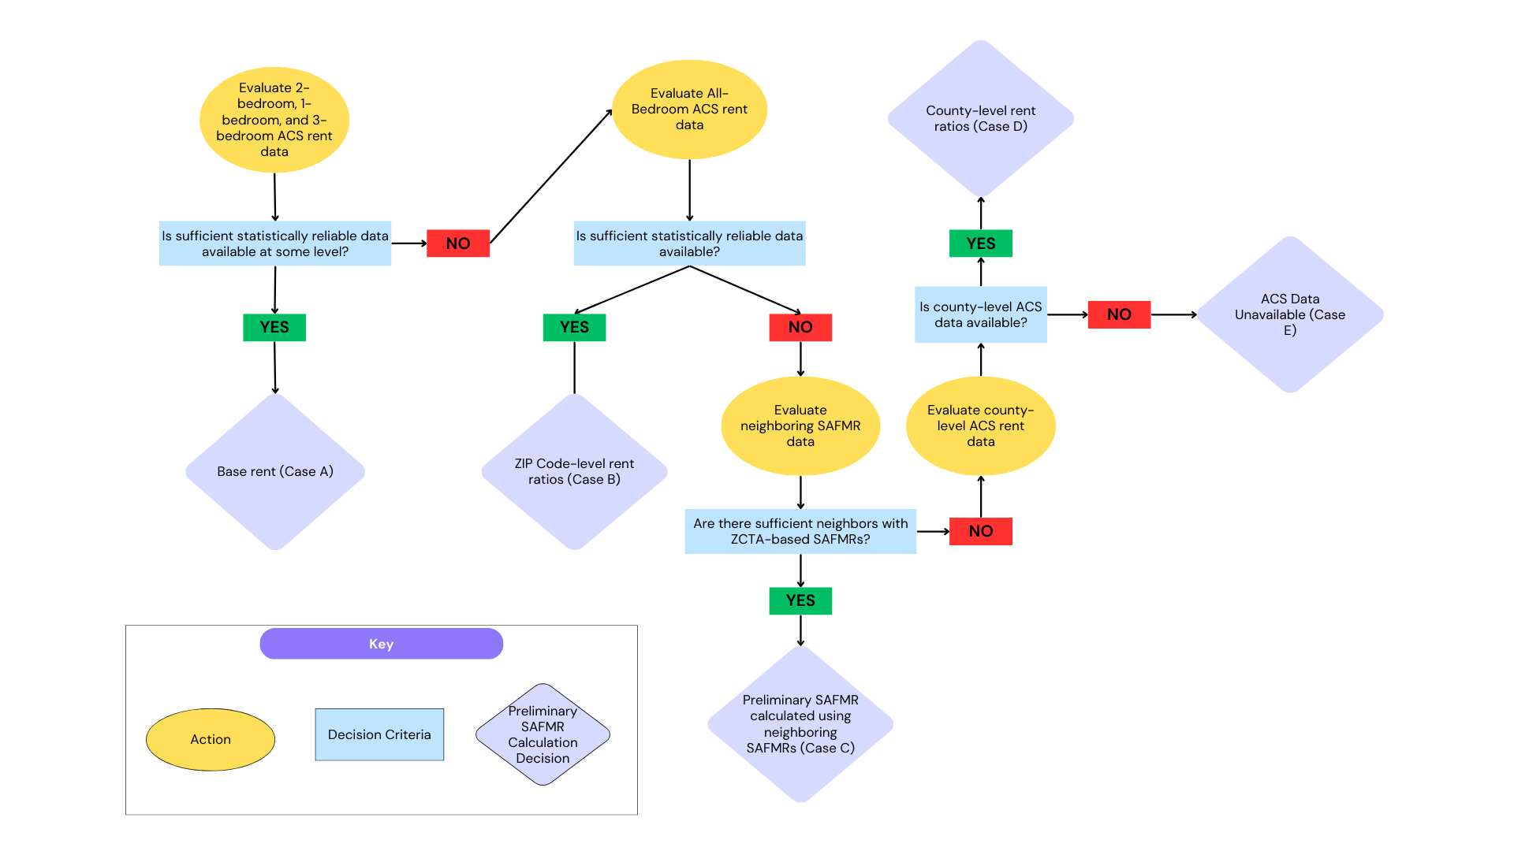
Figure 2: SAFMR Base Rent Methodology – Part 1
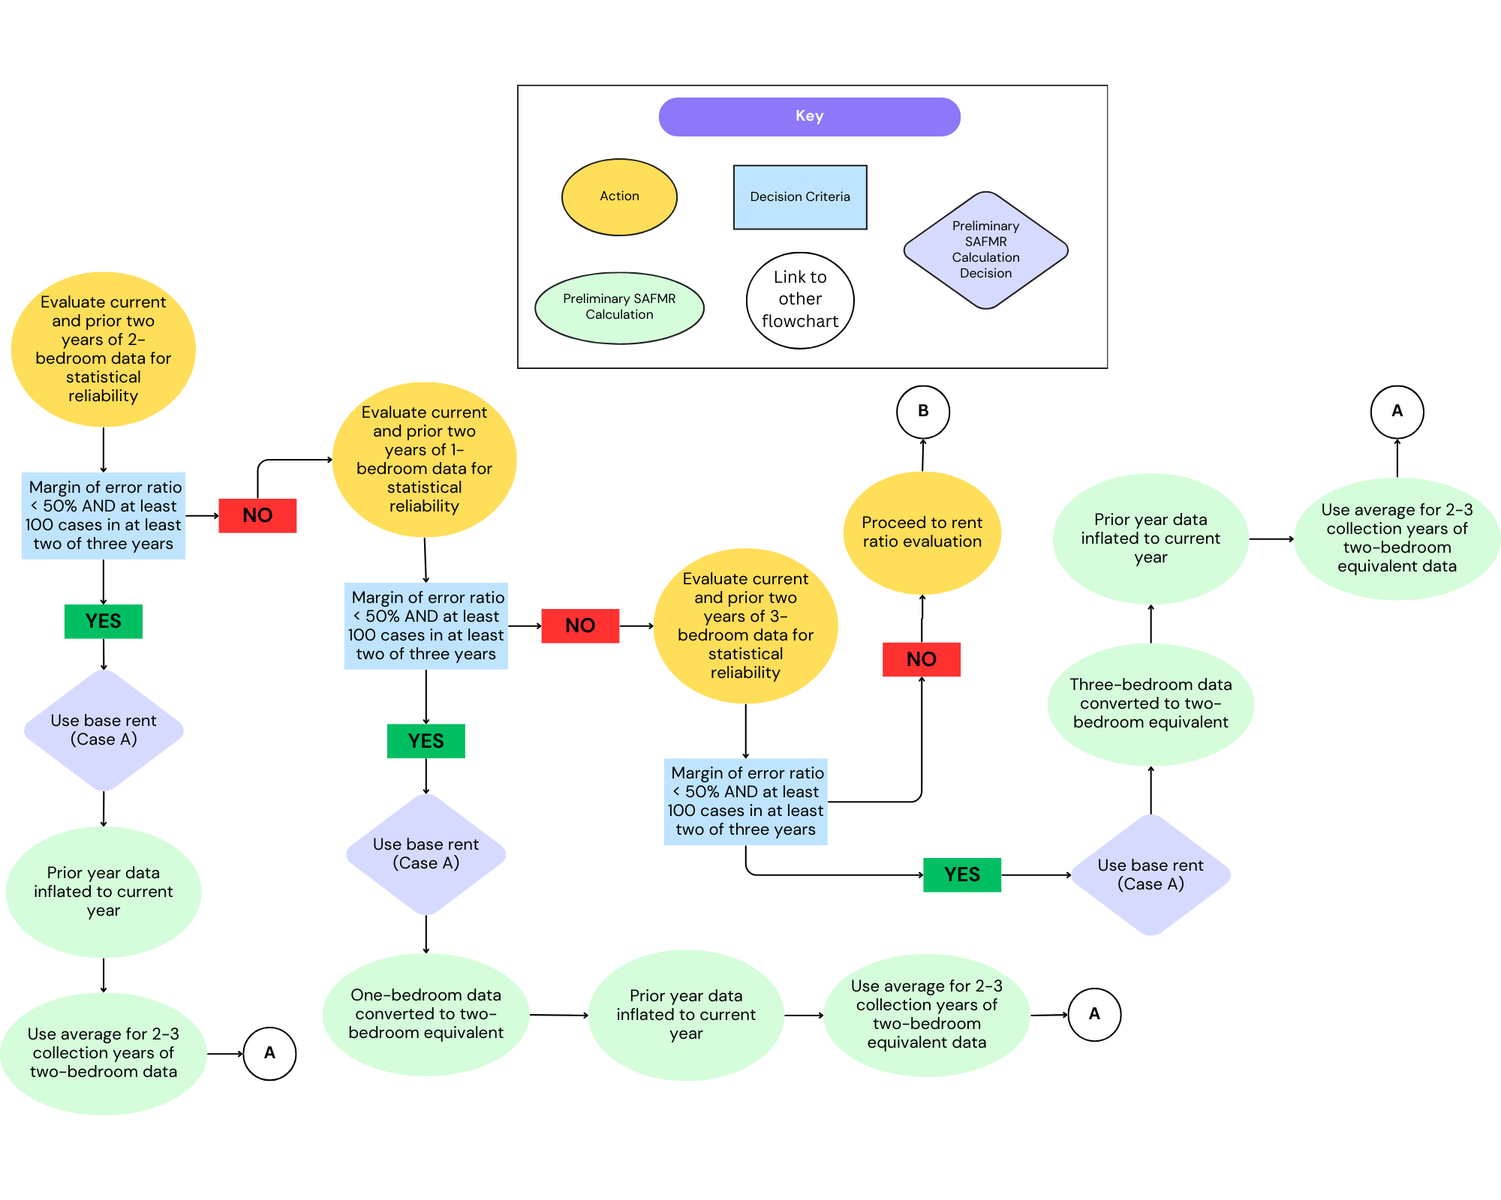
non-metropolitan county bedroom ratio developed for FMRs. The use of bedroom ratios is discussed in more detail in Section 3.3. However, for a complete explanation of their development and use in the context of FMRs, see Section VIII of the FMR methodology.
Prior two ACS years: The same evaluation needs to be made for each earlier collection year of five-year data. So, the statistical reliability of the prior year’s two-bedroom gross rent estimate needs to be examined, and one-bedroom and three-bedroom (in that order) examined as well, if needed. If either one-bedroom or three-bedroom data is statistically reliable (where two-bedroom is not) and is, therefore, selected for use as part of calculating the base rent average, it must be converted to a two-bedroom rent using the appropriate parent HUD metropolitan area or non-metropolitan county bedroom ratio. This same process is followed for the prior prior year (i.e., two years before the current year and a year before the prior year).
As long as two-bedroom rents (or two-bedroom equivalent rents, based on one- or three-bedrooms) can be found as described above for at least two of the three collection years of data (current year, prior year, and prior prior year), a base rent can be created. Essentially, an average of the gross rents for these collection years forms the base rent. Prior to creating the average that will form the base rent, any earlier data must be inflated to the current year.
Some examples of the base rent calculation are described below, along with links to their related SAFMR documentation system page:
- ZIP Code 44224 in the Akron, Ohio (OH) MSA has statistically reliable two-bedroom gross rent estimates for all three years of data. As seen in step 1, the quality counter (or indicator variable, as discussed earlier in this section) is 4 or greater and the margin of error ratio (also discussed above) is less than 50 percent in all cases. Therefore, after an inflation adjustment is applied to gross rents from the two earlier collection years, the base rent is an average of the three years of two-bedroom gross rents.
- ZIP Code 31705 in the Albany, Georgia (GA) MSA has statistically reliable gross rent estimates for all three years of data, but only for three-bedroom units. In particular, the quality counter/indicator variable is only 4 or greater for three-bedroom units, even though the margin of error ratio is acceptable for all the data. The bedroom ratios for this ZIP Code can be found through the FMR documentation system page for the Albany, GA MSA. The three-bedroom ratio itself, as well as the calculation can be found on this page. The bedroom ratio is applied to all three collection years and an inflation adjustment is also applied for the non-current years of data.
Because the base rent represents a 5-year, all-mover estimate, it must be further updated using three factors from the ZIP Code’s parent metropolitan area or non-metropolitan county:
- the recent mover factor,
- the gross rent inflation update factor, and
- the forecasted inflation trend factor.
SAFMRs use the same factors developed for FMRs for each of these. As shown in Figure 3, these factors are applied to the base rent calculation, whether it was made from two-bedroom rents or two-bedroom equivalent rents, to get the preliminary SAFMR.
Section III of the FMR methodology describes how the recent mover factor (1) is calculated in detail. Here, the focus is on what the recent mover adjustment factor represents and why it is necessary. FMRs, including SAFMRs, are required by regulation to be set on the basis of “recent movers” (defined as those who moved in during the current year or prior year) to help ensure they reflect current market conditions as much as possible. It also avoids biasing the base rent low due to things like rent control laws. This is done by comparing a 1-year 40th percentile recent mover to the 5-year 40th percentile ASQ gross rent for all movers. There are additional complexities that may enter the calculation due to a lack of statistical reliability which would result in data for higher levels of geography being used. In some cases, this could require additional modification if the geography crosses state lines. ZIP Code 97322 within the Albany, Oregon MSA provides such as example, with the recent mover factor being laid out in its corresponding FMR documentation system page, as described in Section III of the FMR methodology.
The gross rent inflation update factor (2), also referred to as the inflation adjustment factor, is described in significant detail in Section IV of the FMR methodology. Consumer Price Index (CPI) and private inflation data, as well as utility price changes, are used to calculate the gross rent inflation factor. The gross rent inflation factor is intended to inflate estimates of recent mover gross rents from the most recent survey year of the ACS to the end of the subsequent calendar year.
The forecasted inflation trend factor (3) (also referred to as simply the trend factor) is used with both FMRs and SAFMRs to bring estimates from the most recent ACS data year up to the current FY. Trend factors are calculated by forecasting values of select CPI series for local and regional CPI areas using one of three models that generates the lowest Root Mean Square Error (RMSE) statistic (see Section V of the FMR methodology for additional details).
So, in summary, as a final step, when there is some statistically reliable two-, one-, or three- bedroom ACS data, (1) more current market conditions are incorporated (recent mover factor), (2) brought to the end of the subsequent calendar year for the recent mover data (gross rent inflation update factor), and finally base rent is (3) brought into the current FY (forecasted inflation trend factor). The application of all of these factors can be seen for ZIP Code 99501 in the Anchorage, AK HUD Metro FMR Area. To see how the various factors are calculated, one may go to the FMR documentation system page for the Anchorage, Alaska HUD Metro FMR Area. Applying these factors to the base rent yields the preliminary two-bedroom SAFMR.

Figure 3: SAFMR Base Rent Methodology – Part 2
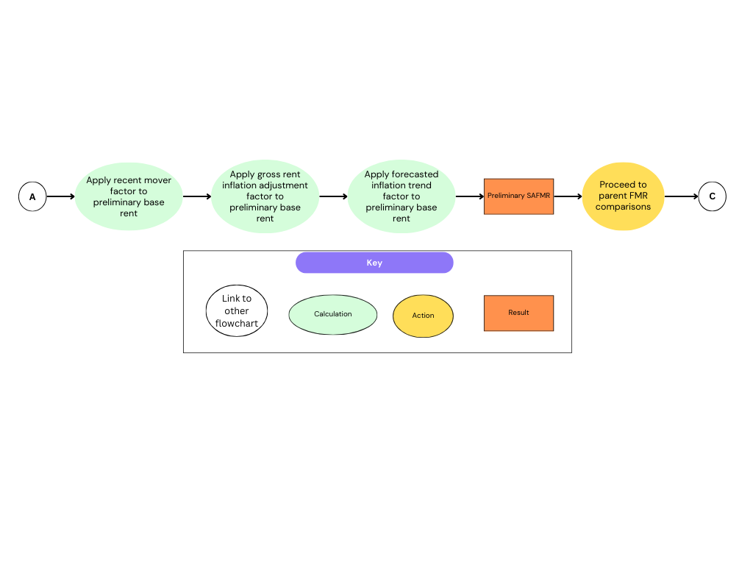
For ZIP Codes that cross area boundaries (which may include both metropolitan and non-metropolitan areas), the preliminary two-bedroom SAFMR is the population-weighted average of the preliminary SAFMRs for each area. For example, ZIP Code 30165 within the Cherokee County, Alabama (AL) / Rome, GA MSA is a non-metropolitan area with statistically reliable two-bedroom current-year data. However, the ZIP Code crosses three areas: Chattooga County (non-metropolitan), Cherokee County (non-metropolitan), and Rome, GA MSA (metropolitan). Therefore, the base rent for ZIP Code 30165 is modified for each of these areas using the (1) recent mover factor, (2) gross rent inflation update factor, and (3) trend factor for those areas. The result, as shown in the table in step 3, is a preliminary two-bedroom SAFMR unique to each area. A final preliminary SAFMR for ZIP Code 30165 is then developed by using a weighted average of the three preliminary SAFMRs, where the weight used is the proportion of the ZIP Code 30165 population in each area.

Case B: Rent Ratio
If there is no statistically reliable ZIP Code-level ACS data for one-, two-, or three-bedrooms on which to calculate a base rent, a rent ratio is calculated instead. The process is shown graphically in Figure 4 below.
First, the 5-year ACS ASQ median all-bedroom gross rent is evaluated for the most recent three years. If at least two of the three years have minimally reliable data (using only the margin of error ratio), a ratio of the ZIP Code’s median all-bedroom gross rent relative to that of the ZIP Code's parent HUD metropolitan area or relevant non-metropolitan county (ZIP Code gross rent ÷ parent gross rent) is created for them. These ratios are then averaged. This was the method used in FY 2026 for ZIP Code 12020 within the Albany-Schenectady-Troy, NY MSA. As can be seen in step 3 at the bottom of the page, when 5-year ACS ASQ median all-bedroom gross rent for the three most recent ACS collection years was evaluated, all three years had minimally reliable data. Therefore, a rent ratio was created for all three years of data (ZIP Code gross rent ÷ parent gross rent) and those ratios were averaged together to get the SAFMR rent ratio for the ZIP Code.
Once the rent ratio has been calculated, it is multiplied by the two-bedroom FMR for the ZIP Code’s parent HUD metropolitan area or non-metropolitan county and then rounded to the nearest $10. For example, for ZIP Code 12020 within the Albany-Schenectady-Troy, NY MSA examined in the prior paragraph, the SAFMR rent ratio 1.242 is multiplied by the two-bedroom FMR for the Albany-Schenectady-Troy, NY MSA (which can be found on the FMR documentation page for Albany-Schenectady-Troy, NY MSA) to get the preliminary two-bedroom SAFMR for that ZIP Code, rounded to the nearest $10 ($2,110).

Figure 4: SAFMR Rent Ratio Methodology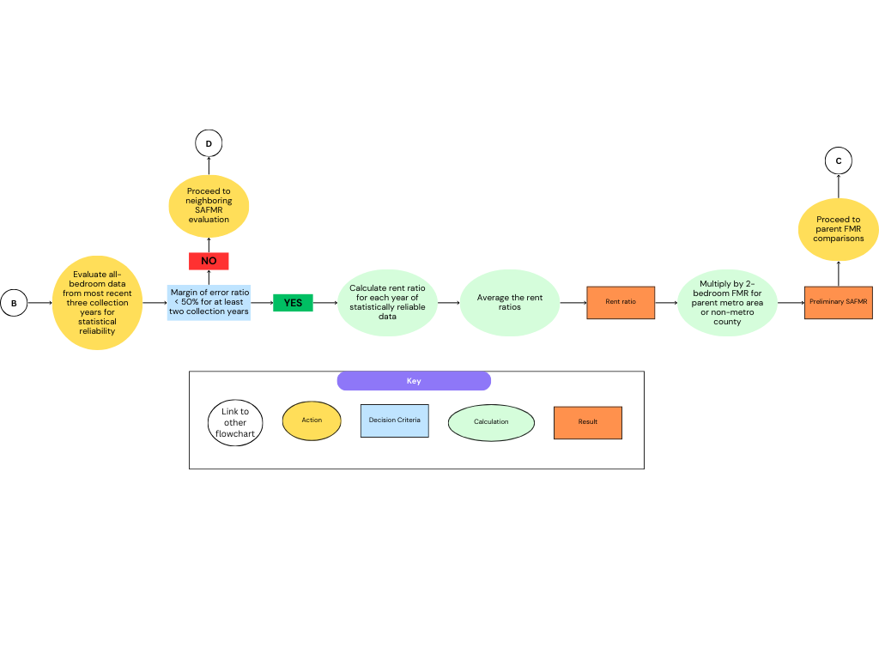
If the ZIP Code does not have statistically reliable all-bedroom gross rent data, the ZIP Code is first evaluated to determine whether neighboring SAFMRs can be used (see Section 3.1.3). If not, the ZIP Code’s parent county data will be used to create a rent ratio if possible (see Section 3.1.4).

Case C: Neighboring SAFMRs
In cases where there is no base rent, and a ZIP Code does not have statistically reliable all-bedroom gross rent data, data from neighboring ZCTA-based ZIP Codes is used to calculate the preliminary SAFMR where possible, rather than develop a rent ratio using a ZIP Code’s parent county data. Using neighboring ZCTA-based ZIP Code data allows SAFMRs to capture localized rental conditions that may not be visible at the county or metropolitan level which are required in the next step (Case D, Section 3.1.4). However, neighboring SAFMRs can only be used with actual ZCTAs because the spatial relationship data to determine neighbors comes from the ACS and is therefore ZCTA-based.
The use of neighboring ZIP Codes is currently considered possible in cases where the number of neighbors with usable preliminary SAFMR data meets or exceeds 50 percent of the total number of neighbors for a ZIP Code. In such cases, a weighted average of the neighboring ZIP Code SAFMRs will be used instead of relying on parent county data. The weights are set based on the length of the border they share with the ZIP Code being evaluated. This process is shown in Figure 5 below.
Obviously, the number of neighboring ZIP Codes that would be considered sufficient will, therefore, vary from one ZIP Code to another. ZIP Code 57214 within Kingsbury County, SD is one example where the SAFMR was set using the SAFMRs from neighboring ZIP Codes. In this case, only two ZIP Codes were sufficient. In the case of ZIP Code 07458 within the Bergen-Passaic, NJ HUD Metro FMR Area, eleven neighboring ZIP Codes were available for the weighted average calculation.

Case D: County-Level Rent Ratio
If a ZIP Code does not have statistically reliable all-bedroom gross rent data and neighboring SAFMR data cannot be used as an alternative, the ZIP Code’s parent county data will be used to create the rent ratio if possible. Figure 6 provides a flowchart showing this process. As long as at least two of the most recent three years of data are statistically reliable, the rent ratio will be the average of (county median gross rent) ÷ (county's parent gross rent) for those years. An example of this is ZIP Code 12007 within the Albany-Schenectady-Troy, NY MSA. None of the bedroom size data or all-bedroom data is statistically reliable, so a county-level rent ratio for

Figure 5: Neighboring SAFMRs Methodology

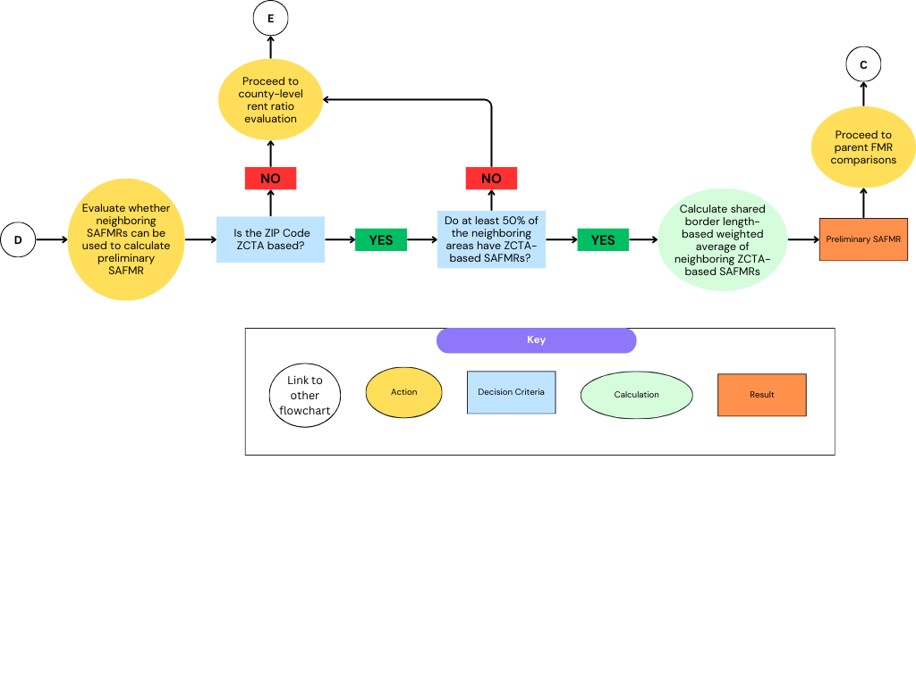
Figure 6: SAFMR County-Level Rent Ratio Methodology
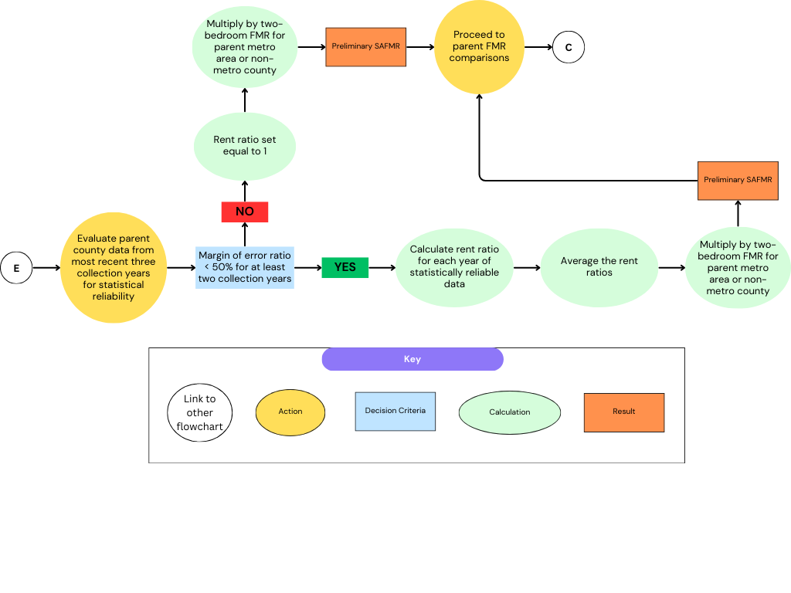

each year is created (county median gross rent ÷ county's parent gross rent). The SAFMR rent ratio is the average of these three rent ratios.
In another example, when the ZIP Code is not in the ACS (i.e., not one of the ZCTAs), ZIP Code 18105 within the Allentown-Bethlehem-Easton, PA HUD Metro FMR Area, the use of county-level ACS data is required. However, when using county gross rent data, weights based on the length of the border they share with the relevant ZIP Code are used.
As with ZIP Code-level rent ratios, the county-level rent ratio is multiplied by the two-bedroom FMR for the ZIP Code’s parent HUD metropolitan area or non-metropolitan county and then rounded to the nearest $10 to get the preliminary SAFMR.

Case E: ACS Data Insufficient
As already discussed, when there is insufficient statistically reliable ZIP Code-level ACS data on which to develop a base rent, a rent ratio may be developed instead (see Section 3.1.2). If sufficient statistically reliable all-bedroom data for the ZIP Code is also unavailable (and the neighboring SAFMR method cannot be used), the ZIP Code’s parent county data will be used to create the rent ratio if possible (Section 3.1.4). However, if the county-level estimates are not statistically reliable or, in the rare case that ACS data is completely unavailable at either the ZIP Code or parent county level for a non-metropolitan area, the data is deemed insufficient, and the rent ratio is set equal to 1.
In those cases, if the ZIP Code does not cross FMR area boundaries, the preliminary two-bedroom SAFMR is essentially set at the county FMR and rounded to the nearest $10, because a rent ratio of 1 multiplied by the county FMR equals the county FMR. This process is shown in Figure 6 and Figure 7. For example, see ZIP Code 82336 within Sweetwater County, WY, where the two-bedroom FMR for Sweetwater County, WY ($996) is used to set the preliminary SAFMR ($1,000). Because the SAFMR is set using the county FMR, the parent FMR comparisons (see Section 3.2) are irrelevant. However, the bedroom ratios are still used to develop SAFMRs for other bedroom sizes (see Section 3.3) and the limits on year-to-year declines (see Section 3.4) are still applied.

Parent FMR Comparisons
Once the preliminary two-bedroom SAFMR calculations are made, whether they result from Case A (base rents adjusted by the recent mover factor, the gross rent inflation update factor, and the forecasted inflation trend factor), Case B (rent ratios multiplied by the two-bedroom FMR for the ZIP Code’s parent HUD metropolitan area or non-metropolitan county), Case C (weighted average of neighboring SAFMRs), or Case D (county-level rent ratios), comparisons

Figure 7: ACS Data Unavailable Methodology
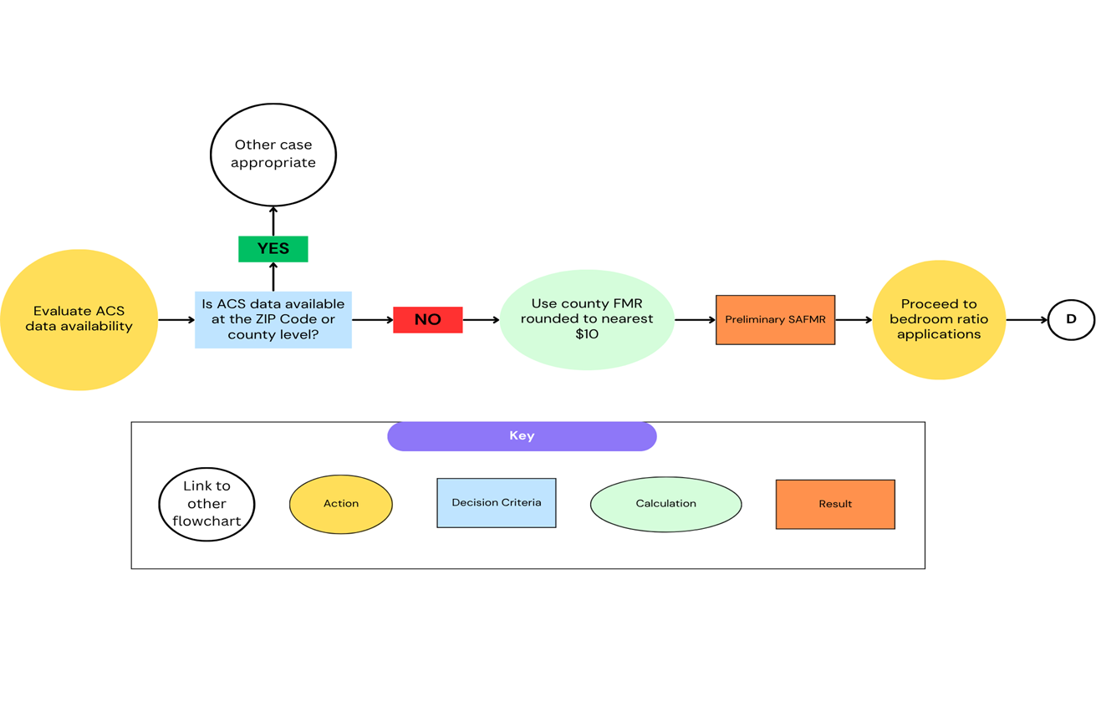
to the ZIP Code’s parent areas need to be made to ensure that the SAFMR does not exceed or fall below certain levels. There are two specific checks:
- no SAFMR can exceed 150 percent of the parent HUD metropolitan FMR or relevant non-metropolitan county FMR, and
- no SAFMR should be below the ZIP Code's parent state minimum FMR.
For example, in the case of ZIP Code 01731 within the Boston-Cambridge-Quincy, MA-NH HUD Metro FMR Area, the preliminary SAFMR is developed using the all-bedroom ACS data to create a rent ratio (Case B). A ZIP Code to metro ratio is created for two of the three most recent ACS release years using the ZIP Code’s all-bedroom median gross rent for the numerator and the median gross rent for the ZIP Code’s parent HUD metropolitan area for the denominator. These rent ratios are then averaged. However, because the average (small area rent ratio) is greater than 1.5, a ratio of 1.5 is used instead to ensure that the SAFMR does not exceed 150 percent of the parent FMR for this area (first check). Then the revised small area rent ratio is applied to the two-bedroom FMR for the ZIP Code’s parent HUD metropolitan area and rounded to the nearest $10. The resulting preliminary 2-bedroom SAFMR is compared to the ZIP Code’s state minimum (check 2). In this case, the preliminary SAFMR does not fall below the state minimum, so it is not applied. These checks, as well as the bedroom ratio applications and year-to-year decline limits (Sections 3.3 and 3.4 respectively) are shown in Figure 8.

Bedroom Ratio Applications
After any necessary parent ceilings and floors are applied (Section 3.2), the two-bedroom SAFMRs need to be converted to SAFMRs for other bedroom sizes. This is done using the FMR bedroom ratios for the ZIP Code's parent metropolitan area or non-metropolitan county, shown as part of Figure 8. As discussed in the FMR methodology, these bedroom ratios are created by first evaluating the gross rent estimates for each bedroom size from the five-year ACS for each of the past three ACS releases. If the result is statistically significant (using only the margin of error ratio), then the ratios of the 1-, 3-, and 4- bedroom gross rent to the two-bedroom gross rent ratio are calculated. An average of the gross rent ratios for each bedroom size is used as the bedroom ratio. Caps and floors are applied, as appropriate, as are increases for larger bedroom units that are considered especially difficult to obtain for voucher holders.
Once the appropriate bedroom ratios are multiplied by the preliminary two-bedroom SAFMR for a given ZIP Code, they are rounded to the nearest $1. As an example, consider ZIP Code 95605 within the Yolo, California (CA) HUD Metro FMR Area. This ZIP Code uses a rent ratio based on the all-bedroom ACS data (Case B) to derive the preliminary two-bedroom SAFMR which is not subject to the state minimum FMR or the ceiling (Section 3.2). In step 7 of the table at the bottom of the page, the line titled “Preliminary FY 2026 SAFMR” shows how the $1,850 two-bedroom preliminary SAFMR is converted to the other bedroom sizes. However, to find the bedroom ratios used to make this conversion, the FY 2026 FMR bedroom ratios must be

Figure 8: SAFMR Methodology – Final Calculations
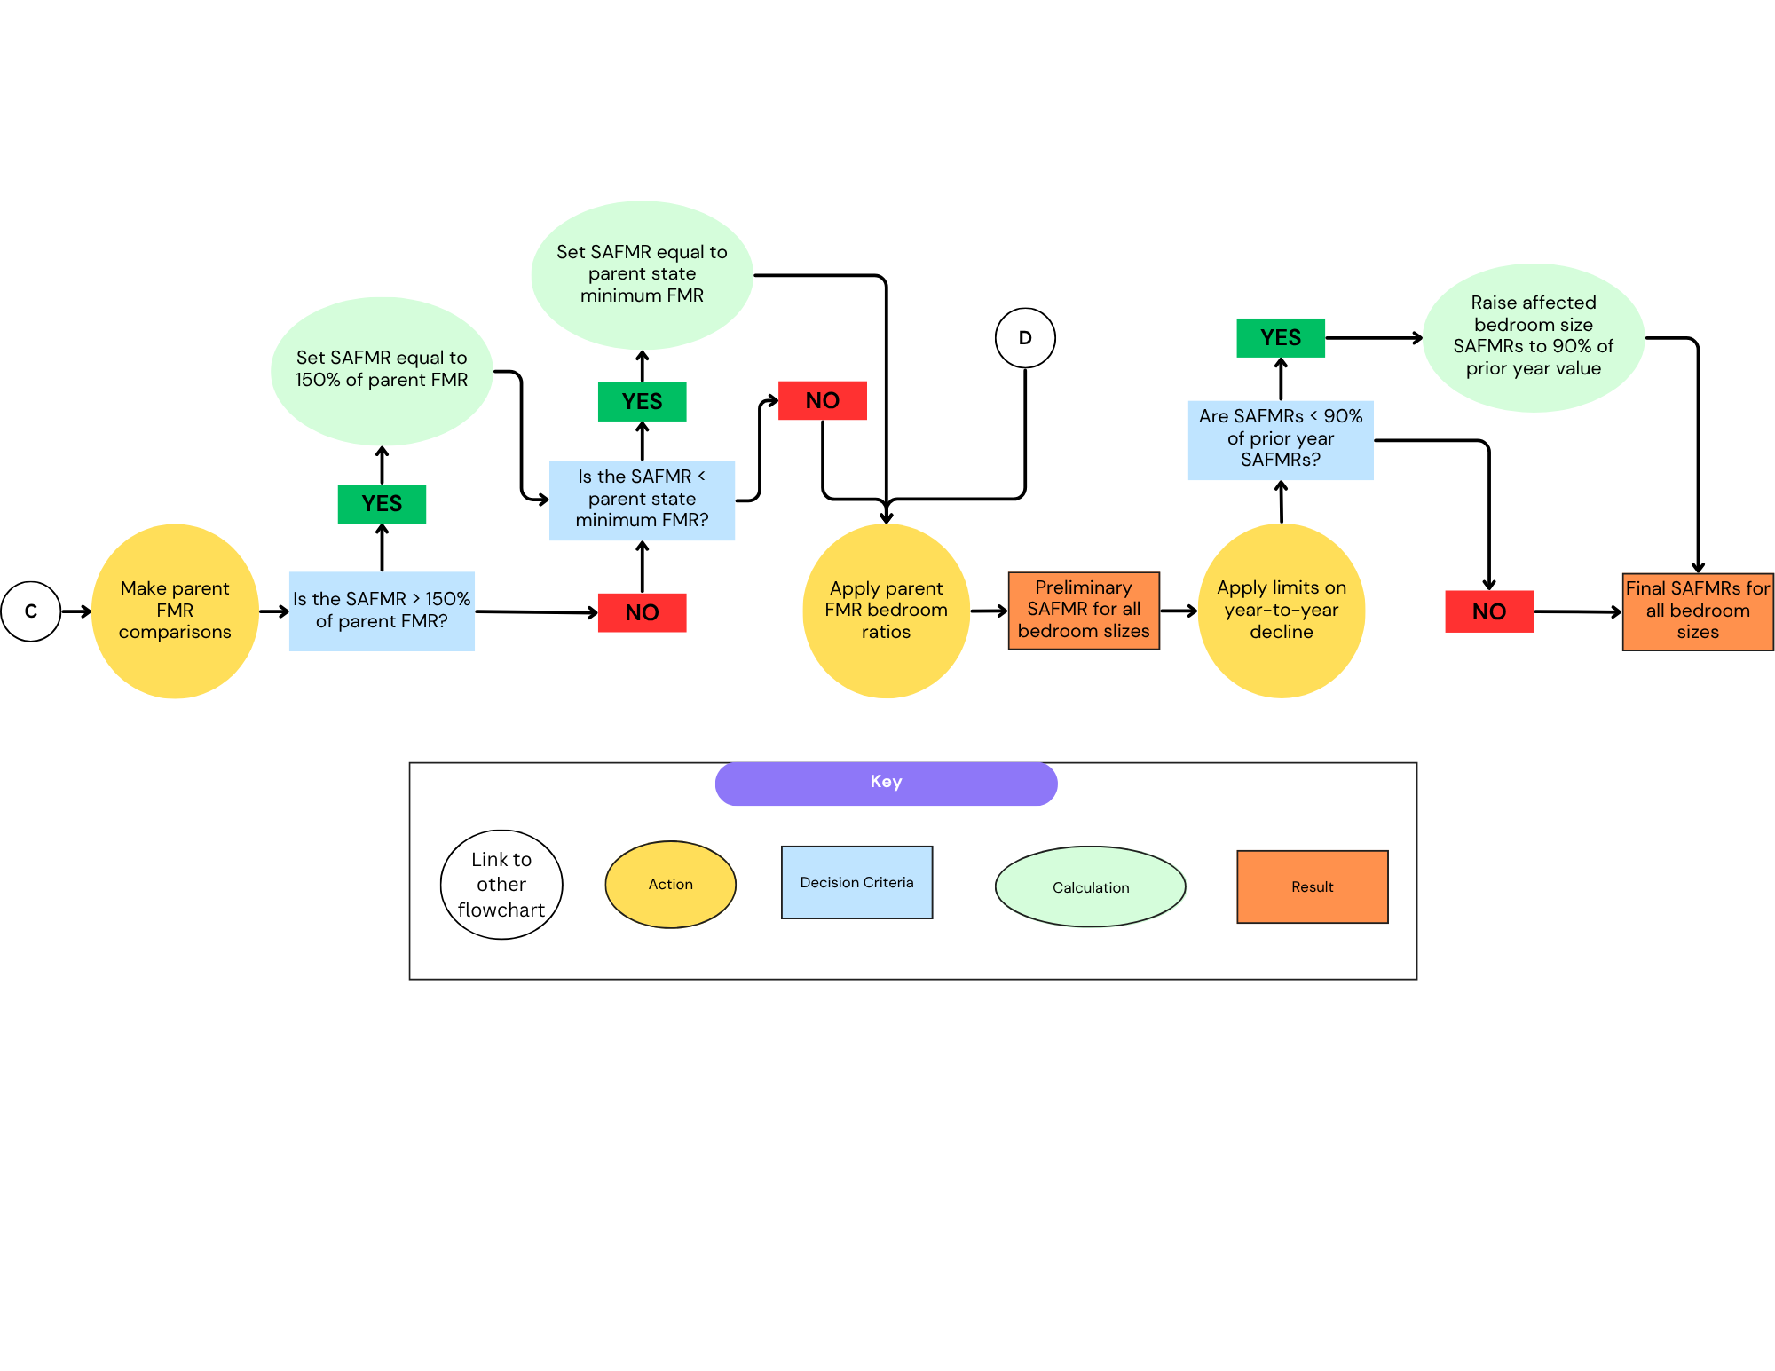
accessed through the FMR page for the Yolo, CA HUD Metro FMR Area. The ratios for each bedroom size (and how they are calculated) can be accessed by clicking the links in the table at the top of the page (“Efficiency”, “One-Bedroom”, etc.). The FMR efficiency bedroom ratio page shows that the final efficiency bedroom ratio for ZIP code 95605 is 0.762. Multiplying this ratio by the preliminary two-bedroom SAFMR yields the preliminary efficiency SAFMR, rounding to the nearest $1. The same calculation is performed for the other bedroom sizes.

Limits on Year-to-Year Declines
Once all the above SAFMR calculations have been made, there is one last check before they can be finalized. As with FMRs, SAFMRs cannot be less than 90 percent of the prior year’s FMR. So, the values need to be checked to ensure that none of them decrease by more than 10 percent. This is in addition to the state minimum and 150 percent cap discussed in Section 3.2. Again, this step is shown as part of Figure 8.
This limit on yearly declines was applied in FY 2026 for ZIP Code 85333 within the Phoenix-Mesa-Chandler, AZ MSA / Yuma, AZ MSA. As can be seen in the final table, the “Preliminary FY 2026 SAFMR” is less than 90 percent of the “FY 2025 FMR,” as shown in the line “FY 2025 Floor.” Therefore, the final FY 2026 SAFMRs for ZIP Code 85333 are set at 90 percent of the FY 2025 level or the “FY 2025 Floor.”

Appendices
- Selection Criteria
Designated metropolitan areas whose PHAs are subject to the mandatory use of SAFMRs are determined using the criteria laid out in the initial selection criteria Federal Register notice that accompanied the SAFMR Final Rule Federal Register notice on November 16, 2016, although the PHAs operating in those areas did not start using the SAFMRs until April 1, 2018.
The criteria used to determine whether a metropolitan FMR area should be subject to the mandatory use of SAFMRs include:
- Total vouchers ≥ 2,500. This is expressed in terms of HCVs and voucher counts are pulled from PIC extracts.
- At least 20 percent of the standard quality rental stock within the area is in ZIP Codes where the SAFMR is more than 110 percent of the metropolitan FMR.
- The percentage of voucher families living in concentrated low-income areas relative to all renters within the area must be at least 25 percent. This criterion is intended to better target communities where voucher concentration is most severe.
- The percentage of voucher holders living in concentrated low-income areas relative to all renters within these areas over the entire metropolitan area exceeds 155 percent (or 1.55).
- The vacancy rate for the metropolitan area is higher than 4 percent. This criterion’s inclusion helps to exclude rental markets in extreme disequilibrium. The vacancy rate is calculated using 1-year ACS tabulations from the most recent three years of data, where it is equal to the number of Vacant For Rent Units divided by the sum of the number of Vacant For Rent Units, the number of Renter Occupied Units, and the number of Rented, not occupied units.
These criteria were maintained when the SAFMR mandatory areas were reassessed in 2023 and new areas were added (see the October 25, 2023, Federal Register notice, as well as Appendix II below). The Excel spreadsheet with the relevant calculations can be found here (see the file “2023 Small Area FMR Selection Data” under “2023 SMALL AREA FMR EXPANSION” under the Rulemaking tab).
- Current SAFMR Areas
There are two types of SAFMR areas: (1) those that have been designated as mandatory SAFMRs by HUD using the selection criteria described in Appendix I, and (2) those that have opted in. Areas designated as mandatory SAFMR areas by HUD remain that way permanently, although (as discussed in Section I), there are circumstances under which an area may be temporarily removed from SAFMR designation. Each type will be discussed in turn below.
The first area to be designated as a mandatory SAFMR area was the Dallas, TX HMFA in 2011. The Dallas, TX HMFA’s designation was part of a settlement HUD made with the ICP (as discussed in Section I). With the settlement’s implementation on 10/1/2011, the Dallas, TX HMFA, encompassing two PHAs, became the first area in HUD’s SAFMR demonstration project. Starting in 2012, an additional five PHAs joined the two Dallas PHAs in using SAFMRs as part of the SAFMR demonstration project: the Housing Authority of the City of Laredo (TX), the Town of Mamaroneck Housing Authority (NY), the Chattanooga Housing Authority (Tennessee (TN)), the Housing Authority of Cook County (Illinois (IL)), and the City of Long Beach Housing Authority (CA).
The first round of mandatory SAFMR areas was added in 2016 once the SAFMR demonstration project was completed and a final rulemaking on SAFMRs was issued. However, the list of newly designated SAFMR areas was included in the companion FR notice that outlined the SAFMR selection criteria (discussed in Appendix I) rather than in the final rulemaking itself. The list, including the Dallas, TX HMFA, is as follows:
- Atlanta-Sandy Springs-Marietta, GA HUD Metro FMR Area
- Bergen-Passaic, New Jersey (NJ) HUD Metro FMR Area
- Charlotte-Gastonia-Rock Hill, North Carolina (NC)-South Carolina (SC) HUD Metro FMR Area
- Chicago-Joliet-Naperville, IL HUD Metro FMR Area
- Colorado Springs, CO HUD Metro FMR Area
- Dallas-Plano-Irving, TX Metro Division
- Fort Lauderdale-Pompano Beach-Deerfield Beach, Florida (FL) Metro Division
- Fort Worth-Arlington, TX HUD Metro FMR Area
- Gary, Indiana (IN) HUD Metro FMR Area
- Hartford-West Hartford-East Hartford, CT HUD Metro FMR Area
- Jackson, Mississippi (MS) HUD Metro FMR Area
- Jacksonville, FL HUD Metro FMR Area
- Monmouth-Ocean, NJ HUD Metro FMR Area
- North Port-Bradenton-Sarasota, FL MSA
- Palm Bay-Melbourne-Titusville, FL MSA
- Philadelphia-Camden-Wilmington, PA-NJ-Delaware (DE)-Maryland (MD) MSA
- Pittsburgh, PA HUD Metro FMR Area
- Sacramento-Arden-Arcade-Roseville, CA HUD Metro FMR Area
- San Antonio-New Braunfels, TX HUD Metro FMR Area
- San Diego-Carlsbad-San Marcos, CA MSA
- Tampa-St. Petersburg-Clearwater, FL MSA
- Urban Honolulu, Hawaii (HI) MSA
- Washington-Arlington-Alexandria, District of Columbia (DC)-VA-MD HUD Metro FMR Area
- West Palm Beach-Boca Raton-Delray Beach, FL Metro Division
Except for Dallas-Plano-Irving, TX Metro Division which had been designated as an SAFMR area as part of an earlier settlement, all were designated as SAFMR areas in 2016. However, per the final SAFMR rulemaking, PHAs had up to three months to implement the SAFMRs once they went into effect. The effective date for the initial round of SAFMR areas was January 17, 2017. However, due to litigation, the effective date was delayed by over a year, putting the actual implementation date for the initial round of SAFMR areas on April 1, 2018.
As described in the SAFMR rulemaking, HUD evaluates new data every five years as it becomes available, and makes additional SAFMR area designations as appropriate. As such, five years after the first round of SAFMR areas were implemented, the data was re-evaluated using the selection criteria (see Appendix I). The following areas were newly designated as mandatory SAFMR areas:
- Akron, OH MSA
- Augusta-Richmond County, GA-SC HUD Metro FMR Area
- Beaumont-Port Arthur, TX MSA
- Birmingham-Hoover, AL HUD Metro FMR Area
- Buffalo-Cheektowaga-Niagara Falls, NY MSA
- Charleston-North Charleston, SC MSA
- Chattanooga, TN-GA MSA
- Cincinnati, OH-Kentucky (KY)-IN HUD Metro FMR Area
- Cleveland-Elyria, OH MSA
- Columbus, OH HUD Metro FMR Area
- Dayton-Kettering, OH MSA
- Des Moines-West Des Moines, Iowa (IA) HUD Metro FMR Area
- Detroit-Warren-Livonia, Michigan (MI) HUD Metro FMR Area
- Fort Wayne, IN MSA
- Greensboro-High Point, NC HUD Metro FMR Area
- Harrisburg-Carlisle, PA MSA
- Indianapolis-Carmel, IN HUD Metro FMR Area
- Jersey City, NJ HUD Metro FMR Area
- Kansas City, MO-Kansas (KS) HUD Metro FMR Area
- Knoxville, TN HUD Metro FMR Area
- Los Angeles-Long Beach-Glendale, CA HUD Metro FMR Area
- Louisville, KY-IN HUD Metro FMR Area
- Memphis, TN-MS-Arkansas (AR) HUD Metro FMR Area
- Miami-Miami Beach-Kendall, FL HUD Metro FMR Area
- Mobile, AL HUD Metro FMR Area
- Montgomery, AL MSA
- Nashville-Davidson—Murfreesboro—Franklin, TN HUD Metro FMR Area
- Oklahoma City, OK HUD Metro FMR Area
- Omaha-Council Bluffs, Nebraska (NE)-IA HUD Metro FMR Area
- Orlando-Kissimmee-Sanford, FL MSA
- Oxnard-Thousand Oaks-Ventura, CA MSA
- Phoenix-Mesa-Scottsdale, AZ MSA
- Raleigh, NC MSA
- San Jose-Sunnyvale-Santa Clara, CA HUD Metro FMR Area
- Seattle-Bellevue, Washington (WA) HUD Metro FMR Area
- St. Louis, MO-IL HUD Metro FMR Area
- Tucson, AZ MSA
- Tulsa, Oklahoma (OK) HUD Metro FMR Area
- Virginia Beach-Norfolk-Newport News, VA-NC HUD Metro FMR Area
- Wichita, KS HUD Metro FMR Area
- Winston-Salem, NC HUD Metro FMR Area
A discussion of the evaluation criteria and how it led to these designations was presented in the 2023 Federal Register notice.
A complete list of the current metropolitan areas designated as mandatory SAFMR areas can be found here.
In addition to the metropolitan areas that have been designated as mandatory SAFMR areas, some areas have opted in to using SAFMR calculations, although PHAs that have opted in may subsequently opt out, returning to the use of the published FMRs.
Any area can opt in, but only those whose PHA (or PHAs) account for more than half of the vouchers in that area would use the SAFMR from the prior year as their limit on year-to-year declines. Areas that opt in to SAFMR use may also opt out. Therefore, these areas change periodically. The most recent list of SAFMR areas, whether they be mandatory, opt-in, or using SAFMRs as exception payment standards, can be found on the SAFMR dashboard.
- History of Methodological Changes
As discussed in the Introduction, SAFMRs officially began with the final rule that was published on November 16, 2016, but their development began earlier. The table below presents a history of SAFMR development with a focus on methodological changes. It is intended to briefly document the major changes for each FY of SAFMRs, starting with the most recent. References for more detailed information are provided throughout.
FY of SAFMRs | Methodological and Other Major Change(s)
FY 2025 | 41 additional metropolitan areas required to start using SAFMRs in the administration of their HCV program per the October 25, 2023, Federal Register notice.
FY 2025 | Calculated SAFMRs for non-metropolitan areas, as well as metropolitan areas, for the first time. Methodology for various steps modified to include relevant non-metropolitan counties as possible parent.
FY 2020 | Added “neighboring policy.” When a ZCTA does not have reliable data but there is reliable data for bordering ZCTAs, the neighboring data is used before going to county-based SAFMRs.
FY 2018 | Began calculating SAFMRs directly when statistically reliable information at the ZCTA level is available, rather than solely using the rent ratio calculation.
FY 2018 | Link ZCTAs to the smallest metropolitan area available as their parent FMR area for the rent ratio method in order to take advantage of the differing recent mover factors available across subdivided OMB metropolitan areas.
FY 2018 | Due to litigation, the implementation date for the initial group of mandatory SAFMR areas (see FY 2017) did not occur until April 1, 2018.
FY 2017 | Final rule published on November 16, 2016 (effective January 17, 2017), although implementation delayed until following year (see FY 2018). Included 24 metropolitan areas that were required to start using SAFMRs in the administration of their HCV program.
FY 2013 | Demonstration project started (November 20, 2012) with the Housing Authority of the County of Cook (IL), the City of Long Beach (CA) Housing Authority, the Chattanooga (TN) Housing Authority, the Town of Mamaroneck (NY) Housing Authority, and the Housing Authority of  Laredo (TX) joining the Dallas, TX HMFA PHAs.
FY 2011 | HUD mandated the use of SAFMRs in place of FMRs to settle litigation in the Dallas, TX, HMFA, and its PHAs were included in the SAFMR demonstration project.
FY 2010 | HUD announced an SAFMR demonstration project (May 18, 2010).
- Acronyms and Abbreviations
ACS American Community Survey
AL Alabama
AR Arkansas
ASQ adjusted standard quality
AZ Arizona
CA California
CBSA Core Based Statistical Area
CO Colorado
CPI Consumer Price Index
CT Connecticut
DC District of Columbia
DE Delaware
FL Florida
FMR fair market rent
FY fiscal year
GAO Government Accountability Office
GA Georgia
HAP housing assistance payment
HI Hawaii
HCV Housing Choice Voucher
HMFA or CBSAsub HUD Metro FMR Area
HOTMA Housing Opportunity Through Modernization Act
HUD U.S. Department of Housing and Urban Development
IA Iowa
ICP Inclusive Communities Project
IL Illinois
IN Indiana
KS Kansas
KY Kentucky
LIHTC low-income housing tax credits
MA Massachusetts
MD Maryland
MI Michigan
MN Minnesota
MO Missouri
MS Mississippi
MSA metropolitan statistical area
MT Montana
NC North Carolina
ND North Dakota
NE Nebraska
NH New Hampshire
NJ New Jersey
NY New York
OH Ohio
OK Oklahoma
OMB Office of Management and Budget
PA Pennsylvania
PBV Project-Based Voucher
PD&R Office of Policy Development and Research
PHA public housing agency
PIC PIH Information Center
PIH Office of Public and Indian Housing
PPRD Program Parameters and Research Division
PR Puerto Rico
QCT Qualified Census Tracts
RI Rhode Island
RMSE Root Mean Square Error
SAFMR small area fair market rent
SC South Carolina
TN Tennessee
TX Texas
USPS United States Postal Service
VA Virginia
WA Washington
WI Wisconsin
WY Wyoming
ZCTA ZIP Code Tabulation Area

See SAFMR Final Rule Federal Register Notice, as well as the History of Methodological Changes provided in Appendix IV.
“Rental Housing: Use of Small Market Areas to Set Rent Subsidy Levels Has Drawbacks” (GAO/RCED-94-112).
For more information on this, as well as a more detailed history of SAFMRs and their early methodology, see Adam Bibler, Chalita Brandly, Peter Kahn, Marie Lihn, and Lydia Taghavi. U.S. Department of Housing and Urban Development. “Small Area Fair Market Rents.” Cityscape: A Journal of Policy Development and Research • Volume 21, Number 3 (2019).
Described in Bibler et al. (2019) p. 6.
There are circumstances where an area may be temporarily removed. For example, HUD may suspend an SAFMR designation or exempt a PHA from using SAFMRs due to things like a “sudden influx of displaced households needing permanent housing.” For more information on SAFMR suspensions and exemption, see the SAFMR Final Rule Federal Register Notice, modifications to § 888.113 Fair market rents for existing housing: Methodology, or 24 CFR § 888.113(c)(4).￼Additional guidance can be found in Section IV.A.3 of the ﷟HYPERLINK "https://www.hud.gov/sites/dfiles/PIH/documents/PIH_2024-34.pdf"HCV Payment Standard Guidance (p. 9). (p. 9).
Bibler et al. (2019) p. 7.
For more information on ZCTAs and their relationship to zip codes, see here.
See SAFMR FAQ document p. 7.
ZCTAs may cross counties, and this is accounted for using a population-weighted ZCTA average for each county. See Section 3.1.1.
The latter would include university addresses.
See Section I “Area Definitions”.
See https://www.census.gov/geographies/reference-files/time-series/demo/metro-micro/delineation-files.html.
Maine, Massachusetts (MA), New Hampshire (NH), Rhode Island (RI), and Vermont.
As noted in the FMR methodology, the Sullivan City portion of Crawford County, Missouri (MO) requires special consideration, as did Westchester County, New York (NY) prior to FY 2025.
See Section II.
An additional “standard quality” item (not constructed within the last two years) has been eliminated with the most recent ACS special tabulations as a result of the promulgation of the final rule for implementing sections 102, 103, and 104 of the Housing Opportunity Through Modernization Act (HOTMA).
Which has a three-year lag, as already noted.
Considering the parent HMFA rather than the entire CBSA helps to further localize SAFMRs. See Bibler et al. (2019) pp. 10-11.
Where the parent may be either the county’s parent HUD metropolitan area or non-metropolitan county.
As discussed in Section 3.1.5, Case E does not require parent FMR comparisons because the preliminary SAFMR is set using the county FMR.
When non-metropolitan areas were newly added in FY 2025, they did not have prior year SAFMRs. Therefore, the floor was initially set at 90 percent of the prior year’s non-metropolitan county FMR. The limit on year-to-year declines is also set at 90 percent of the FMR for non-mandatory areas where the PHAs optionally using SAFMRs represent less than half of all vouchers for that area.
As noted in the Federal Register notice announcing additional mandatory SAFMR areas.
See here or here for a summary of the selection criteria but see here (p. 80576, response to comments on the proposed selection criteria) for additional details on the final criteria.
‘‘Concentrated low-income areas’’ are census tracts in the metropolitan FMR area with a poverty rate of 25 percent or more; or any tract in the metropolitan FMR area where 50 percent or more of the households earn incomes less than 60 percent of the AMI and designated as Qualified Census Tracts (QCT).
See Bibler et al. (2019) p. 9.
As noted here (p. 2), the Dallas, TX HMFA is used interchangeably with the Dallas-Plano-Irving, TX Metropolitan Division. Therefore, the FR notice added 23 new areas to the already designated Dallas, TX HMFA.
The first round of SAFMR areas were implemented in 2018, so the second evaluation was conducted in 2023.
See HUD’s Office of Public and Indian Housing (PIH), Updated and Consolidated Policy Guidance on Housing Choice Voucher (HCV) Program Payment Standards (Notice PIH 2024-34) (September 30, 2024): p. 11.
Small Area Fair Market Rents - Selection Criteria (huduser.gov), although the actual implementation came later.
See FY 2025 Federal Register notice.
See FY 2020 Federal Register notice.
See FY 2018 Federal Register notice, as well as FY 2020 Federal Register notice.
Small Area Fair Market Rents - Selection Criteria (huduser.gov).
See Federal Register advanced notice of proposed rulemaking for SAFMR and Bibler et al. (2019) p. 9.
See Federal Register advanced notice of proposed rulemaking for SAFMR, Notice of Demonstration Project of SAFMRs and FY 2011 Federal Register notice.
See Federal Register advanced notice of proposed rulemaking for SAFMR, Notice of Demonstration Project of SAFMRs.

